Supplementary Figure 6. Univariate analyses of overall survival.

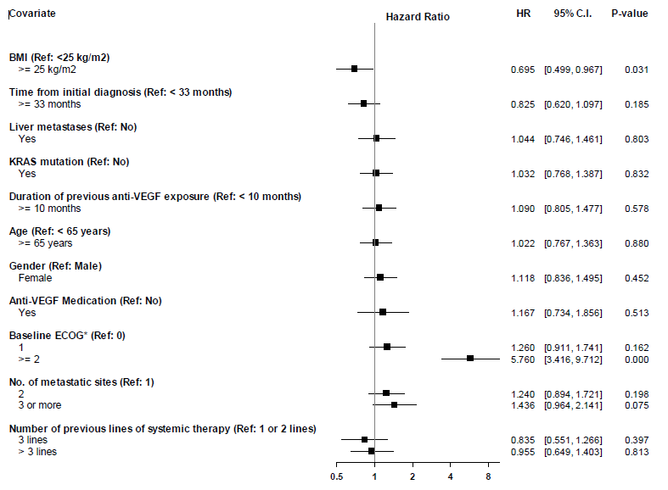

* Met criteria for inclusion in multivariate stepwise procedure.

