Supplementary Figure 5. Overall survival (a) and progression-free survival (b), stratified by prior anti-EGFR therapy.
(a)
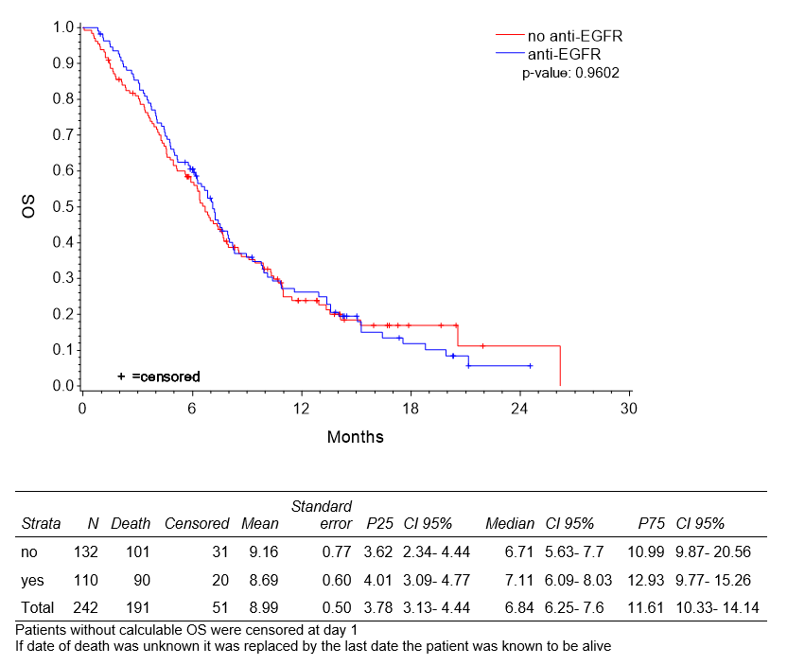
(b)
