Supplementary Figure 3. Overall survival and progression-free survival (b), stratified by ECOG PS.
(a)
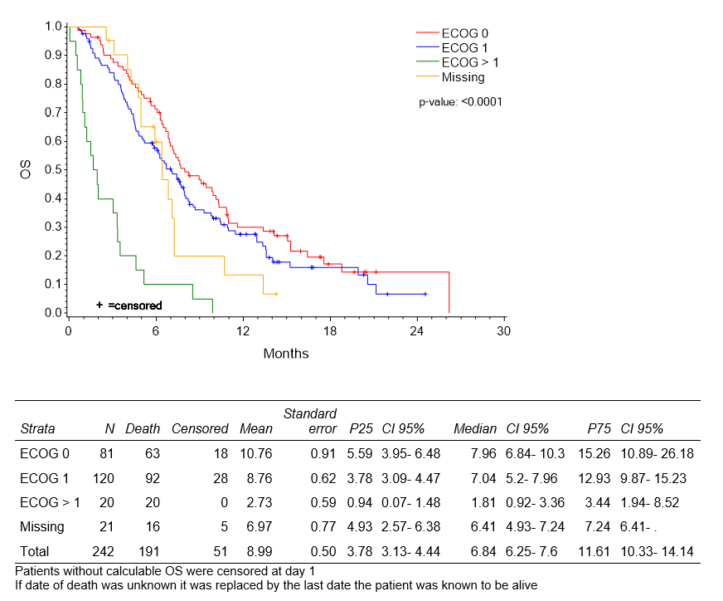
(b)
