Supplementary Figure 2. Overall survival (a) and progression-free survival (b), stratified by age.
(a)
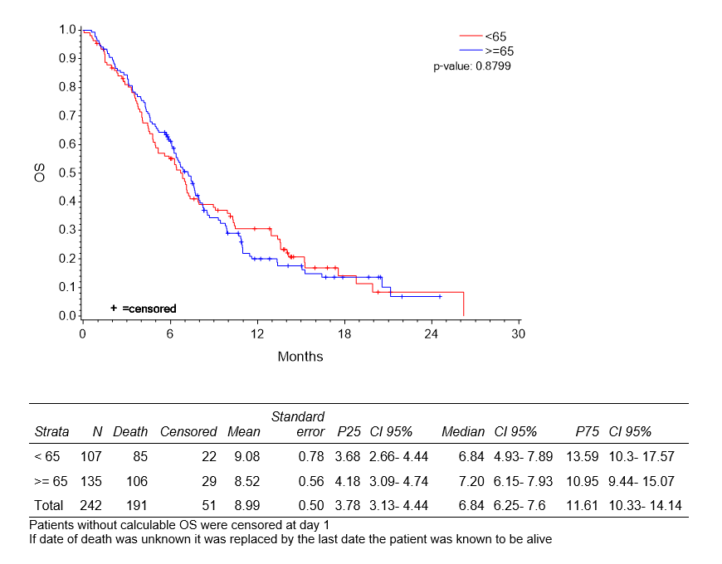
(b)
