Supplementary Figure 1. Overall survival (a) and progression-free survival (b), stratified by starting dose.
(a)
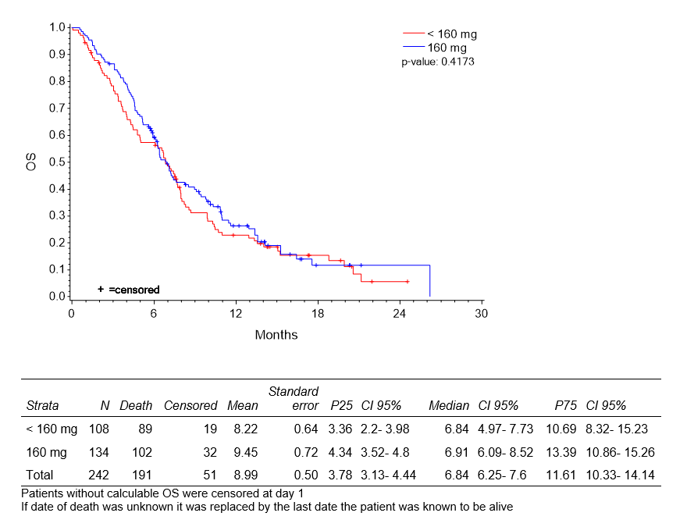

(b)
