Supplementary File 1

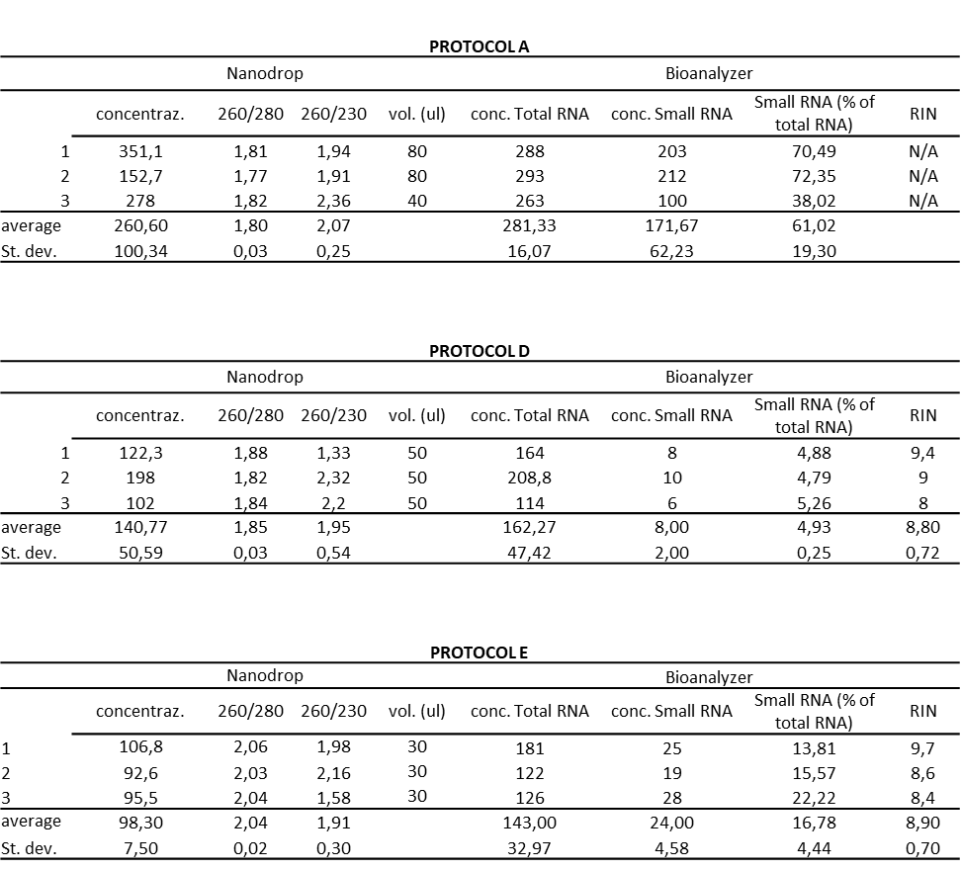

Yield and quality of RNA extracted following the Protocols A, D and E. Data are mean±SD for RNA samples extracted from HSJD-DIPG007 cell lines. T-test was performed for the comparison of the RNAs concentration from Bioanalyzer measurements between the protocols: For Total RNA, Protocol A vs Protocol D p-value=0,00284; Protocol A vs Protocol E p-value= 0,01463; Protocol D vs Protocol E p-value= 0,59438; for Small RNA, , Protocol A vs Protocol D p-value=0,01039; Protocol A vs Protocol E p-value= 0,01486; Protocol D vs Protocol E p-value=0,00518.

