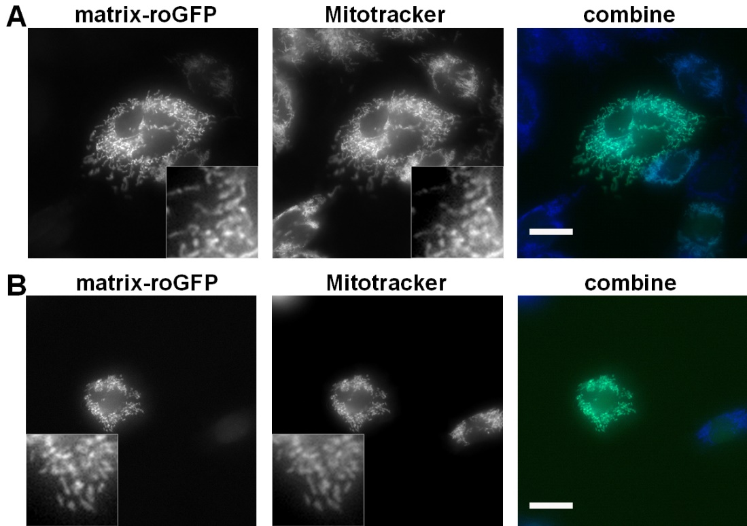

Figure S2. Co-localization of matrix-roGFP with Mitotracker RED CMXRos staining in CHO and MDA-MB-231 cells. CHO (A) and MDA-MB-231 (B) cells expressing matrix-roGFP were trypsinized and plated onto Fn-coated coverslips, fixed, and then stained for visualization of mitochondria. Representative images are shown. Scale bar = 20 μm

