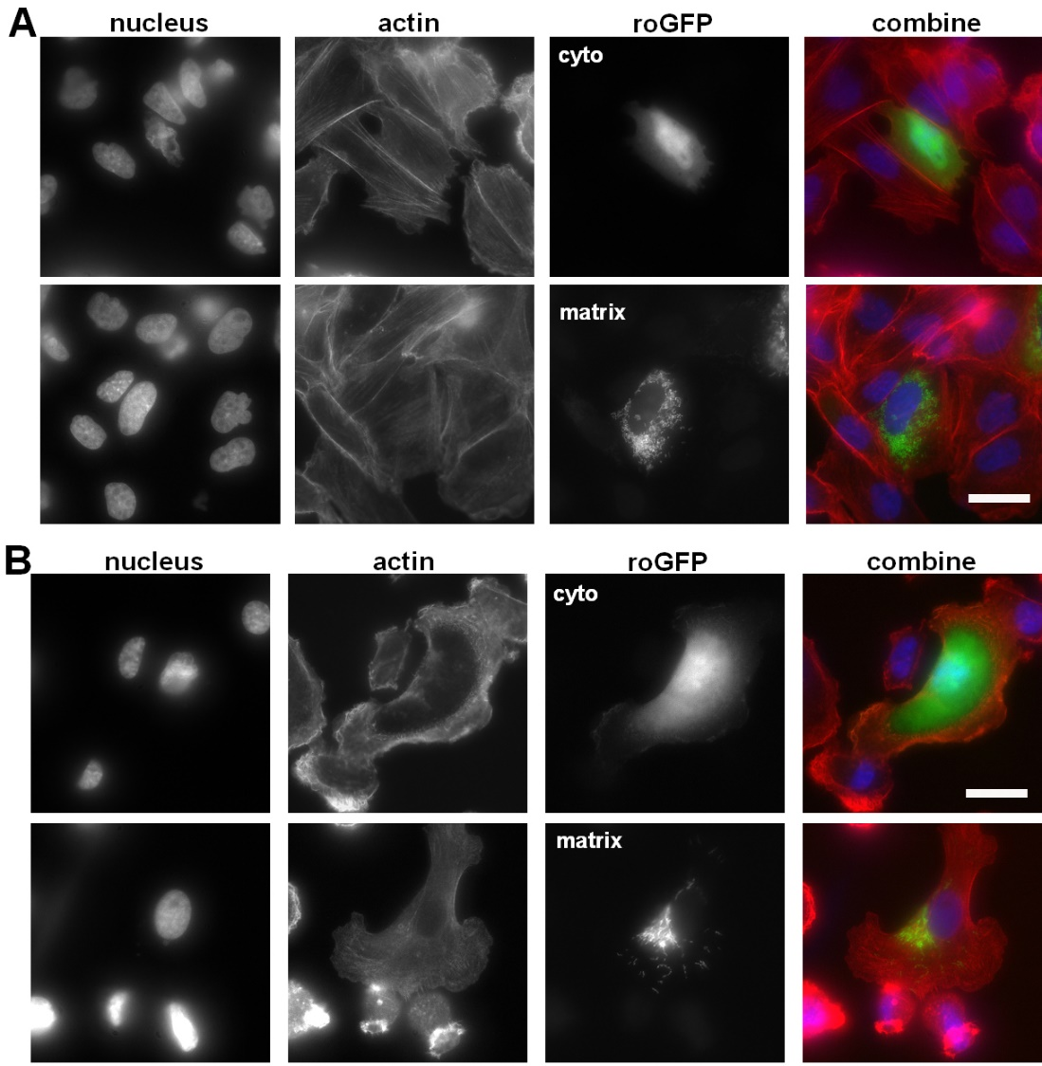

Figure S1. Localization of cyto-roGFP and matrix-roGFP in CHO and MDA-MB-231 cells. CHO (A) and MDA-MB-231 (B) cells expressing cyto-roGFP or matrix-roGFP were trypsinized and plated onto Fn-coated coverslips, fixed, and then stained for visualization of the nucleus and actin. Representative images are shown. Scale bar = 20 μm

