**SUPPLEMENRARY INFOMATION**

Supplementary Table S1. Comparison of sample volume, path length, and detection limit among commercial nano- or micro-volume absorption spectrometers and apparatus. Data in the table were obtained from manufacturers’ webpages (refer to the references indicated in the table). The results of this work are listed at the bottom line for comparison.



*The path length of 5 mm is optionally provided.

** This apparatus is provided to be used with a conventional spectrophotometer.

Supplementary Table S2. Information on the internal volumes of micro-tubes with various combinations of internals dimeters and lengths.



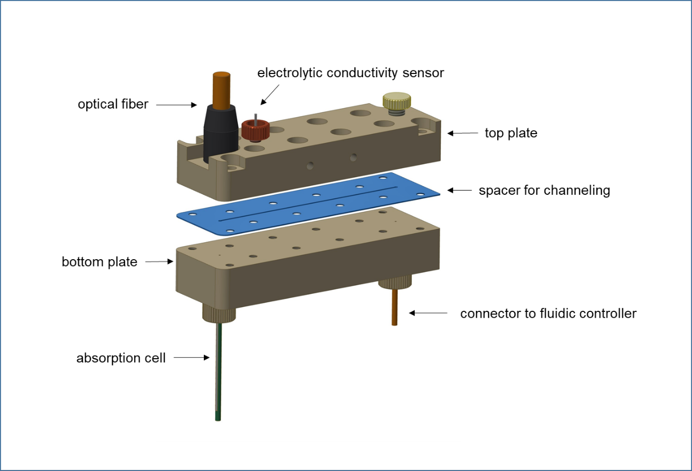

Supplementary Figure S1. Schematic of the fluidic control body to be assembled with the spacer defining the internal fluidic channel. The fluidic control body also provides receptacles for an absorption cell as well as an optical fiber fetch cable to optically couple them together.

C:\Users\박상열\Desktop\OD-biotechniques-revision\고해상도 figs\supplementary figure\Fig. S-2.TIF

Supplementary Figure S2. The detailed presentation of the interfacing area of the fluidic control body.

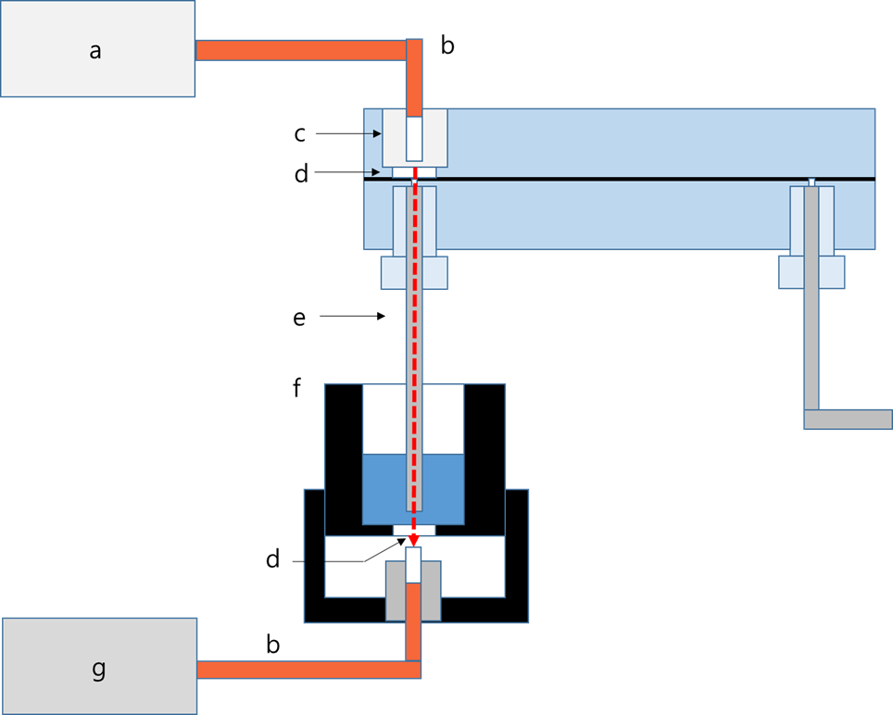 Supplementary Figure S3. Schematic of the light passage for absorption measurement (not to scale): (a) light source, (b) optical fiber, (c) fiber receptacle, (d) window, (e) absorption cell, (f) detection well, (g) spectrophotometer module or photodiode

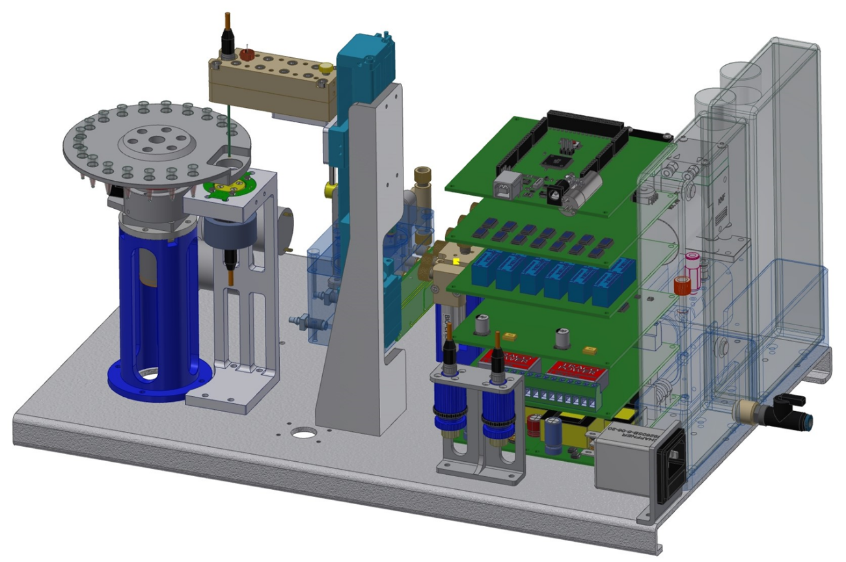

Supplementary Figure S4. Graphical presentation of the prototype instrument equipped with the proposed absorption cell as well as the disk type sample tray.



Supplementary Figure S5. Gradual change in the effective path length of the proposed absorption cell created from absorption curves of a diluted phenolphthalein indicator obtained with the proposed absorption cell and a conventional absorption cell (path length 10 mm) made of quartz. The middle region of wavelength giving poor signal to noise was omitted from plotting to avoid misleading by unreliable data points.



Supplementary Figure S6. Linear relationship between the assigned absorbance and the measured absorbance for the gravimetrically diluted NIST SRM935a at 257 nm. The R2 value of linear fitting was 0.9997 whereas the slope was 0.992 for the standard solutions of absorbance 0.011 – 2.56.