Supplementary Figure 1. Morphological appearance, characterization, and differentiation of MSCs. (A) Morphology of DF-MSCs in P0, P1, P2, and P3 (magnification = 10×). (B) Representative flow cytometry analysis of positive surface markers CD105, CD146, CD90, CD73, CD29, and negative surface marker CD25, CD28, CD14, CD45, CD34 for MSCs at the third passages. (C) Alizarin red staining of osteogenic induced MSCs, oil red staining of adipogenic induced MSCs, alcian blue staining of chondrogenic induced DF-MSCs, scale bar = 1000 µm.

Supplementary Figure 2. The ratio of naive and memory T cell subset in AD and healthy control in the absence and presence of MSCs represent by Flow cytometry. (A, B) CD4⁺CD45RA⁺ and CD8⁺CD45RA⁺ naive T cell ratio increased and CD4⁺CD45RO⁺ and CD8⁺CD45RO⁺ memory T cell ratio decreased in presence of MSCs in AD patients. (C, D) There was no significant difference in naive and memory T cell ratio in healthy controls.

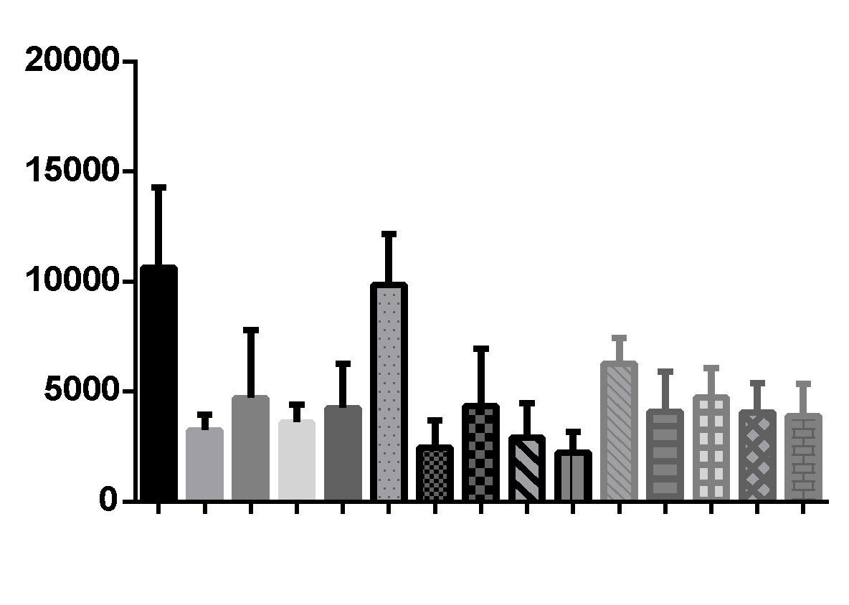
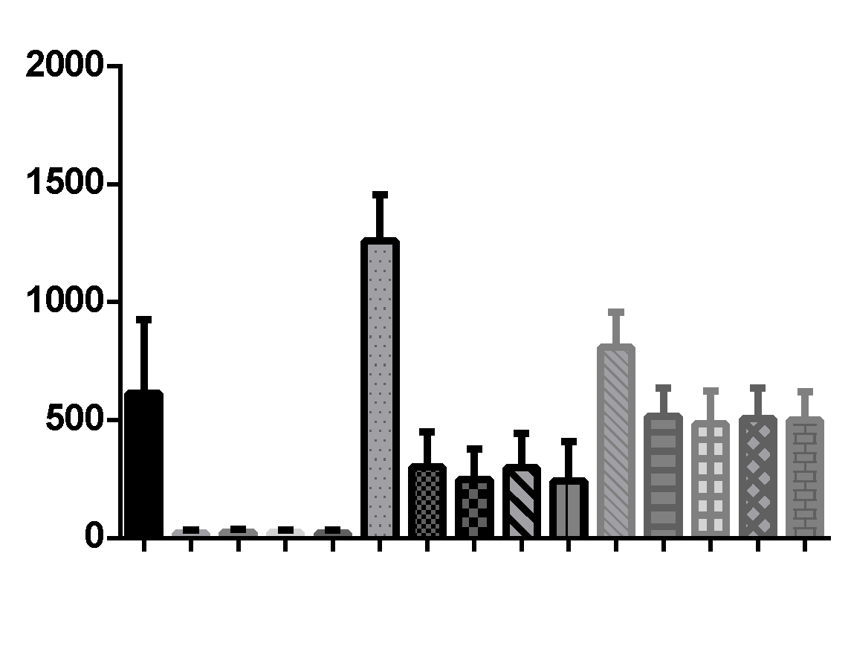
A)
IL-6 (pg/ml)
**
*
**
*
**
*
**
**
**
*
AD
HC
MSC (-)
MSC (+)
MSC (+) anti-TGFβ
MSC (+) Sc58125
MSC (+) 1MDT
MSC (-)
MSC (+)
MSC (+) anti-TGFβ
MSC (+) Sc58125
MSC (+) 1MDT
MSC (-)
MSC (+)
MSC (+) anti-TGFβ
MSC (+) Sc58125
MSC (+) 1MDT
Psoriasis
B)
TNF-α (pg/ml)
**
**
**
**
***
***
***
***
*
*
*
*
AD
HC
MSC (-)
MSC (+)
MSC (+) anti-TGFβ
MSC (+) Sc58125
MSC (+) 1MDTm
MSC (-)
MSC (+)
MSC (+) anti-TGFβ
MSC (+) Sc58125
MSC (+) 1MDT
MSC (-)
MSC (+)
MSC (+) anti-TGFβ
MSC (+) Sc58125
MSC (+) 1MDT
Psoriasis

Supplementary Figure 3. The levels of cytokines in the supernatants of PBMCs were determined using flow cytometry. MSCs significantly decreased TNF-α (A) and IL-6 (B) levels in AD and psoriasis patients. *P <0.05, **P <0.01, ***P <0.001. Results are shown as mean ± SD.

