SUPPLEMENTAL FIGURE 1
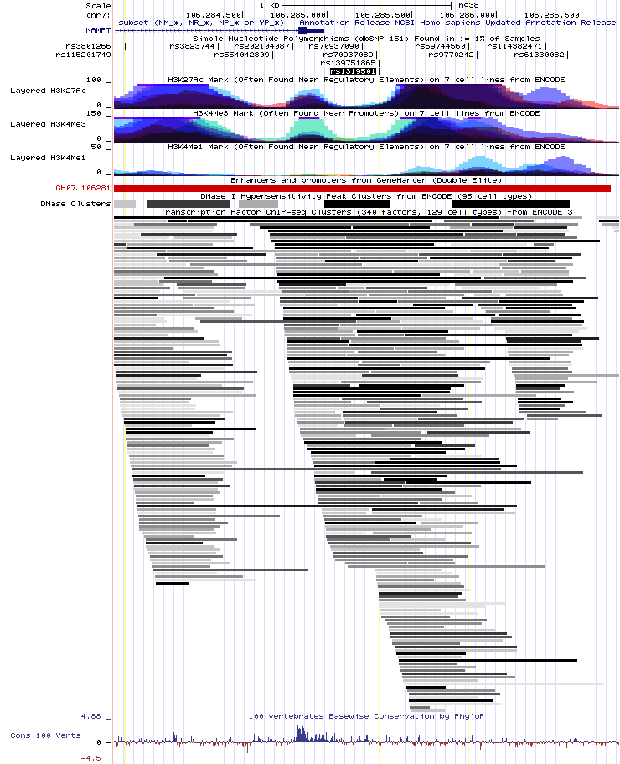
Figure S1. UCSC Genome Browser view of the NAMPT promoter region with the location of the functional SNPs rs59744560 and rs61330082, histone modifications and several ENCODE data. The region shows an enrichment for the active histone mark H3K27ac, the H3K4me3 associated with active promoters, and it has a promoter element identified by GeneHancer (GH07J106281).
SUPPLEMENTAL FIGURE 2

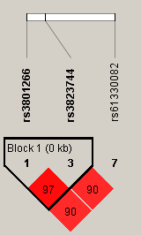
Figure S2. Linkage disequilibrium among SNPs in the NAMPT promoter region for the East Asian (CHB+JPT) population. The numbers below the rs IDs correspond to the number of SNPs found for this population. Values for pairwise D´ are presented in each box; those without values refer to D´=1. Color scheme: bright red, D′ = 1 and logarithm of odds (LOD) ≥ 2.

