Supplementary Figure 1.
GRIN1 | CpG1 CpG2 CpG3
Human | 5’ GTTCGCGCCGCGCAGAGCCAGGCCCGCGGCCCGAGCCCATGAGCACCATGCGCCTGCTGACGCTCGCCCTGCTGTTCTC 3’
 | 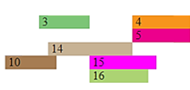
 | 3:AP-2alphaA 14:C/EBPβ 4:Pax-5
 | 10:XBP-1 15:MyoD 5:p53
 | 14:C/EBPβ 16:c-Jun

