Supplementary Appendix

Heterogeneity analyses
- Poor-risk patients
Q=1.03; df=2; I²=0%
- Intermediate-risk patients
Q=1.53; df=2; I²=0%
- Favorable-risk patients
Q=1.03; df=2; I²=39%

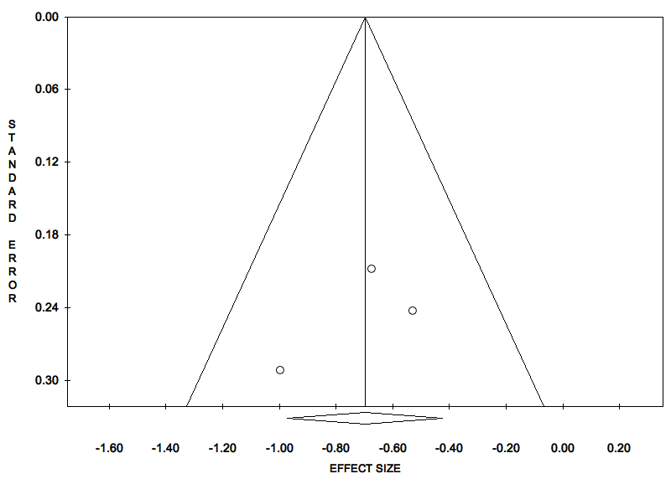
Supplementary Figure 1. Funnel Plot of the Overall Survival (OS) in poor-risk patients, according to IMDC criteria (immune checkpoint inhibitors plus tyrosine kinase inhibitors versus sunitinib monotherapy).

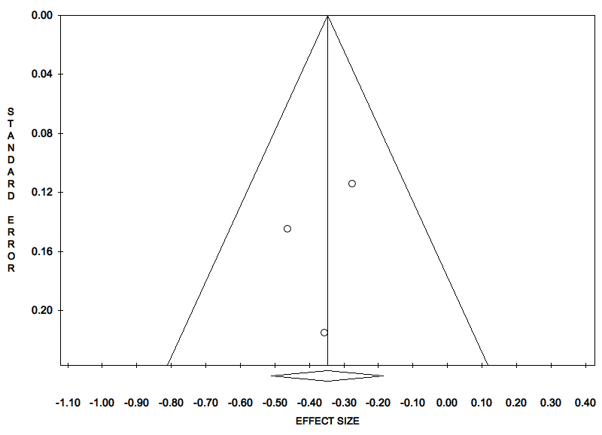
Supplementary Figure 2. Funnel Plot of the Overall Survival (OS) in intermediate-risk patients, according to IMDC criteria (immune checkpoint inhibitors plus tyrosine kinase inhibitors versus sunitinib monotherapy).

Supplementary Figure 3. Funnel Plot of the Overall Survival (OS) in favorable-risk patients, according to IMDC criteria (immune checkpoint inhibitors plus tyrosine kinase inhibitors versus sunitinib monotherapy).

