ANOVA for Response Surface Quadratic Model

Supplementary Table 1: Response1 Particles size(nm) ANOVA for Response Surface Quadratic Model.
Analysis of variance table [Partial sum of squares - Type III]
Sum of Mean F p-value
Source Squares df Square Value Prob > F
Model 3.524E+005 9 39158.33 71.66 < 0.0001 significant
A-PLGA(mg/ml) 10046.53 1 10046.53 18.39 0.0078
B-TS (mg/ml) 15216.40 1 15216.40 27.85 0.0033
C-Poloxamer188(%) 1.524E+005 1 1.524E+005 278.92 < 0.0001
AB 5343.61 1 5343.61 9.78 0.0260
AC 35250.06 1 35250.06 64.51 0.0005
BC 464.40 1 464.40 0.85 0.3989
A2 16989.64 1 16989.64 31.09 0.0026
B2 61221.62 1 61221.62 112.04 0.0001
C2 45828.25 1 45828.25 83.87 0.0003
Residual 2732.07 5 546.41
Lack of Fit 2416.86 3 805.62 5.11 0.1680 not significant
Pure Error 315.21 2 157.60
Cor Total 3.552E+005 14
The Model F-value of 71.66 implies the model is significant. There is only
a 0.01% chance that a "Model F-Value" this large could occur due to noise.
Values of "Prob > F" less than 0.0500 indicate model terms are significant.
In this case A, B, C, AB, AC, A2, B2, C2 are significant model terms.
Values greater than 0.1000 indicate the model terms are not significant.
If there are many insignificant model terms (not counting those required to support hierarchy),
model reduction may improve your model.
The "Lack of Fit F-value" of 5.11 implies the Lack of Fit is not significant relative to the pure
error. There is a 16.80% chance that a "Lack of Fit F-value" this large could occur due
to noise. Non-significant lack of fit is good -- we want the model to fit.
Std. Dev. 23.38 R-Squared 0.9923
Mean 565.95 Adj R-Squared 0.9785
C.V. % 4.13 Pred R-Squared 0.8891
PRESS 39379.01 Adeq Precision 30.676
The "Pred R-Squared" of 0.8891 is in reasonable agreement with the "Adj R-Squared" of 0.9785.

Supplementary Equation 1: Final Equation in Terms of Coded Factors:
Particles size(nm) =
+592.87
+35.44 * A
+43.61 * B
-138.03 * C
-36.55 * A * B
-93.88 * A * C
-10.77 * B * C
-67.83 * A2
+128.77 * B2
-111.41 * C2
Final Equation in Terms of Actual Factors:
Particles size(nm) =
-55.88333
+56.76208 * PLGA(mg/ml)
-75.36083 * TS (mg/ml)
+1033.81667 * Poloxamer188(%)
-0.73100 * PLGA(mg/ml) * TS (mg/ml)
-18.77500 * PLGA(mg/ml) * Poloxamer188(%)
-4.31000 * TS (mg/ml) * Poloxamer188(%)
-0.67833 * PLGA(mg/ml)2
+5.15067 * TS (mg/ml)2
-445.63333 * Poloxamer188(%)2

Supplementary Table 2: Response 2 Zeta potential (mV) ANOVA for Response Surface Quadratic Model. Analysis of variance table [Partial sum of squares - Type III]
Sum of Mean F p-value
Source Squares df Square Value Prob > F
Model 347.96 9 38.66 145.35 < 0.0001 significant
A-PLGA(mg/ml) 23.80 1 23.80 89.49 0.0002
B-TS (mg/ml) 63.85 1 63.85 240.02 < 0.0001
C-Poloxamer188(%) 2.00 1 2.00 7.52 0.0407
AB 15.21 1 15.21 57.18 0.0006
AC 9.00 1 9.00 33.83 0.0021
BC 123.21 1 123.21 463.20 < 0.0001
A2 27.92 1 27.92 104.97 0.0002
B2 24.96 1 24.96 93.83 0.0002
C2 73.12 1 73.12 274.88 < 0.0001
Residual 1.33 5 0.27
Lack of Fit 1.33 3 0.44
Pure Error 0.000 2 0.000
Cor Total 349.29 14
The Model F-value of 145.35 implies the model is significant. There is only
a 0.01% chance that a "Model F-Value" this large could occur due to noise.
Supplementary Equation 2: Final Equation in Terms of Coded Factors:
Zeta potential (mV) =
-27.50
+1.72 * A
+2.83 * B
-0.50 * C
+1.95 * A * B
-1.50 * A * C
-5.55 * B * C
-2.75 * A2
-2.60 * B2
-4.45 * C2
Final Equation in Terms of Actual Factors:
Zeta potential (mV) =
-95.20000
+1.18250 * PLGA(mg/ml)
+4.08500 * TS (mg/ml)
+62.80000 * Poloxamer188(%)
+0.039000 * PLGA(mg/ml) * TS (mg/ml)
-0.30000 * PLGA(mg/ml) * Poloxamer188(%)
-2.22000 * TS (mg/ml) * Poloxamer188(%)
-0.027500 * PLGA(mg/ml)2
-0.10400 * TS (mg/ml)2
-17.80000 * Poloxamer188(%)2

Supplementary Table 3: Response 3 EE (%)ANOVA for Response Surface Quadratic Model. Analysis of variance table [Partial sum of squares - Type III].
Sum of Mean F p-value
Source Squares df Square Value Prob > F
Model 230.08 9 25.56 76.12 < 0.0001 significant
A-PLGA(mg/ml) 18.91 1 18.91 56.31 0.0007
B-TS (mg/ml) 2.10 1 2.10 6.26 0.0544
C-Poloxamer188(%) 3.64 1 3.64 10.85 0.0216
AB 0.040 1 0.040 0.12 0.7440
AC 2.500E-003 1 2.500E-003 7.444E-003 0.9346
BC 0.20 1 0.20 0.60 0.4726
A2 104.37 1 104.37 310.78 < 0.0001
B2 35.87 1 35.87 106.80 0.0001
C2 93.85 1 93.85 279.46 < 0.0001
Residual 1.68 5 0.34
Lack of Fit 1.55 3 0.52 8.17 0.1110 not significant
Pure Error 0.13 2 0.063
Cor Total 231.76 14
The Model F-value of 76.12 implies the model is significant. There is only
a 0.01% chance that a "Model F-Value" this large could occur due to noise.
Values of "Prob > F" less than 0.0500 indicate model terms are significant.
In this case A, C, A2, B2, C2 are significant model terms.
Values greater than 0.1000 indicate the model terms are not significant.
Supplementary Equation 3: Final Equation in Terms of Coded Factors:
EE (%) =
+80.57
+1.54 * A
-0.51 * B
+0.67 * C
-0.100 * A * B
-0.025 * A * C
-0.22 * B * C
+5.32 * A2
+3.12 * B2
+5.04 * C2
Final Equation in Terms of Actual Factors:
EE (%) =
+129.66667
-1.94792 * PLGA(mg/ml)
-2.46583 * TS (mg/ml)
-37.98333 * Poloxamer188(%)
-2.00000E-003 * PLGA(mg/ml) * TS (mg/ml)
-5.00000E-003 * PLGA(mg/ml) * Poloxamer188(%)
-0.090000 * TS (mg/ml) * Poloxamer188(%)
+0.053167 * PLGA(mg/ml)2
+0.12467 * TS (mg/ml)2
+20.16667 * Poloxamer188(%)2

Supplementary Table 4: Fit Summary of different mathematical models for mixed PLNs size.
Source | Sequential Lack of Fit Adjusted Predicted Rejected /Suggested p-value p -value R-Squared R- Squared
Linear
 | 0.0472 0.0080 0.03640 -0.0633
2FI | 0.5267 0.00 0.3278 -1.0164
Quadratic | 0.0001 0.1680 0.9785 0.8891 Suggested Suggested
Cubic | 0.1680 Aliased

Supplementary Table 5 : Fit Summary of different mathematical models for mixed PLNs zeta potential.
Source | Sequential Lack of Fit Adjusted Predicted Rejected /Suggested p-value p -value R-Squared R- Squared
Linear | 0.3324 0.0548 -0.3580
2FI | 0.0698 0.4394 0.2655
Quadratic | 0.0001 0.9880 0.9315 Suggested Suggested
Cubic | 0.0001 Aliased

Supplementary Table 6: Fit Summary of different mathematical models for mixed PLNs entrapment efficiency
Source | Sequential Lack of Fit Adjusted Predicted Rejected /Suggested p-value p-value R-Squared R- Squared
Linear
 | 0.7313 0.0027 - 0.1373 -0.2489
2FI | 0.9997 0.0018 -0.5620 -0.9580
Quadratic | 0.0001 0.1110 0.9797 0.8916 Suggested
Cubic | 0.1110 Aliased

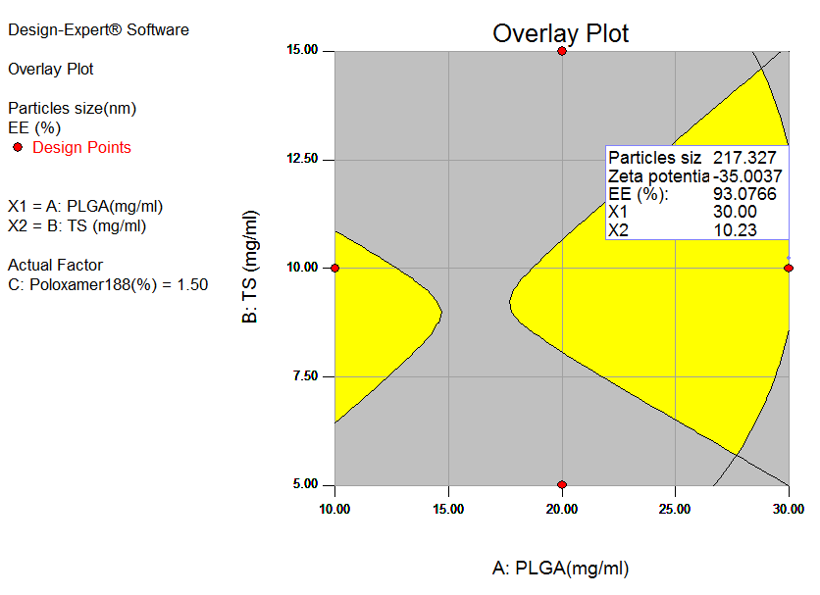
Supplementary Figure 1: Design space for IBU-PLNs. nanoparticles. Yellow areas contain the feasible settings to obtain desired values for average particle size 217 nm), %EE (93%) and Zeta potential (-35).

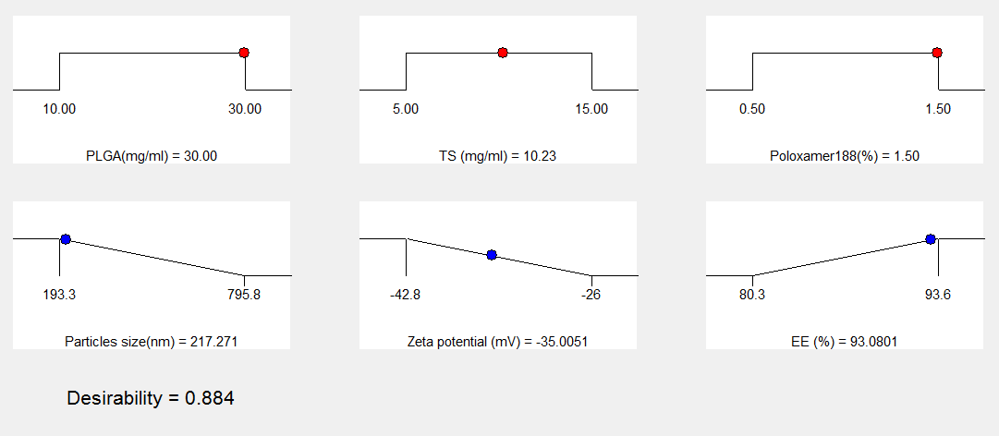

Supplementary Figure 2: Desirability ramp for optimized conditions for PLNs process conditions.

