Supplementary Figure 1
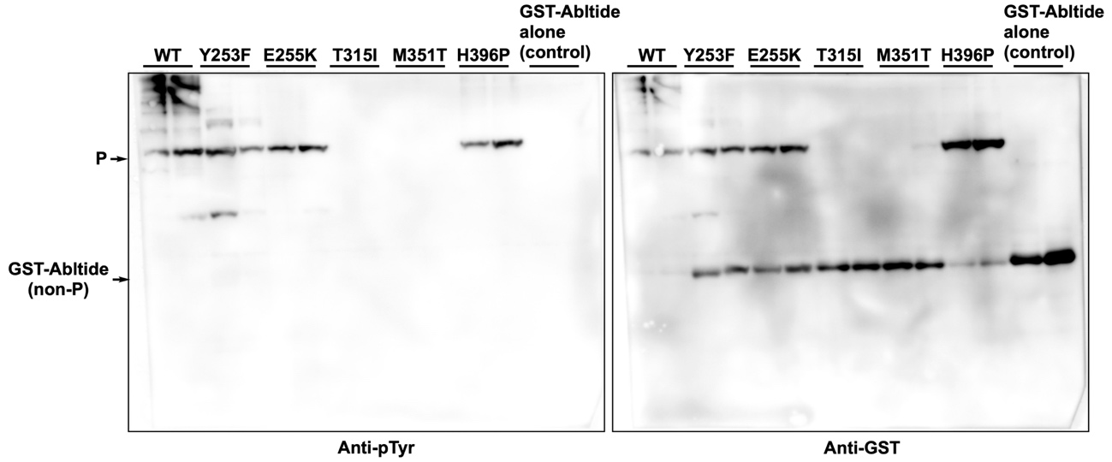

Supplementary Figure 1. Demonstration of the presence of tyrosine-phosphorylated GST-Abltide in WT and H396 lysates by western blotting with anti-phosphotyrosine antibody. E. coli BL21(DE3) was co-transformed with pET21a(+)_ABL (WT, Y253F, E255K, T315I, M351T, or H396P) and pCDF_GST-Abltide. The cells were suspended in a Tris-buffered saline (TBS, pH 7.4) containing 1 mM dithiothreitol, and then they were sonicated. The soluble fractions of lysate samples (200-µg protein per 100 µL) were separately incubated with GST-Accept resins (each 100 µL) for 10 min at room temperature. Each GST-Accept resin was washed with TBS containing 1 mM dithiothreitol and was mixed with 3× sample-loading buffer for SDS-PAGE. All the samples were analyzed by Phos-tag SDS-PAGE (10% w/w polyacrylamide and 15 µM Zn2+–Phos-tag) followed by western blotting with anti-phosphotyrosine antibody PY20 (left-hand panel). The same blot was re-probed with anti-GST antibody (right-hand panel).

