Supplemental information:
Bacterial Strains and Media:
E. coli DH5αλpir was used for most cloning experiments due to the ability of blue/white screening, but plasmids were also constructed in Transformax EC100D pir+ (Lucigen; also enables blue/white screening but is Str^{R}) and OneShot Pir1 (ThermoFisher; no blue/white screening). DH5αλpir and Transformax EC100D pir+ were transformed with pTA-Mob [1] for some conjugation experiments, otherwise plasmids were transformed into SM10λpir for conjugation into target bacteria. V. cholerae strain O395 (Str^{R}) [2] and S. typhimurium strain KK105 (Tet^{R}) [3] were used as recipients in conjugation. Concentrations of antibiotics used were: Strep 100 μg/ml, Tet 10 μg/ml, Amp 100 μg/ml, Kan 50 μg/ml, Cm 20 μg/ml (E. coli) or 2 μg/ml (V. cholerae), Erm 150 μg/ml. E. coli, V. cholerae, and S. typhimurium were grown in Luria Broth (LB) media (supplemented with 2 mM glutamine for S. typhimurium).

Plasmid Construction:
The allelic exchange plasmids were constructed in several steps. First, NotI and ApaI sites were added to the MCS of pUC118 [5] by site-directed mutagenesis using Quick Change (Stratagene), resulting in pKEK2094; the introduction of these sites was designed to maintain the coding frame of lacZα. The MCS is shown in Fig. 1. Next, the lacZα fragment from pKEK2094 was PCR amplified with primers lacZa F and lacZa R, and introduced by IVA cloning [7] into pDS132 [6] which was PCR amplified with primers pDS132R6K and pDS132 sacBp, resulting in pKEK2200. The Kan^{R} fragment from pKEK898 [8] was PCR amplified with primers Fnp F and pKEK898 KanR R, and introduced into pKEK2200 PCR amplified with primers pDS132Lac F and pDS132Lac R by IVA cloning, resulting in pKEK2201. The Amp^{R} fragment from pUC118 was PCR amplified with primers AmpR F and AmpR R, digested with NdeI and BamHI, and ligated into pKEK2201 that had been digested with NdeI and BglII, to form pKEK2202.

The plasmid pKEK2297, described as an example used to delete the flgH gene from V. cholerae, was constructed by first PCR amplifying the two flanking fragments individually with flgHflank1 F + flgHflank1 R, and flgHflank2 F + flgHflank2 R, respectively. flgHflank1 F contains 16 bp sequence at the 5’ end complementary to universal priming site 1 (CGAGCTCGGTACCCGG), and flgHflank2 R contains 16 bp sequence at 5’ end complementary to universal priming site 2 (CTTGCATGCCTGCAGG). flgHflank1 R and flgHflank2 F contain 20 bp of complementary sequence that includes the flgH deletion. We typically use ThermoFisher Tm calculator website (www.thermofisher.com) and design primers with approximate Tm of 65°C. pKEK2200 was PCR amplified with primers universal 1 + universal 2, then digested for 1 h with DpnI. We routinely achieve robust full-length vector (pKEK2200, pKEK2201, and pKEK2202) amplification with the following PCR conditions: KOD Hot Start Mastermix (Sigma Aldrich), 95°C 2 min, 19-30 cycles of 95°C 20 sec, 55°C 10 sec, 70°C 2 min. The three PCR fragments were mixed together (5 μl each) and transformed into DH5αλpir carrying pTA-Mob that had been prepared for chemical transformation [9]. After 1 h incubation in LB at 37°C, cells were plated on LB Cm²⁰ XGal⁴⁰. Six plasmids from white colonies were screened, and all six had the correct digestion pattern.

The plasmid pKEK2287 used to inactivate glnA in S. typhimurium was constructed by PCR amplification of gDNA from KK27 [10] with primers STglnA F and STglnA R, which was then mixed with pKEK2200 that had been PCR amplified and DpnI digested as above, and then transformed into DH5αλpir by chemical transformation.

Strain construction:
Plasmids were moved into target bacteria by conjugation, either from DH5αλpir/pTA-Mob, Transformax EC100D pir+/pTA-Mob, or from SM10λpir. Mating was accomplished by cross-streaking and growth on LB agar, and transconjugants were then selected by growth on media containing the antibiotic resistance present on the mobilized plasmid and in the recipient bacteria (V. cholerae Str^{R} Cm^{R}, S. typhimurium Tet^{R} Cm^{R}), indicating the plasmid had integrated into the chromosome by homologous recombination. Transconjugants were grown in LB for several cycles to allow the plasmid to excise from the chromosome by homologous recombination. In our hands it typically takes three cycles (i.e. inoculation at low cell density and outgrowth to stationary phase) of growth in LB to obtain sufficient colonies that have lost the plasmid, but this varies with different bacteria. The culture is then plated on LB agar (no NaCl) with 15% sucrose. Sucrose resistant colonies were screened for loss of antibiotic resistance associated with the plasmid; in our hands all sucrose resistant colonies are also Cm^{S}, indicating they have all lost the plasmid. In the examples in this report we analyzed Suc^{R} Cm^{S} colonies for the phenotypes associated with mutant genotypes (flgH = reduced motility; glnA = glutamine auxotrophy on minimal media). The chromosomal mutations were confirmed by PCR and sequencing.

Table S1 – Oligonucleotides used in this study.
Name | Sequence
Universal 1 | CCGGGTACCGAGCTCGAATTC
Universal 2 | CCTGCAGGCATGCAAGCTT
pDS132 sacBp | GATCCTTTTTAACCCATCACATATACCTGCCG
pDS132R6K | CCATGTCAGCCGTTAAGTGTTCCTGTG
lacZa F | TGGGTTAAAAAGGATCAGCGCCCAATACGCAAACC
lacZa R | TTAACGGCTGACATGGTTAATGCGCCGCTACAGGG
pDS132Lac R | CCGCTTACAGACAAGCTGTGACCG
pDS132Lac F | AGATCTGCTCCTGCCCTATGGGATTCACC
Fnp F | GCTTGTCTGTAAGCGGTTTGGGTTGTCACTCATCGTATTTGG
pKEK898 KanR R | GGGCAGGAGCAGATCTTTAGAAAAACTCATCGAGCATCAAATGAAAC
AmpR F | GCGCCATATGAGTATTCAACATTTCCGTGTCGCCC
AmpR R | GCGCGGATCCTTACCAATGCTTAATCAGTGAGGCACCT
flgHflank1 F | CGAGCTCGGTACCCGGATTGCGAACGCCAATACGTTTG
flgHflank1 R | TCGAGTTACGCCATGGCTTAGTTAGCAATTACAGTTGTTGGTTAAC
flgHflank2 F | TAAGCCATGGCGTAACTCGAGCCGCTGGGCTAGTTTATTG
flgHflank2 R | CTTGCATGCCTGCAGGTTCACCATGTTTTCTTTGCGTGACCG
flgH screen F | GGTTTAGAGCCGGTTGGACAAA
flgH screen R | TAAAAGGTGTCGACTCGCCAG
STglnA F | CGAGCTCGGTACCCGGagatctgcatctgcaacggac
STglnA R | CTTGCATGCCTGCAGGcagtacttgctcaatttgttccgg
glnA screen F | GACCAATCCGGGAGAGTACAAG
glnA screen R | CGATTAAACGCTGTAGTACAGCTC

Table S2 – Strains and plasmids used in this study.
Strain | Description | Reference
DH5α λ pir | E. coli
SM10 λ pir | E. coli | [12]
EC100D pir⁺ | E. coli | Lucigen
OneShot pir-1 | E. coli | ThermoFisher
O395 | V. cholerae wildtype | [2]
KKV3177 | ΔflgH V. cholerae | This study
ATCC14028 | S. typhimurium wildtype | ATCC
KK802 | ΔglnA S. typhimurium | This study
Plasmid | Description | Reference
pDS132 | Sucrose-counterselectable suicide vector; Cm^{R} | [6]
pUC118 | High copy blue/white cloning vector; Amp^{R} | [5]
pKEK2094 | pUC118 with NotI, ApaI sites added to MCS | This study
pKEK2200 | Sucrose-counterselectable blue/white suicide vector; Cm^{R} | This study
pKEK2202 | Sucrose-counterselectable blue/white suicide vector; Kan^{R} | This study
pKEK2203 | Sucrose-counterselectable blue/white suicide vector; Amp^{R} | This study
pKEK2297 | ΔflgH in pKEK2200 | This study
pKEK2287 | ΔglnA in pKEK2200 | This study

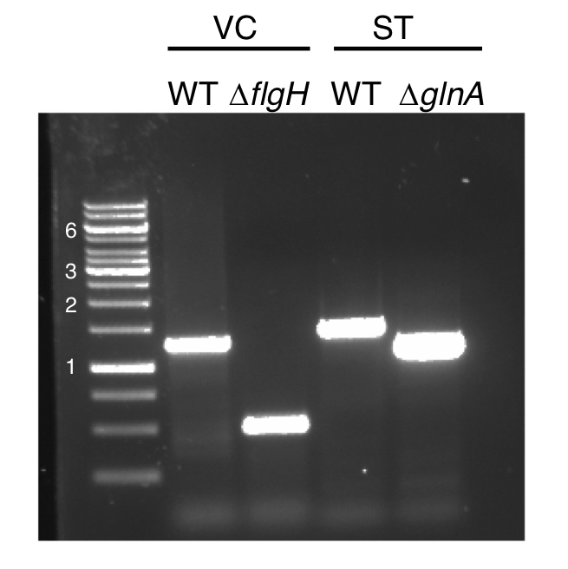
Fig S1: PCR confirmation of V. cholerae and S. typhimurium mutants constructed with pKEK2200. The length of select DNA size markers (in kbp) is on left. gDNA from O395 (WT) and KKV3177 (ΔflgH) were PCR amplified with flgHscreen F & flgHscreen R, KKV3177 shows the expected 786 bp deletion. gDNA from ATCC14028 (WT) and KK802 (ΔglnA) were PCR amplified with glnAscreen F & glnAscreen R, KK802 shows the expected 267 bp deletion.

Supplemental references

1. Strand TA, Lale R, Degnes KF, Lando M, Valla S. A new and improved host-independent plasmid system for RK2-based conjugal transfer. PloS one. 2014;9(3):e90372. Epub 2014/03/07. doi: 10.1371/journal.pone.0090372. PubMed PMID: 24595202; PubMed Central PMCID: PMCPMC3940858.
2. Mekalanos JJ, Collier RJ, Romig WR. Enzymic activity of cholera toxin. II. Relationships to proteolytic processing, disulfide bond reduction, and subunit composition. J Biol Chem. 1979;254:5855-61.
3. Prouty MG, Correa NE, Klose KE. The novel s⁵⁴- and s²⁸-dependent flagellar gene transcription hierarchy of Vibrio cholerae. Mol Microbiol. 2001;39:1595-609.
4. Rodriguez SA, Yu J-J, Davis G, Arulanandam BP, Klose KE. Targeted inactivation of Francisella tularensis genes by group II introns. Appl Environ Microbiol. 2008;74:2619-26.
5. Vieira J, Messing J. Production of single-stranded plasmid DNA. Methods Enzymol. 1987;153:3-11.
6. Philippe N, Alcaraz JP, Coursange E, Geiselmann J, Schneider D. Improvement of pCVD442, a suicide plasmid for gene allele exchange in bacteria. Plasmid. 2004;51:246-55.
7. Garcia-Nafria J, Watson JF, Greger IH. IVA cloning: A single-tube universal cloning system exploiting bacterial In Vivo Assembly. Sci Rep. 2016;6:27459. Epub 2016/06/07. doi: 10.1038/srep27459. PubMed PMID: 27264908; PubMed Central PMCID: PMCPMC4893743.
8. Liu J, Zogaj X, Barker JR, Klose KE. Construction of targeted insertion mutations in Francisella tularensis subsp. novicida. Biotechniques. 2007;43:487-90.
9. Green R, Rogers EJ. Transformation of chemically competent E. coli. Methods Enzymol. 2013;529:329-36. Epub 2013/09/10. doi: 10.1016/B978-0-12-418687-3.00028-8. PubMed PMID: 24011059; PubMed Central PMCID: PMCPMC4037286.
10. Klose KE, Mekalanos JJ. Simultaneous Prevention of Glutamine Synthesis and High-Affinity Transport Attenuates Salmonella typhimurium Virulence. Infect Immun. 1997;65:587-96.
11. Lauriano CM, Barker JR, Nano FE, Arulanandam BP, Klose KE. Allelic Exchange in Francisella tularensis using PCR products. FEMS Microbiol Lett. 2003;229:195-202.
12. Miller VL, Mekalanos JJ. A novel suicide vector and its use in construction of insertion mutations: osmoregulation of outer membrane proteins and virulence determinants in Vibrio cholerae requires toxR. J Bacteriol. 1988;170:2575-83.

