R132S Wild (394 CGT) |  | R132S Mutant (394 CGT>AGT)
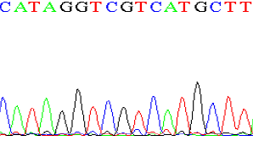 |  | 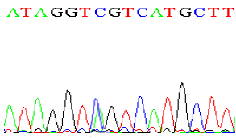

Supplementary Figure 1: DNA Sequencing Electropherograms depicting IDH1 mutation
R172K Wild (515AGG) |  | R172K Mutant (515 AGG>AAG)
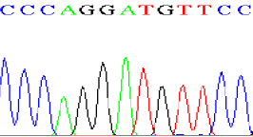 |  | 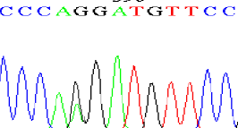

Supplementary Figure 2: DNA Sequencing Electropherograms depicting IDH2 mutation

Supplementary Figure 4: Age distribution of glioma patients

