Supplemental Figure Legends
Supplemental Figure 1. A histogram of the blood vessel radii segmented from the heart showing a wide distribution of mean vessel sizes from the voxel limit of 5.9 µm to 72.9 µm.
Supplemental Figure 2. A comparison of the measurements of the three vessels indicated in Figure 3.
Supplemental Figure 3. An orthogonal view of the circle of willis fully visualizes the major arteries. The arteries and landmarks labeled: (I) Anterior Cerebral, (II) Middle Cerebral, (III) Circle of Willis, (IV) Posterior Cerebral, (V) Superior Cerebellar, (VI) Basilar.
Supplemental Figure 4. A histogram of the blood vessel radii segmented from the brain. The segmentation technique captured a wide range of mean blood vessel radii from the resolution limit up to 62.7 µm.
Supplemental Figure 1
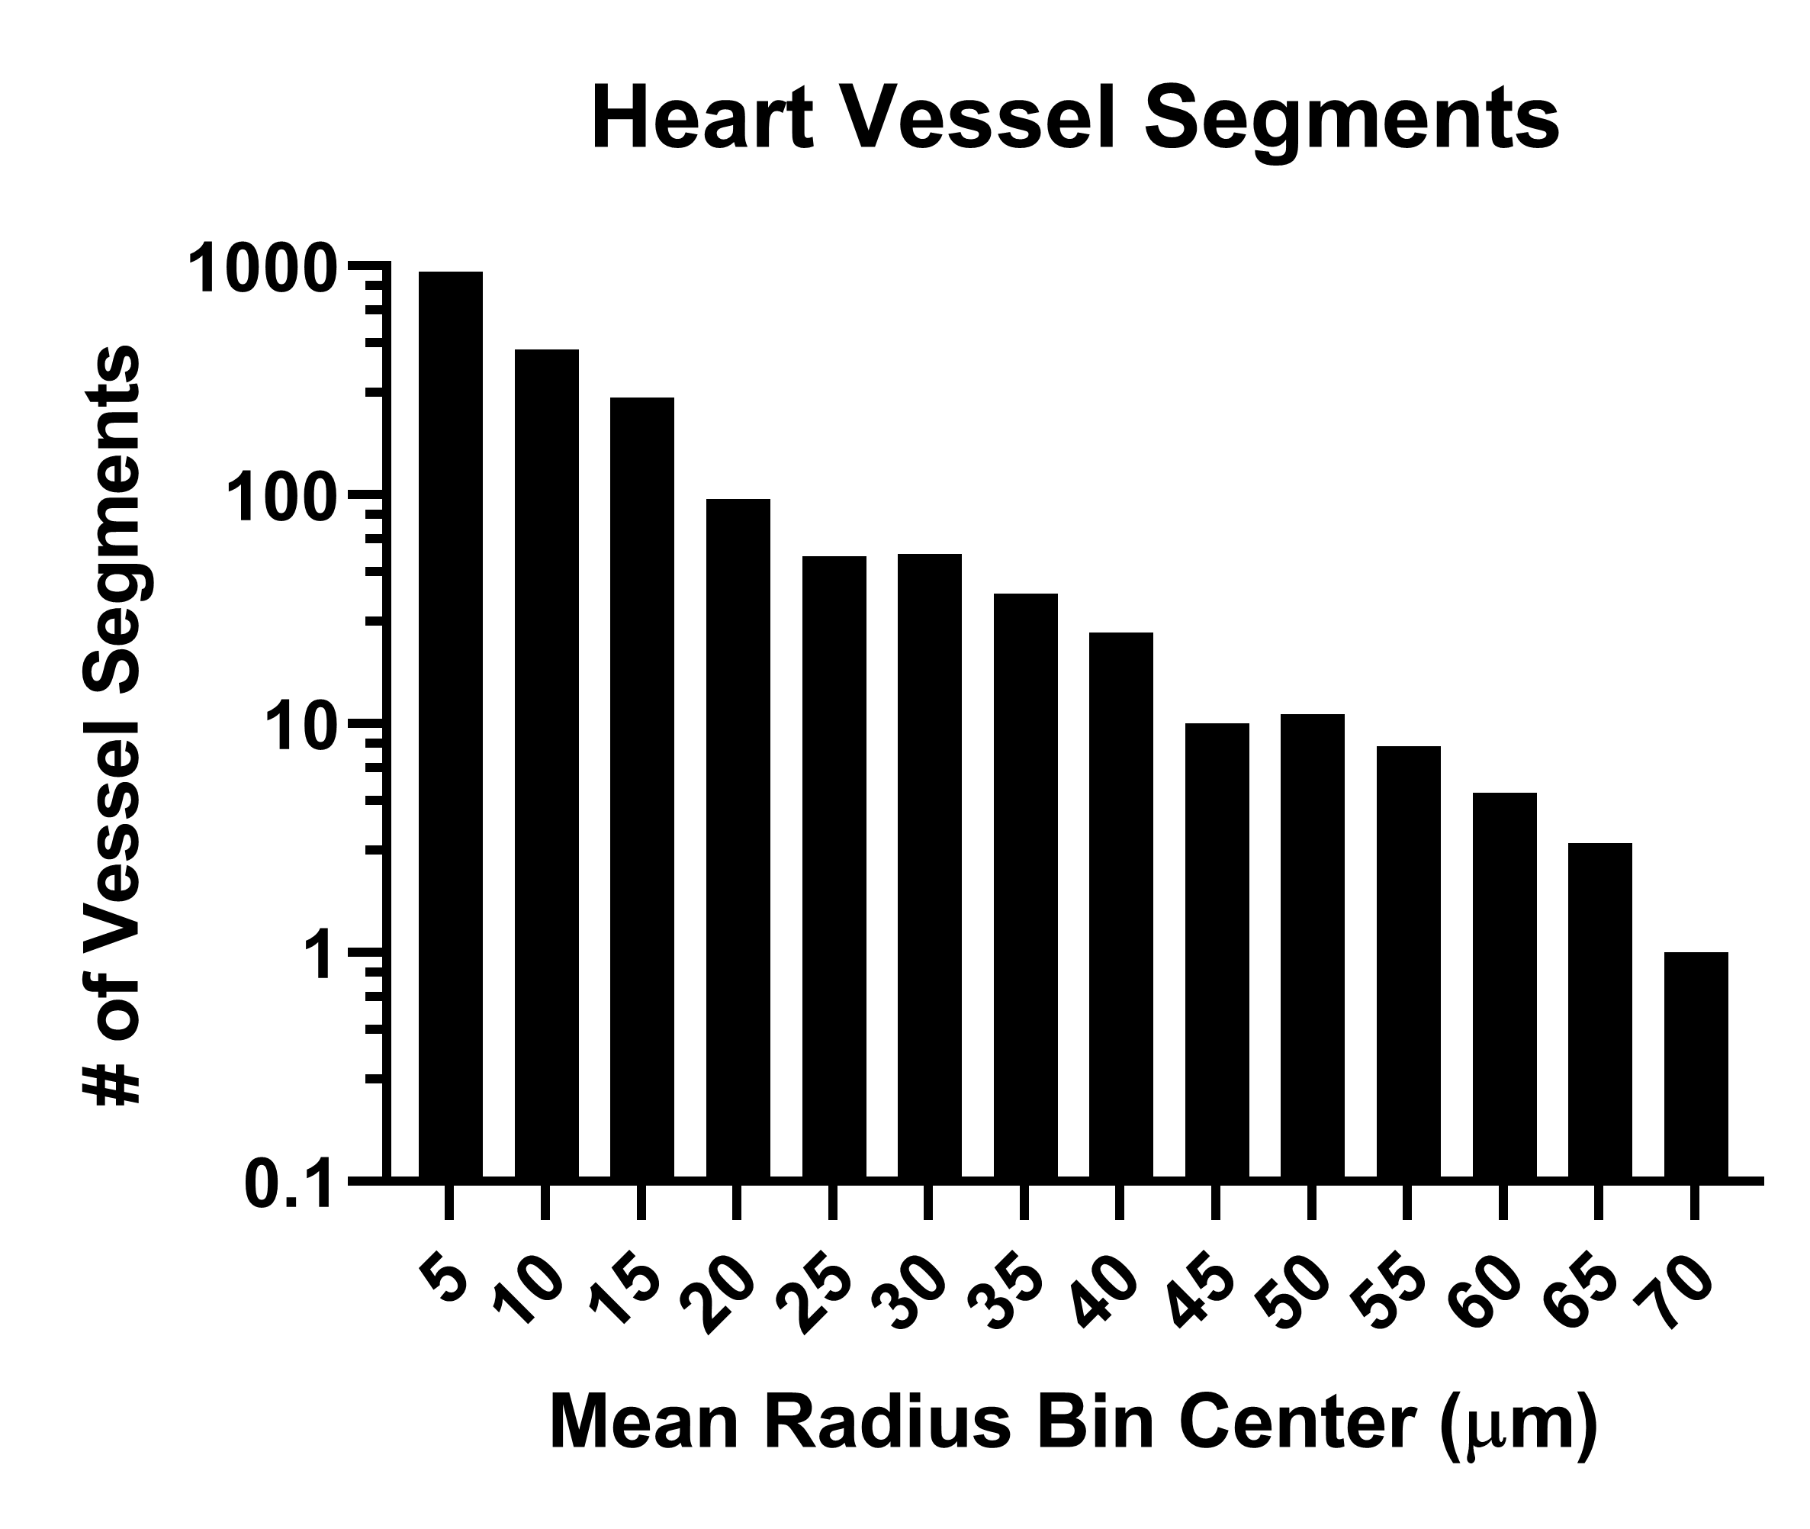

Supplemental Figure 2
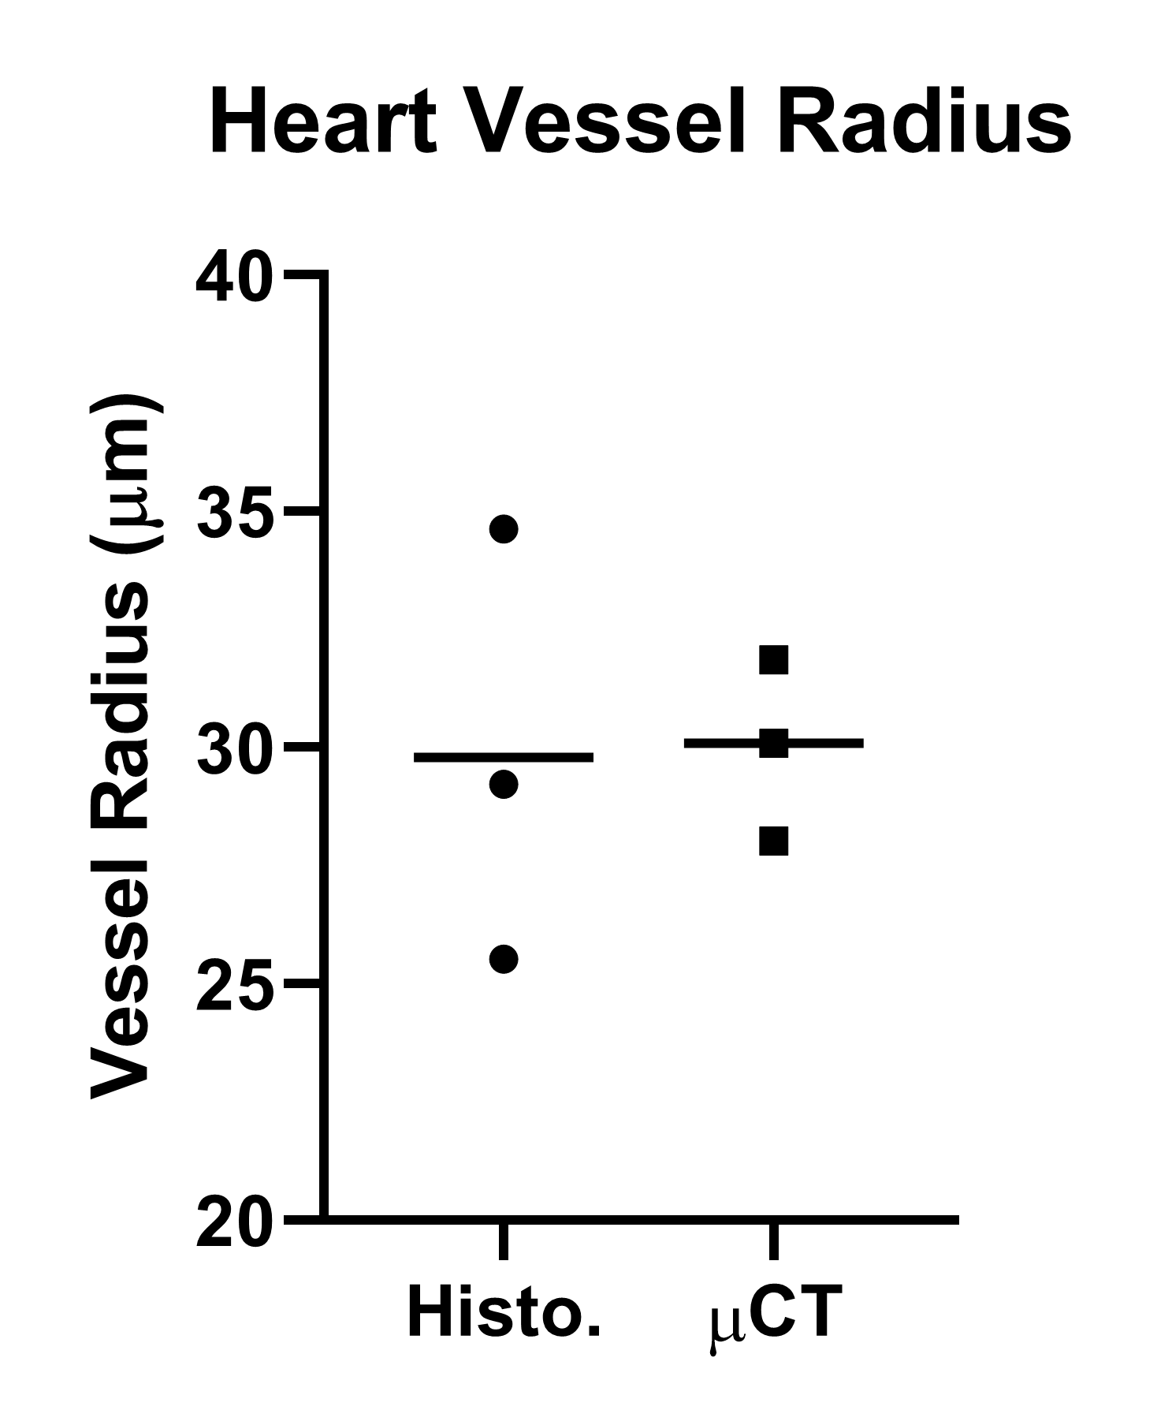
Supplemental Figure 3
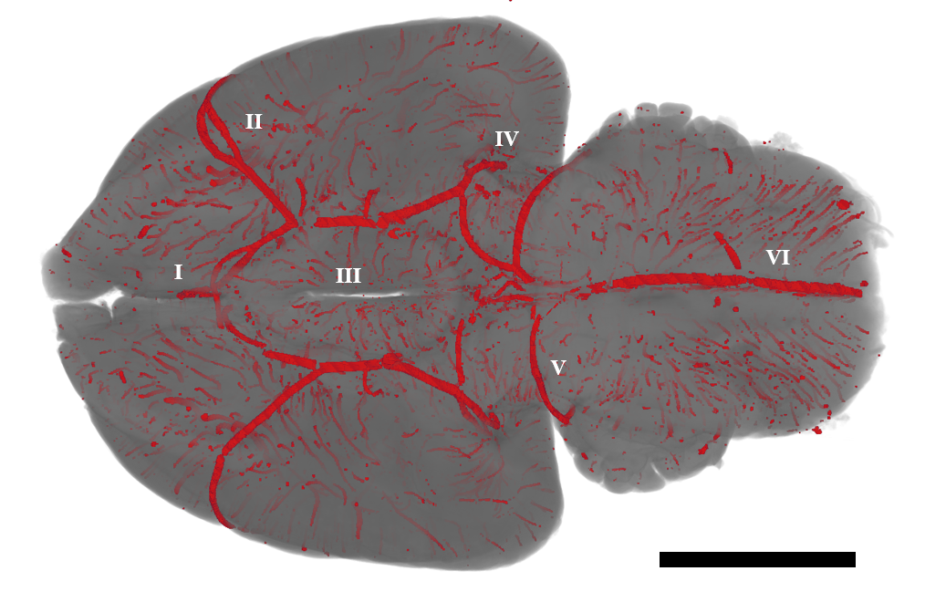
Supplemental Figure 4
