Supplementary Material

Supplementary Table 1. Solution affinities of mAb1 and mAb2 for their target antigen (Ag) measured on Gyrolab and KinExA 3000.
Technique | mAb1 |  | mAb2
 | K_{D} (pM) | 95% CI (pM) | K_{D} (pM) | 95% CI (pM)
GyroLab | 52 | 14-90 | 37 | 6-68
KinExA | 41 | 33-51 | 14 | 11-17
CI: confidence interval

Supplementary Figure 1. Bioanalytical characterization of Adnectin samples. (A) SDS-PAGE: lane 1, standard; lane 3, His-ADX_5322_A02-DBCO; lane 5, ADX_5322_A02-DBCO; lane 6, ¹⁹F-BMS-986192; lanes 2 and 4, other constructs. (B) Analytical SEC. (C) Mass spectrometry (MS).
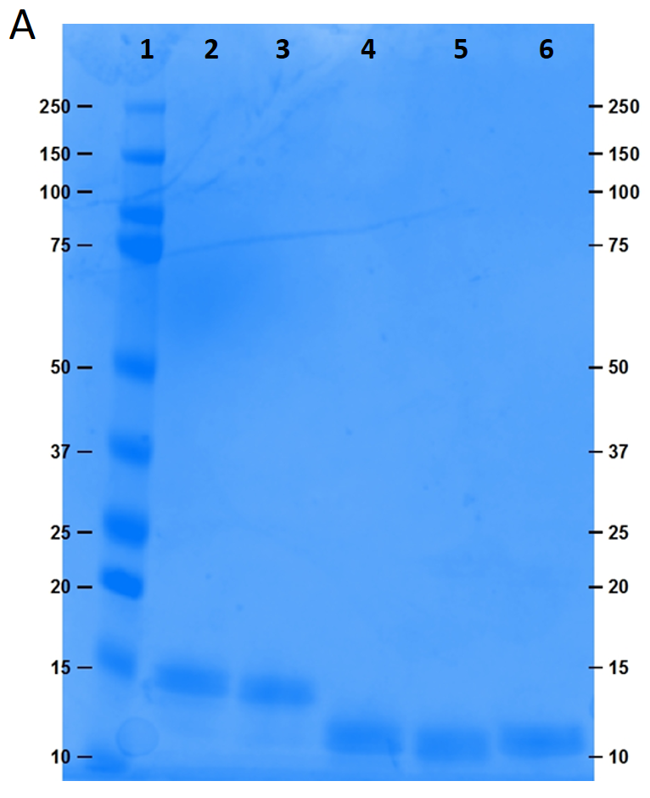
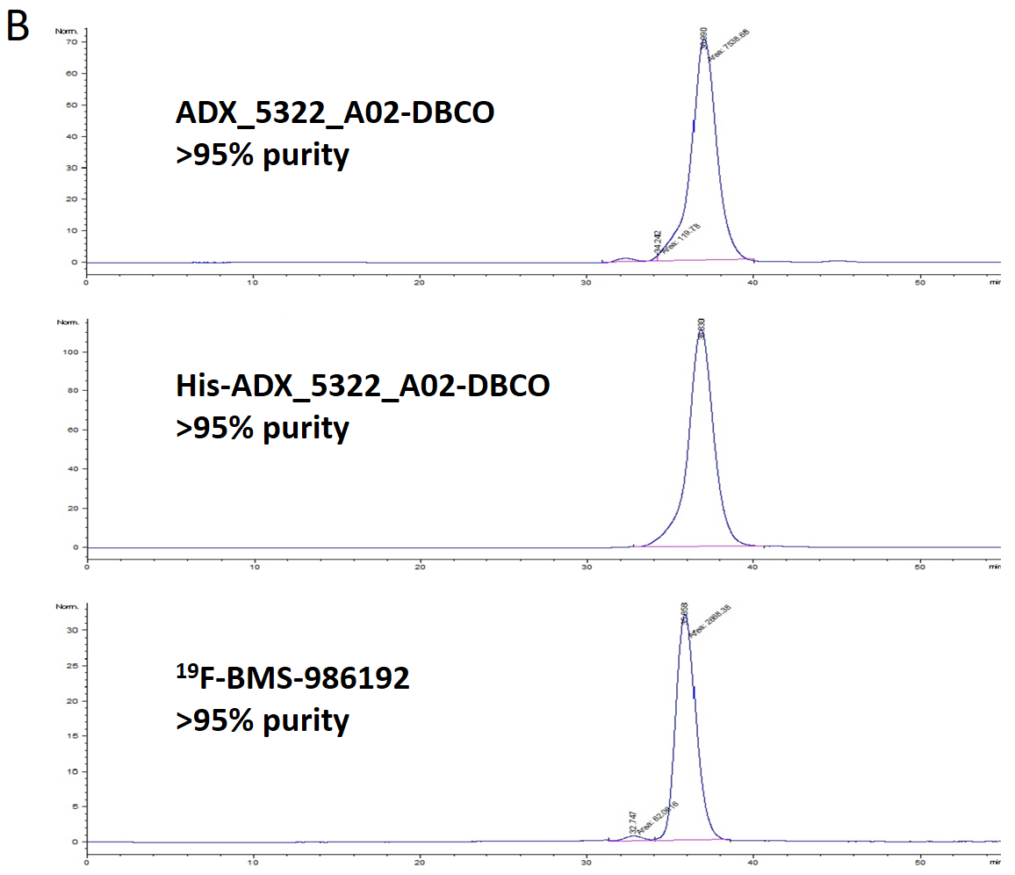

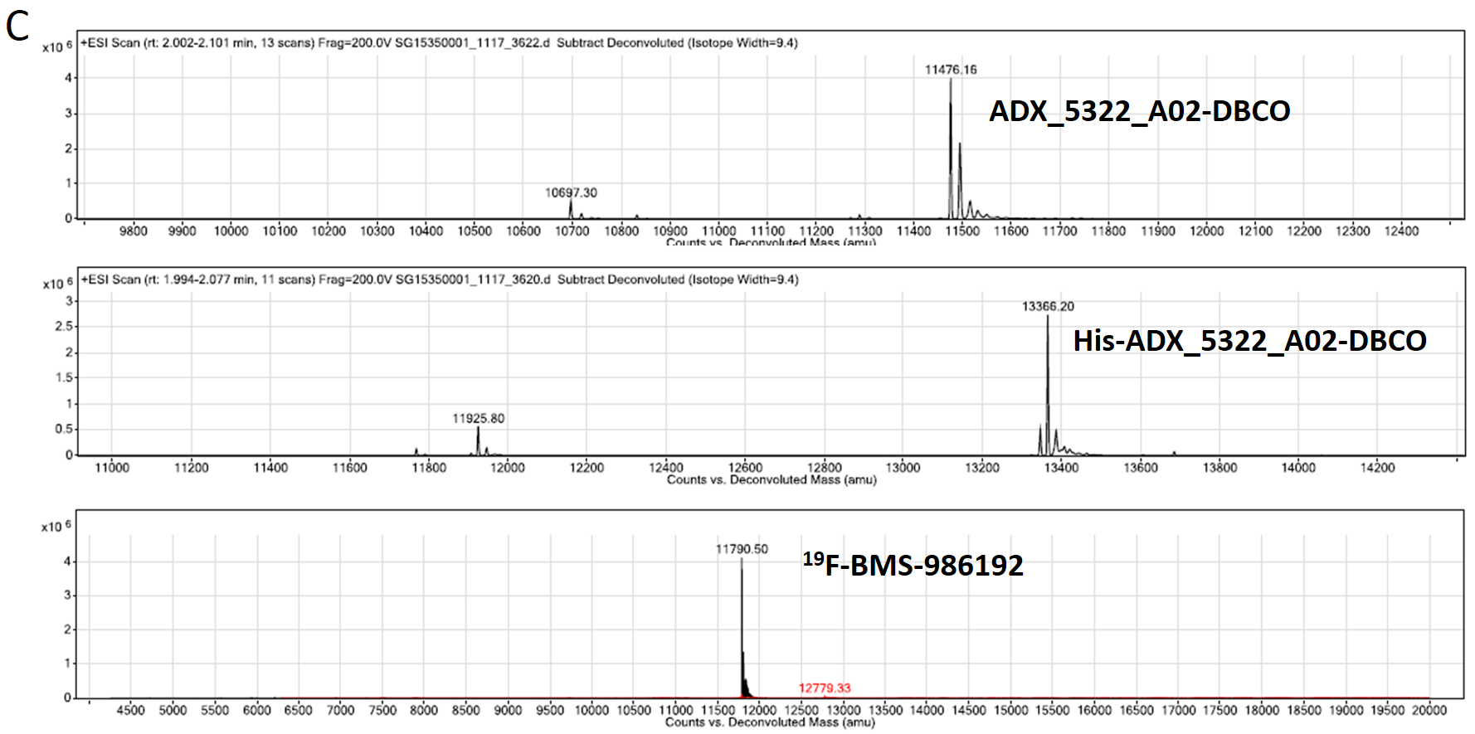
Supplementary Figure 2. Multi-curve analysis of the affinity series for PD-L1 Adnectins after 22 h or 44 h equilibration at room temperature (data points and fitted curve: 50 pM Adnectin in orange and 150 pM Adnectin in blue). (A) ADX_5322_A02-DBCO, 44 h; (B) His-ADX_5322_A02-DBCO, 22 h; (C) His-ADX_5322_A02-DBCO, 44h; (D) ¹⁹F-BMS-986192, 22 h; (E) ¹⁹F-BMS-986192, 44 h.
