Supplemental Materials for An improved gene synthesis method with asymmetric directions of oligonucleotides designed based on a simulation program.

Supplement1 Oligonucleotides of AESOE reactions

Table S1 Name, length and nucleotide sequence of oligonucleotide used in AESOE reaction

Product Name | Oligomer number | Sense | Oligomer length | Nucleotide Sequence
DEV1-4-1 | 1 | f | 59 | GGAAACATTGTGTCGGCAGTGAACATGACATCCAGAATGTTACTGAATCGATTCACAAT
 | 2 | r | 67 | TTCCAGCGCCTAAGTCCACGTCTCTTTCATATGTTGGCTTCCTGTGAGCCATTGTGAATCGATTCAG
 | 3 | r | 67 | GCCAATGATATCTAGGTTGGCTACCTCTGGTTCCACTGCCACATGTCTTGTTCCAGCGCCTAAGTCC
 | 4 | r | 67 | TCATAGTGCCATGTTGACTTGTGTTCATTTTTTATATTCTCTATCCTCTGGCCAATGATATCTAGGT
DEV1-4-2 | 1 | f | 69 | TCAACATGGCACTATGATGAGGACAATCCATACAAAACATGGGCCTATCATGGATCATATGAGGTCAAG
 | 2 | r | 67 | GTGAGCAATCTCACCACTCCATTCACCATAGATGAGGCTGATCCTGATGGCTTGACCTCATATGATC
 | 3 | r | 67 | TATCGGTCATAGCTATTTGTGTGACCATGGGGATAACATCCCATGGTTTTGTGAGCAATCTCACCAC
 | 4 | r | 67 | GCGCGTGTCAACTTTCTCTTTGAACACTCTCTGTTGTCCAAAGGGTGTGGTATCGGTCATAGCTATT
DEV1-4-3 | 1 | f | 69 | AGAAAGTTGACACGCGCACACCAAGAGCAAAACGAGGCACAACACAAATTATGGAGGTGACAGCCAAGT
 | 2 | r | 67 | TCTTGTGCAGATTCTGGGTTTTTTGTTTCTGGAAAGGAAACCCCATAACCACTTGGCTGTCACCTCC
 | 3 | r | 67 | AACACTGCTCCTATTGCTGCGTTTGACCTAACCTTTCTTGTGAACTCCTCTCTTGTGCAGATTCTGG
 | 4 | r | 60 | TTCCACTGCTTCTTTTGCTGAGTTCCATTGGTTTTCATCAACGAACACTGCTCCTATTGC
DEV2-2-1 | 1 | f | 58 | GTGAGGAATCCACTCTCACGAAACTCCACGCATGAAATGTACTGGGTATCTAATGCCA
 | 2 | r | 66 | TTAATCAACATCCTTGAAATCATATTCACTGATGACACTATGTTTCCGGTGGCATTAGATACCCAG
 | 3 | r | 66 | GTCAACATCTGGCTCGTAGGTGGCTTTCTTGTGTTTCATTGTGAATCTGTTAATCAACATCCTTGA
 | 4 | r | 66 | GATTTGGTATCTCACTTTCAATTCCAATGTTGCGGGTTCCACTTCCTAGGTCAACATCTGGCTCGT
DEV2-2-2 | 1 | f | 69 | AAGTGAGATACCAAATCTAGACATAATAGGAAAGAGAATAGAGAAAATAAAACAAGAGCATGAAACATC
 | 2 | r | 66 | GCCGTGGTAAGCCCACGTTTTGTATGGGTGGTCTTGATCATAGTGCCATGATGTTTCATGCTCTTG
 | 3 | r | 66 | CTCCGTTCACCATAGATGATGCTGATCCAGTTTGTTTTGTTTCATAGCTGCCGTGGTAAGCCCACG
 | 4 | r | 66 | TGTGTCACCATAGGGACGACGTCCCAAGGTTTTGTCAGCAGTCTGACCACTCCGTTCACCATAGAT
DEV2-2-3 | 1 | f | 69 | GTCCCTATGGTGACACAGATGGCAATGACAGACACGACTCCATTTGGACAACAGCGCGTTTTTAAAGAG
 | 2 | r | 66 | TCAGCTTCTTTGTGCCTTCTTTCGGTTCTTGGGTTCTCGTGTCCACCTTCTCTTTAAAAACGCGCT
 | 3 | r | 66 | GTCTTTTTCTTTCCTAGTTCTTTCCAAAGCCACTCTGCCGTGATTCTCATCAGCTTCTTTGTGCCT
 | 4 | r | 66 | GTTGCTTCTCACTTTTCTTGTGAATTCTTCTCTGGTACACATTCTAGGGGTCTTTTTCTTTCCTAG
DEV2-2-4 | 1 | f | 69 | GAAAAGTGAGAAGCAACGCAGCCTTGGGGGCCATATTCACTGATGAGAACAAATGGAAATCGGCACGTG
 | 2 | r | 66 | TTTCTTTCCCTGTCAACCAGCTCCCAAAACCTACCATCTTCAACAGCCTCACGTGCCGATTTCCAT
 | 3 | r | 66 | TCCCATCATGTTGTACACACATGTTTCACACTTTCCTTCAAGATGGAGATTTCTTTCCCTGTCAAC
 | 4 | r | 62 | GCTGCCTTTTGCCTTGCCGAACTCCCCTAGTTTCTTCTCTCTTTTTCCCATCATGTTGTACA
DEV2-4-1 | 1 | f | 59 | TGACATAGGGGAGTCATCACCAAATCCCACAGTGGAAGCAGGACGAACACTCAGAGTCC
 | 2 | r | 67 | TTTTATGCAAAATTGAGTGTTGTTGTTCAACCAATTTTCTACTAAGTTAAGGACTCTGAGTGTTCGT
 | 3 | r | 67 | TGCAGTGCTTCCATTTTTTCTATAACTGAGGGCATATATGGGTTGAGAACTTTTATGCAAAATTGAG
 | 4 | r | 67 | TGGAGTTCCGTGAGAGTGGATTTCTCACTAAGGCTCCTCCATATTTCCTTTGCAGTGCTTCCATTTT
DEV2-4-2 | 1 | f | 68 | ACTCTCACGGAACTCCACACATGAGATGTACTGGGTATCCAATGCTTCTGGGAACATAGTGTCATCGG
 | 2 | r | 67 | CTTGTGTCTCATTGTGAATCTGTTGATCAACATCCTTGAAATCATGTTCACCGATGACACTATGTTC
 | 3 | r | 67 | ATGTTGCGGGTTCCGCTTCCGAGGTCAACATCCGGCTCGTAAGTGGCTTTCTTGTGTCTCATTGTGA
 | 4 | r | 67 | CTATTCTTTTCCCAATTATGTCTAGGTTTGGTATTTCACTTTCAATTCCAATGTTGCGGGTTCCGCT
DEV2-4-3 | 1 | f | 68 | AATTGGGAAAAGAATAGAAAAAATAAAGCAAGAGCATGAAACATCATGGCACTACGATCAAGACCACC
 | 2 | r | 67 | TCCAGTCTGTTTTGTTTCATAGCTACCATGGTATGCCCACGTTTTGTATGGGTGGTCTTGATCGTAG
 | 3 | r | 67 | CAAGGTTTTGTCAGCAGCCTGACCACTCCGTTGACCATGGATGATGCTGATCCAGTCTGTTTTGTTT
 | 4 | r | 67 | ATGGAGTCGTGTCTGTCATTGCCATCTGTGTCACCGTGGGGAGGACGTCCCAAGGTTTTGTCAGCAG
DEV2-4-4 | 1 | f | 68 | GACAGACACGACTCCATTTGGACAACAGCGTGTTTTTAAAGAAAAAGTGGACACGAGAACCCAAGAAC
 | 2 | r | 67 | CCACAGCCATTCTGCTGTGATTTTCATTAATTTCTTCGTGCCTTCTTTCGGTTCTTGGGTTCTCGTG
 | 3 | r | 67 | AATTCTTCTCTGGTGCACATCCTAGGTGTCTTTTTCTTCCCCAATTCTTTCCACAGCCATTCTGCTG
 | 4 | r | 67 | CGTCAGTGAATATGGCCCCCAAGGCTGCATTGCTTCTCACCTTTCTTGTGAATTCTTCTCTGGTGCA
DEV2-4-5 | 1 | f | 68 | GGCCATATTCACTGACGAGAATAAGTGGAAGTCGGCACGTGAGGCTGTTGAAGATAGTAGGTTTTGGG
 | 2 | r | 67 | TGTCTCACACTTTCCTTCAAGATGGAGATTCCTTTCCTTGTCAACCAGCTCCCAAAACCTACTATCT
 | 3 | r | 67 | CCGAATTCCCCTAGCTTCTTTTCTCTTTTTCCCATCATGTTGTACACACATGTCTCACACTTTCCTT
 | 4 | r | 61 | CTCCAAGCCACATGTACCATATGGCTCTGCTGCCTTTTGCCTTGCCGAATTCCCCTAGCTT
DEV2-5-1 | 1 | f | 53 | GGACACGAAGAACCCATTCCCATGTCAACATATGGTTGGAATCTGGTGCGTCT
 | 2 | r | 61 | CACACTTTTCTGGCGGAGTAAAAAAGACATCGACTCCACTTTGCAGACGCACCAGATTCCA
 | 3 | r | 61 | CGTGGGGTTTGGTGACGACTCCCCTATGTCACACAGCAATGTGTCACACTTTTCTGGCGGA
 | 4 | r | 61 | TTTTCCACTAAGTTTAGAACTCTGAGTGTTCGTCCTGCCTCGACCGTGGGGTTTGGTGACG
DEV2-5-2 | 1 | f | 62 | CTAAACTTAGTGGAAAACTGGCTGAACAATAATACCCAATTTTGCATAAAGGTTCTTAATCC
 | 2 | r | 61 | TCCTTTGTAGTGCTTCCATTTTTTCTATAACTGAGGGCATATATGGATTAAGAACCTTTAT
 | 3 | r | 61 | GGAATTTCGTGAGGGTGGATTCCTCACCAAAGCTCCTCCGTATCTCCTTTGTAGTGCTTCC
 | 4 | r | 54 | TCCCGGAAGCATTGGATACCCAGTACATCTCGTGTGTGGAATTTCGTGAGGGTG
DEV2-6-1 | 1 | f | 52 | TGGTGACACAGATGGCAATGACAGACACGACCCCATTTGGACAACAGCGTGT
 | 2 | r | 60 | TTCTTTTGGTTCTTGGGTTCTCGTGTCCACTTTCTCTTTGAAAACACGCTGTTGTCCAAA
 | 3 | r | 60 | TCCAGAGCCATTCAGCCGTGATTTTCATTAGTTTCTTCGTGCCTTCTTTTGGTTCTTGGG
 | 4 | r | 60 | TCTCTAGTGCACATCCTAGGTGTCTTTTTCTTTCCTAGTTCTTTCCAGAGCCATTCAGCC
DEV2-6-2 | 1 | f | 63 | AGGATGTGCACTAGAGAAGAATTCACAAGAAAGGTGAGAAGCAATGCAGCCCTAGGTGCCATA
 | 2 | r | 60 | CAACAGCCTCACGTGCCGACTTCCACTTGTTCTCATCAGTGAATATGGCACCTAGGGCTG
 | 3 | r | 60 | AGATTCCTTTCTTTGTCAACCAGTTCCCAAAATCTGCTGTCTTCAACAGCCTCACGTGCC
 | 4 | r | 60 | CATCATGTTGTACACACATGTCTCACACTTTCCTTCAAGATGGAGATTCCTTTCTTTGTC
DEV2-6-3 | 1 | f | 63 | GTGTGTACAACATGATGGGAAAGAGAGAGAAGAAGCTAGGGGAATTCGGCAAAGCAAAAGGCA
 | 2 | r | 60 | TCTAAGAAGCGTGCTCCAAGCCACATGTACCATATGGCTCTGCTGCCTTTTGCTTTGCCG
 | 3 | r | 60 | GGAAAACCAGTGATCCTCATTCAAGAATCCTAGGGCTTCAAACTCTAAGAAGCGTGCTCC
 | 4 | r | 56 | CAGCCCTTCTCCTTCCACTCCACTCAGAGAGTTTTCTCGGGAAAACCAGTGATCCT
DEV3-1-1 | 1 | f | 59 | GTCAACATGGTATCTAGACTGCTACTGAACAGGTTCACGATGACACACAGAAGACCCAC
 | 2 | r | 67 | CCGCATTAACATGTCGAGTTCCTGCTCCTAAATCCACATCTTTCTCAATGGTGGGTCTTCTGTGTGT
 | 3 | r | 67 | GATCCTTTTTATTCTTTCCCCAATGACATCCATGTTGGGTGTTTCTGGTTCCGCATTAACATGTCGA
DEV3-1-2 | 1 | f | 69 | AAAGAATAAAAAGGATCAAGGAGGAGCATAATTCAACATGGCACTATGATGACGAAAACCCCTACAAAA
 | 2 | r | 67 | GGAGGCTGAGCCTGTGGCTTTGACTTCATAAGATCCATGGTAAGCCCACGTTTTGTAGGGGTTTTCG
 | 3 | r | 67 | ACCACATCCCATGGTTTAGTGAGGAGTTTCACGACTCCATTTATCATGGAGGAGGCTGAGCCTGTGG
DEV3-1-3 | 1 | f | 69 | AAACCATGGGATGTGGTGCCCATGGTGACACAGATGGCAATGACAGATACAACTCCATTTGGCCAGCAG
 | 2 | r | 67 | CCTGGCATGGACCTGGGTGTCCTGGTGTCCACTTTCTCTTTAAAGACTCTCTGCTGGCCAAATGGAG
 | 3 | r | 61 | TTCTCCAGAGCCACTCCGCTGTGATCCCCATAACCCTTCTTGTTCCTGGCATGGACCTGGG
DEV4-2-1 | 1 | f | 53 | ATGGTGGAAGTCTTGTCAGATGCCCGCTATCTAGGAATTCCACTCACGAGATG
 | 2 | r | 61 | TTTACAGAGCTCACGATGTTTCCCGACACACCTGACACCCAATACATCTCGTGAGTGGAAT
 | 3 | r | 61 | TATGCCTTGTGGTAAATCTGTTCAACAACATCTTTGATGTTGTGTTTACAGAGCTCACGAT
 | 4 | r | 61 | CGTTCCTGCTCCAAGGTCTACGTCCTTCTCATAAGTGGGTTTTCTATGCCTTGTGGTAAAT
DEV4-2-2 | 1 | f | 64 | ACCTTGGAGCAGGAACGAGAAGTGTCTCCACTGAAACAGAAAAACCGGACATGACAATCATTGG
 | 2 | r | 61 | GCCAAGTTTCTTTGTGCTCTTCTTGCAGTCGCTGAAGCCTTCTCCCAATGATTGTCATGTC
 | 3 | r | 61 | TCCATGATACGCCCAGGTTCTGTATGGGTTTTCCTGATCATAGTGCCAAGTTTCTTTGTGC
 | 4 | r | 61 | TTCACCATGGAGGATGCTGAGCCTGTCGAAGGAGCTTCATAGCTTCCATGATACGCCCAGG
DEV4-2-3 | 1 | f | 64 | GCATCCTCCATGGTGAACGGGGTAGTAAAATTGCTGACAAAACCCTGGGACGTGATTCCAATGG
 | 2 | r | 61 | CTGTTGCCCAAAAGGGGTTGTGTCTGTCATAGCCAACTGGGTCACCATTGGAATCACGTCC
 | 3 | r | 61 | TTTGGTTGTGGTGTTCTGGTGTCCACCTTCTCTTTAAACACTCTCTGTTGCCCAAAAGGGG
 | 4 | r | 61 | ACAGCCAGTTAGCTGTCGTGGTCATAACCATTCGTGTGCCGGGTTTTGGTTGTGGTGTTCT
DEV4-2-4 | 1 | f | 64 | GACAGCTAACTGGCTGTGGGCTCTCCTCGGGAAGAAGAAAAATCCCAGACTGTGCACAAGGGAA
 | 2 | r | 61 | ACTGCGCCTATGGCTGCGTTTGACCTAACTTTTGAGATGAACTCTTCCCTTGTGCACAGTC
 | 3 | r | 61 | TCACAGCTTCACTGGCTGATGTCCATCCCTGTTCTTCCTGAAAGACTGCGCCTATGGCTGC
 | 4 | r | 58 | AGCCCTTTCTTTGTCAACCAGTTCCCAAAATCGGCTGTCATTCACAGCTTCACTGGCT
Zika1 | 1 | f | 50 | GATGTGGCAGAGGGGGCTGGAGTTACTACGCCGCCACCATCCGCAAAGTT
 | 2 | r | 58 | TCATGACCAGGGCCTCCTTTTGTGTATCCTTTCACTTCTTGAACTTTGCGGATGGTGG
 | 3 | r | 50 | TTCCACCCATAGCTTTGCACCAACACGGGTTCTTCATGACCAGGGCCTCC

Supplement2. Gel electrophoresis of AESOE-synthesized DNA-fragments

Figure S1 Gel electrophoresis of AESOE-synthesized DNA-fragments
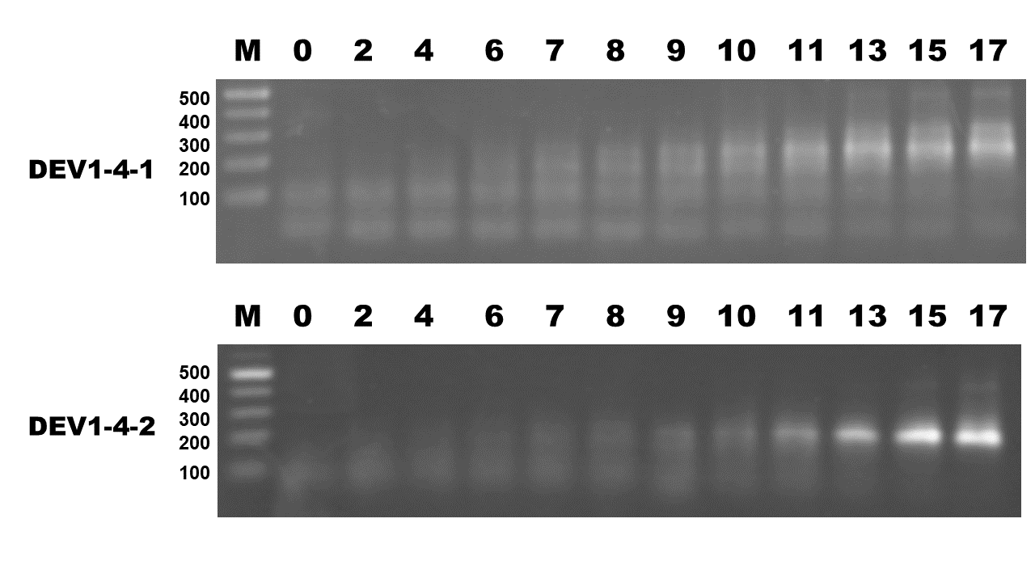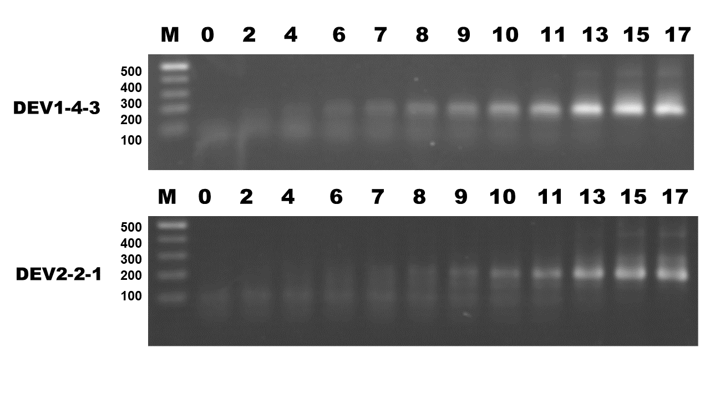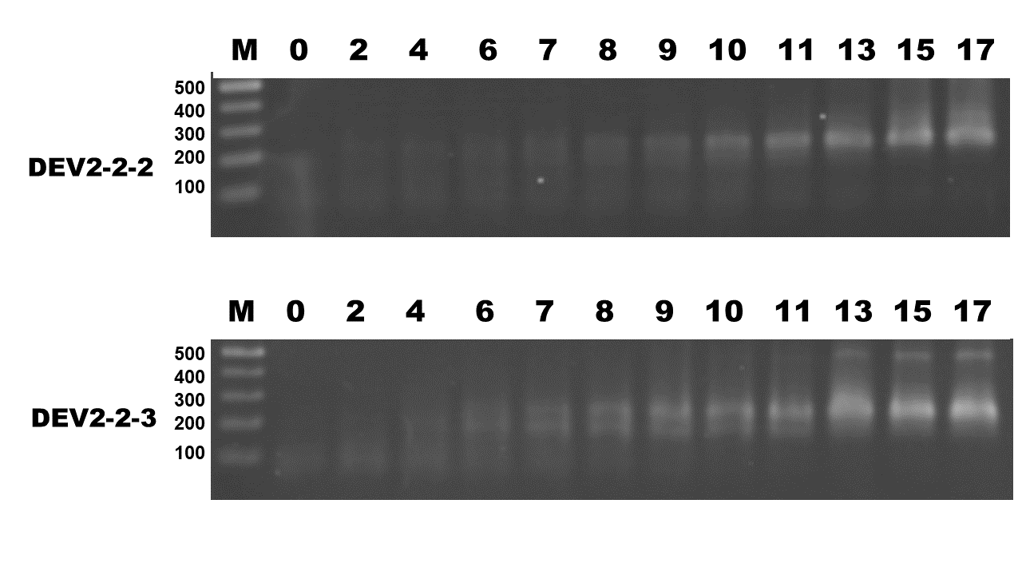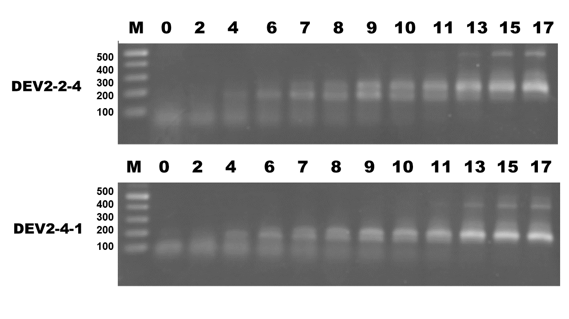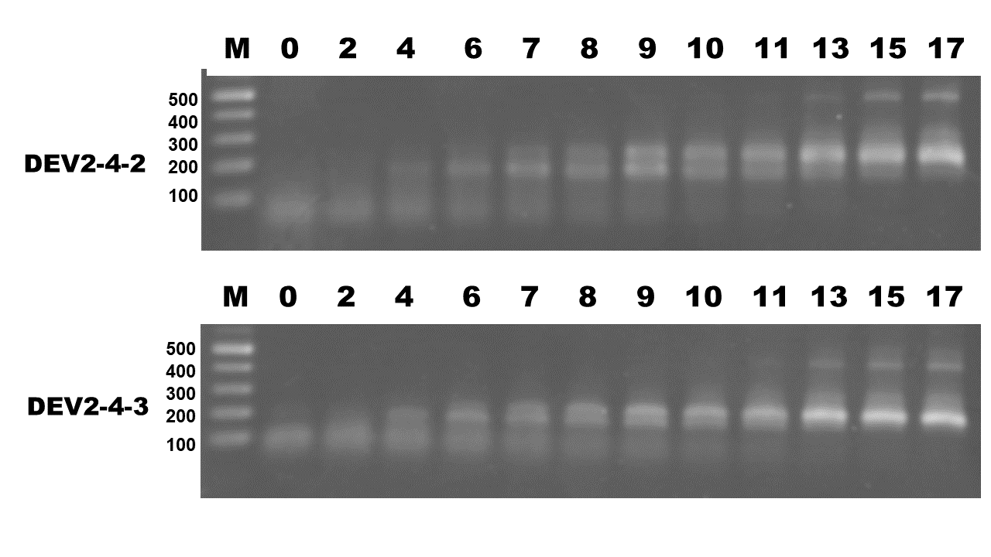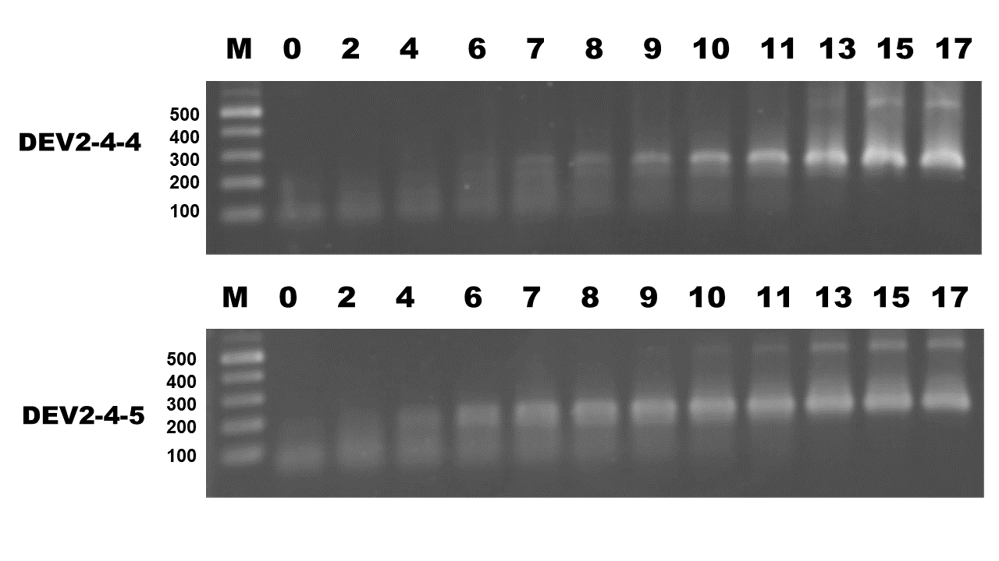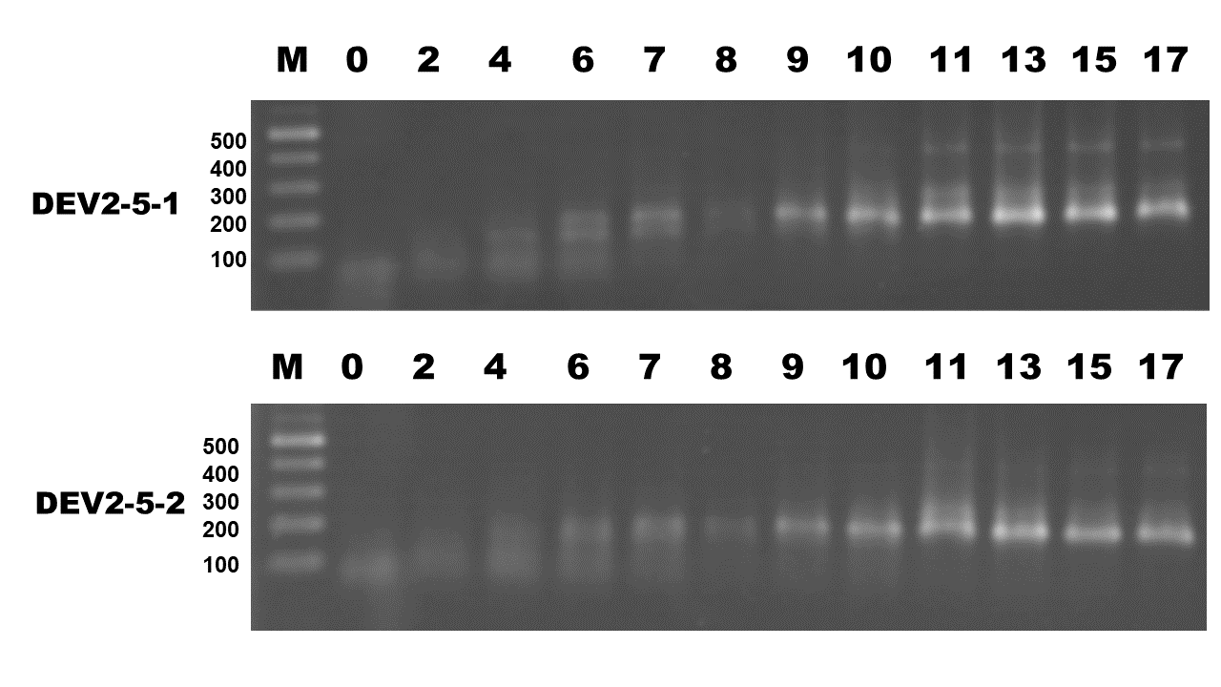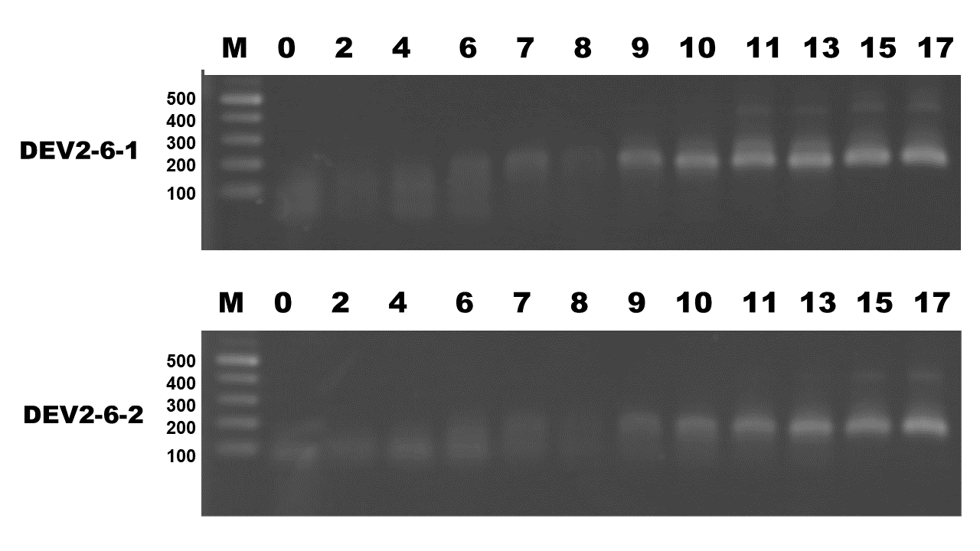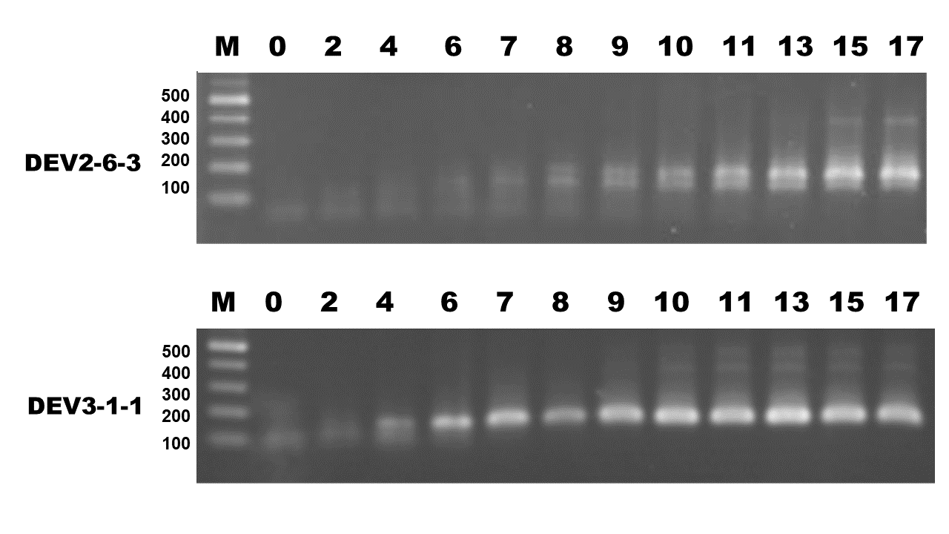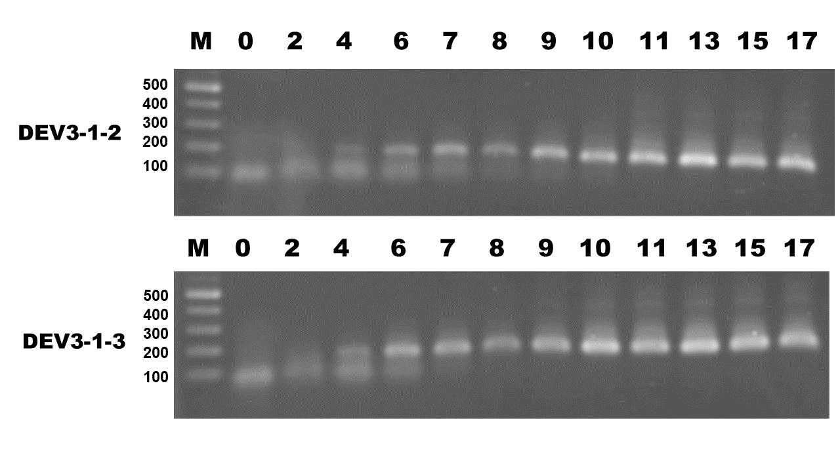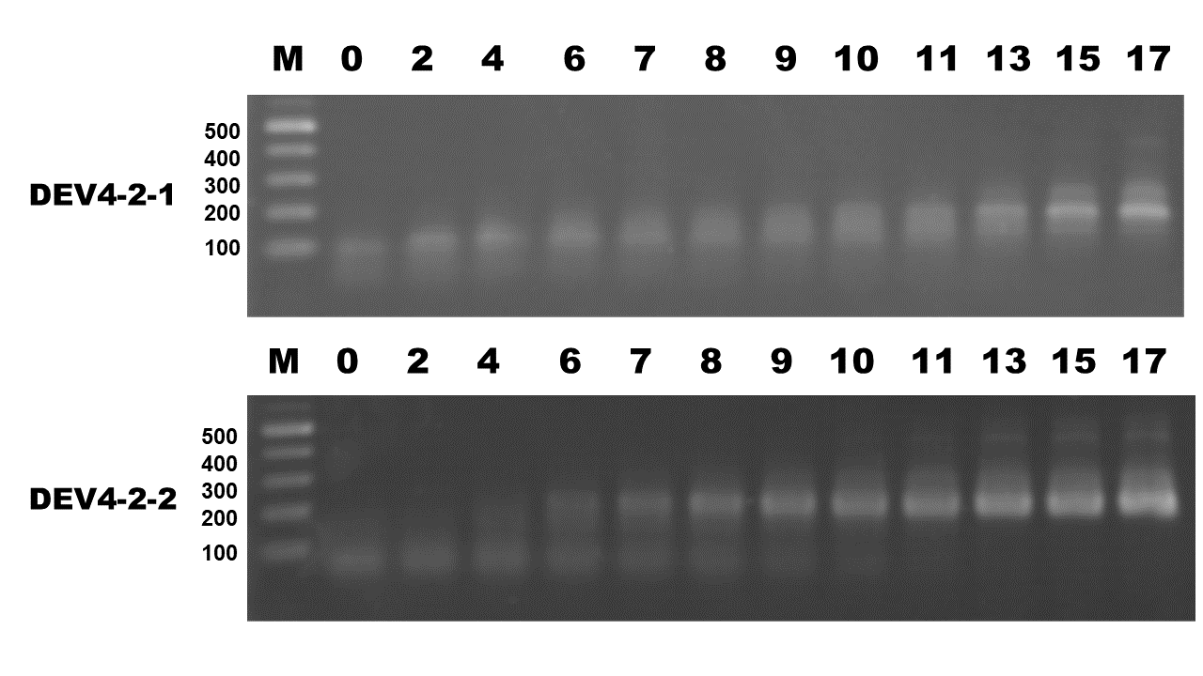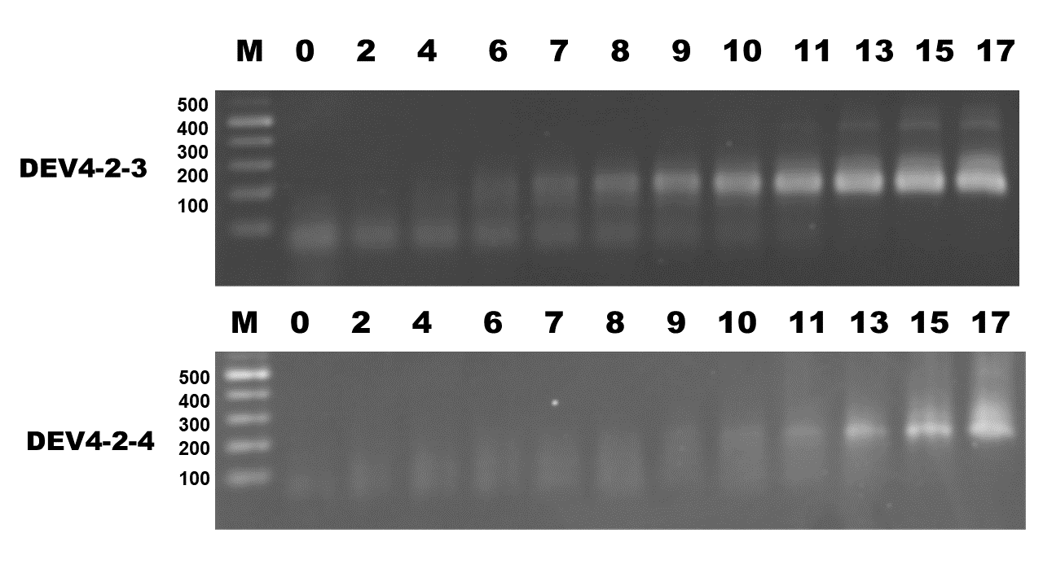

- Five μl of the AESOE reaction solution taken out after the cycle shown on the photograph was analyzed by 1.5% agarose electrophoresis. M: Size marker (100, 200, 300, 400 and 500 bases from the bottom). The name of the oligomer set is shown on the left of the photograph.

Supplemental method. Simulator for Oligomer Polymerization

3-1 Principle and calculation method to simulate extensions

We have created a reaction simulator program using Ruby program (https://github.com/daijiendoh/aesoe_extension_simulator) to search for the optimal conditions for DNA synthesis by oligomer annealing and extension reaction. Here, single-stranded DNA (ssDNA), single-stranded oligomer or synthetic DNA is collectively referred to as ‘ssDNA.’ In order to simulate the annealing and extension reaction of the oligomer, it is represented by a different integer for each type (Figure 4A in the manuscript). For the type of oligomer, all of the ssDNAs generated by possible reactions have been listed, and the oligomer in the forward direction is represented as an odd number, and the oligomer in the reverse direction is represented as an even number. The relative concentration of the oligomer is expressed as an integer number of repeats in the ‘Array.’ Annealing expresses two types of oligomers in the sequence as a combined sequence, and the synthesis of a new oligomer by extension reaction is expressed as substitution of a sequence that is a pair of oligomers after synthesis of the combined sequence of the two oligomers. The simulator has been designed to express the progress of annealing and extension reaction based on the following rules.

Figure 4A in the manuscript
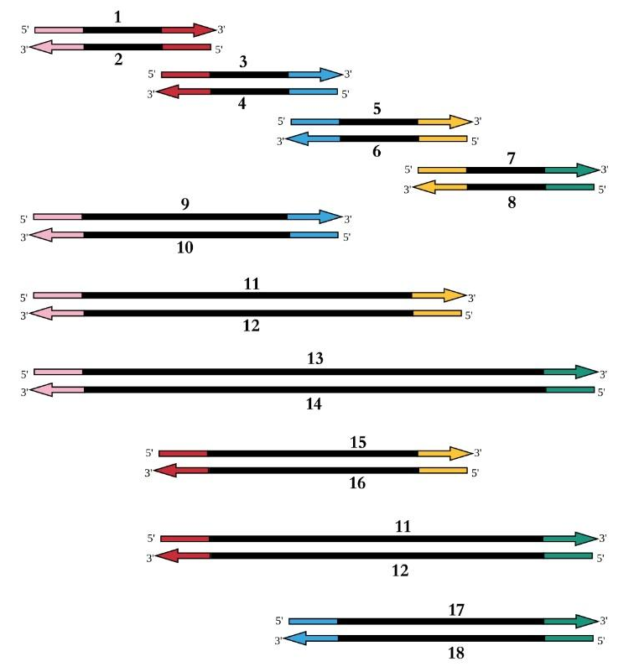
This figure shows a complete double-stranded DNA that can be constituted from the four oligomers that have been considered in the oligomer annealing/extension reaction. The ssDNA constituting each double strand is indicated by an individual number. Of these, the ones in the numbers 13 and 14 indicate the final product.

3-2. Rules on the simulation of reactions

We premise that to simulate synthesis of single-stranded DNA by the extension reaction of oligomers, a program is designed (aesoe.rb) to reproduce all of the following assumptions.

- Annealing partial or entire Duplex is formed when some or all the base sequences are complementary.
- Extension starts with an incomplete dimer in which a part (3' end) of the oligomer forms a double stranded product.

Figure S3
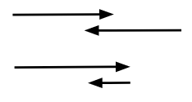

- Schematic diagram of the incomplete dimer from which an extension reaction is initiated. The direction of the arrow indicates the direction of the base sequence of the oligomer (5’->3’).

- There is no extension for a complete dimer or a dimer that becomes double-stranded at the 5' end.

Figure S4
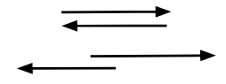

- Schematic diagram of the dimers from which any extension reaction is not initiated. The direction of the arrow indicates the direction of the base sequence of the oligomer (5’->3’).

- When there is a plurality of combinations that form a dimer, it is depicted that the longer is the double-stranded region, then a higher possibility of dimer formation becomes evident.

Figure S5
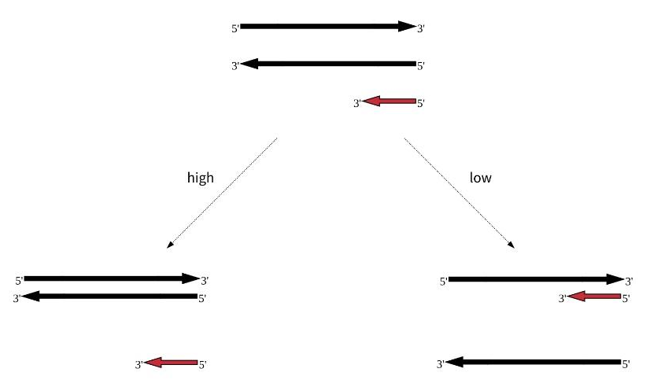

- Schematic diagram of tendency on reconstruction of original duplex of DNA comparing incomplete dimer formation. The direction of the arrow indicates the direction of the base sequence of the oligomer (5’->3’). Black and red arrows indicate original duplex DNA and short oligomer respectively.

- When two or more ssDNAs form a dimer in the same annealing region, it is shown that the shorter the length of the ssDNA, the higher the possibility of dimer formation is seen. This assumption was partially simulated in the aesoe.rb program

Figure S6
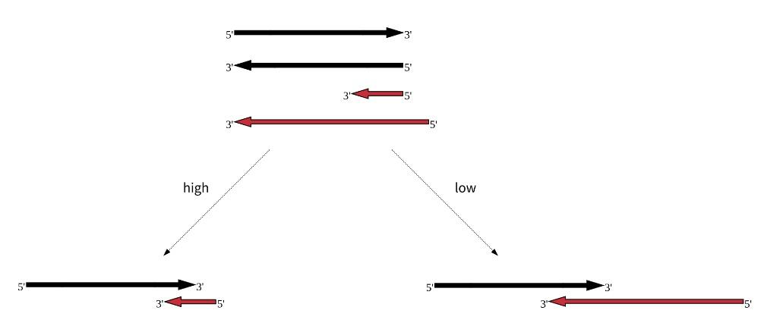

- Schematic diagram of tendency on dimer formation. Possibility of hybridization with short oligomers is higher than with long oligomers. The direction of the arrow indicates the direction of the base sequence of the oligomer (5’->3’).

- When two or more oligomers capable of forming a dimer are present, it is demonstrated that the higher is the concentration, the easier the reaction proceeds.

Figure S7
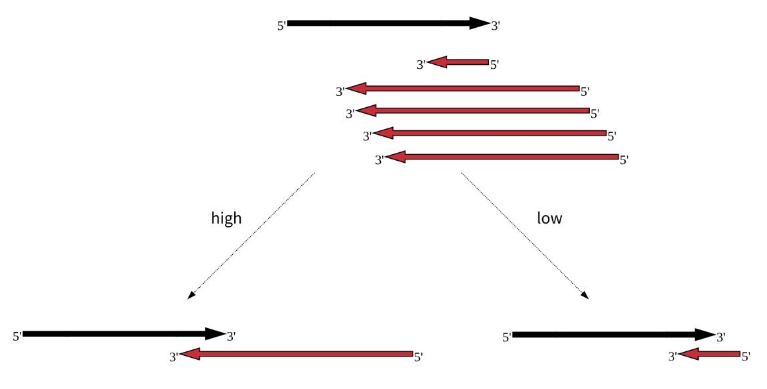

- Schematic diagram of tendency on dimer formation. Possibility of hybridization with oligomers present in high concentration is higher than those in low concentration. The direction of the arrow indicates the direction of the base sequence of the oligomer (5’->3’).

3-3. Implementations of the rules

In order to simulate the reaction on these assumptions, the simulator program has been configured as follows.

- The positive direction of the final product is set to the direction of the reference to the 5'→3', the positive direction of an odd number in a ssDNA, is applied to an even number in the opposite direction (Fig. 4A; in the main body).
- The double-stranded forming pair and the new pair of single-stranded DNA resulting from the double-stranded formation and extension reaction are manually defined as a pair-alteration table (Table S1). This is where the program is judged by its annealing for elongation. Table S1 includes reannealing of double-stranded DNA including single-stranded DNA (for example 11,12 => 11,12).
- Solution containing ssDNA was expressed as ‘Arrays’ (“orioligos” and “resoligos”) on the program, and the molar ratio is expressed as a list of integers indicating oligomers. When ssDNAs of 1; 4; 6; 8 as a row are mixed at a molar ratio of 10: 1: 5: 10, the sequence indicating the solution is [1,1,1,1,1,1,1,1, 1,1,1,4,6,6,6,6,6,8,8,8,8,8,8,8,8,8,8].
- In order to simulate annealing, ssDNA was divided into odd and even numbers, and after its shuffling, a pair sequence containing each odd and even number was created. Example: [[1,4], [1,6], [1,6], [1,6], [1,6], [1,6], [1,8], [1,8] , [1,8], [1,8], [1,8], [1,8], [1,8], 8]
- The unpaired ssDNA has been shuffled again to prepare a paired ssDNA including one odd number and one even number. (5) and (6) have been performed 10 times, so that the generation of the synthesized pair sequence is advanced according to its probability.
- The steps (4) to (5) correspond to the actual denaturation of AESOE or OE-PCR, annealing and the number of repetitions of the extension reaction. The number of end products after each step is expressed as the number of the longest products (Nos 13, 14 of ssDNAs in Figure 4A).

Table S2 Integer-number pairs simulating annealing and extension reaction of ssDNA

Before reactions |  | After reactions
1 | 4 | 9 | 10
4 | 9 | 10 | 9
6 | 9 | 12 | 11
3 | 10 | 9 | 10
8 | 11 | 13 | 14
8 | 13 | 13 | 14
7 | 14 | 13 | 14
1 | 10 | 9 | 10
5 | 12 | 11 | 12
7 | 12 | 11 | 12
1 | 10 | 9 | 10
1 | 12 | 11 | 12
1 | 14 | 13 | 14
3 | 12 | 15 | 12
3 | 14 | 14 | 17
5 | 14 | 14 | 19
15 | 6 | 15 | 16
15 | 8 | 17 | 18
1 | 15 | 11 | 12
3 | 16 | 15 | 16
1 | 18 | 13 | 14
3 | 18 | 17 | 18
5 | 18 | 18 | 19
17 | 8 | 17 | 18
19 | 8 | 19 | 20
19 | 14 | 13 | 14
11 | 14 | 13 | 14
9 | 14 | 13 | 14
13 | 6 | 13 | 21
21 | 6 | 11 | 12
21 | 4 | 21 | 10
21 | 8 | 13 | 14
9 | 10 | 9 | 10
11 | 12 | 11 | 12
13 | 14 | 13 | 14

- The numbers indicate the ssDNA shown in Fig. 4A. Numbers shown in the right 2 columns are synthesized by annealing and extension of left 2 columns.

3-4. Source code (https://github.com/daijiendoh/aesoe_extension_simulator)

require 'csv'

# Principle, assumption and implementation of annealing and extension of ssDNAs are described in Readme.md of this program.
# Pairs of ssDNAs which can be annealed and extended are set on row[0] and row[1] and ssDNAs after reaction are set on row[2] and row[3].
ojoin=Hash.new
CSV.foreach("connections.csv") do |row|
orioligos=row[0,2].map{|x| x.to_i}.sort
dstdnas=row[2,2].map{|x| x.to_i}.sort
ojoin[orioligos]=dstdnas
end
# if the ojoin hash for an odd-even oligo-number pair has a value, the odd-even oligo-number pair is explained as annealed and extendable pair.
# p ojoin

narr=0
no_connset=0
connset=[]
resoligo=[] # Array for resultant ssDNAs after annealing and extension.
unmatchpair=[] # Array to collect unmatched ssDNAs.
soligos=[1,1,1,1,1,1,1,1,1,1,1,1,1,1,1,1,1,1,1,1,4,4,6,6,6,8,8,8,8,8,8,8,8,8,8,8,8,8,8,8,8,8,8,8,8] # Array for original ssDNAs after annealing and extension.
orioligos=soligos.flatten
no_final_products=Hash.new
(1..14).to_a.each{|i|
p "cycle #{i}"
#p "orioligos #{orioligos}"
#p "orioligos before wile #{orioligos}"
connset=Array.new
oddoligo=orioligos.select{|x| x.odd?}.shuffle #Collect original forward ssDNAs.
#p oddoligo
nodd=oddoligo.length
evenoligo=orioligos.select{|x| x.even?}.shuffle #Collect original reverse ssDNAs.
#p evenoligo
neven=evenoligo.length
noarr=[nodd,neven].min

preconnset_no=0
no_connset=1
# p "connset #{no_connset} noarr #{noarr}"
while preconnset_no < no_connset do
# p "preconnset_no #{preconnset_no} connset #{no_connset}"
preconnset_no=no_connset

resoligo=Array.new
# p "connset #{connset}"
# p "orioligos #{orioligos}"
oddoligo=orioligos.select{|x| x.odd?}.shuffle #Shuffle forward ssDNAs numbers to simulate random annealing in the solution.
# p oddoligo
nodd=oddoligo.length
evenoligo=orioligos.select{|x| x.even?}.shuffle #Shuffle reverse ssDNAs numbers to simulate random annealing in the solution.

# p evenoligo
neven=evenoligo.length
noarr=[nodd,neven].min
resoligo=Array.new
if nodd > noarr then
resoligo =oddoligo[noarr..-1]
else
resoligo =evenoligo[noarr..-1]
end
mixoligo=oddoligo.shuffle[0,noarr].zip(evenoligo[0,noarr]) #Zip of two Arrays simulate annealing of ssDNAs.

# p "mixoligo #{mixoligo}"
mixoligo.each{|pair|
if ojoin[pair.sort] then #A value of ojoin[pair] indicates the pair exists on the left side of Table S1 which means they can form a (partial) double-stranded product.
# p "hit"
connset << ojoin[pair.sort]
else
resoligo << pair
end
}
orioligos=resoligo.flatten
# p "connset #{connset}"
no_connset=connset.length
# p "no_connset #{no_connset}"
end
# p "connset #{connset} resoligo #{resoligo}"
orioligos=(connset+resoligo).flatten
# p "orioligos after wile #{orioligos}"
# count end_products no
endset=connset.select{|set| set == [13,14]}
p "number of end-products #{endset.length}"
no_final_products[i]=endset.length
}

CSV.open("final_products.csv","w") do |csv|
no_final_products.each{|i,nop|
csv << [i,nop]
}
End

