Supplementary Material

Optimization of staining with SYTO 9/Propidium iodide: interplay, kinetics and impact on Brevibacillus brevis

List of Supporting Information:
Text. S1. Preparation of negative and positive groups
Text. S2. FCM analysis
Text. S3. Live: dead bacterial mixtures verification
Text. S4. Extraction and determination of membrane fatty acids
Fig. S1. The flow cytometric graph of the negative and positive groups
Fig. S2. Excitation and emission spectra of SYTO 9 and PI
Fig. S3. Gas chromatogram mass spectra of 32 fatty acid standards
Table S1. Data of detection time and number of cells

Table S2. The retention time and types of fatty acids mixed standard sample
Table S3. Changes in fatty acid composition and content in cells exposed to SYTO 9 and PI

Text S1. Preparation of negative and positive groups
Results of optical density measurement, agar plate experiments, and microscopic observation together revealed that cells treated with 70% isopropanol could be considered as dead cells [1-3]. 1 mL of 20 g/L bacterial suspension was added to 19 mL of 0.85% NaCl (for live bacteria) and 70% isopropyl alcohol (for killed bacteria) as negative and positive controls, respectively. The cells were incubated for 1 h at room temperature and mixed every 15 minutes, and then centrifuged at 6000 × g for 10 minutes. Finally, the cell pellets were resuspended in 0.85% NaCl solution in tubes at a final density of 10⁶ cells/mL.

Text S2. FCM analysis
The excitation/emission maxima for these dyes were about 480/500 nm for SYTO 9 and 490/635 nm for PI. The fluorescence signal of SYTO 9 was collected using a 550nm Dichroic filters and a 525/40 nm bandpass filter. PI fluorescence was collected using a 655 nm dichroic filter and a 620/30 nm bandpass filter.
The cells dyed with SYTO 9 were counted using flow cytometry instead of tradition plate counting. Numbers of B. bervis in 1 mL suspension was calculated as follows:
$$N_{s}={{(V}_{s}×N_{d})}/{(ν_{d}×t_{d})}$$
where N_{s} (cells/mL) is the number of cells in the suspension; V_{s} (mL) is the volume of the suspension; ν_{d} (μL/min) is flow rate of the flow cytometer (10μL/min at low speed, 30μL/min at medium speed, and 60μL/min at high speed); N_{d} (cells/mL) is the number of cells detected and t_{d} (s) is the detection time. The measurement parameters of the flow cytometer were: 10000 detection cells and 30μL/min flow rate. The number of cells in 1 mL of cellular suspension was calculated by measuring the detection time. Formula (1) was written as:
$N_{s}={2.0×{10}^{7}}/{t_{d}}$

Text S3. Live: dead bacterial mixtures verification
Each bacterial suspension was shaken at 130 rpm at 30 °C for 1 h. Live and dead bacterial cells were harvested via centrifugation (6000×g 10 min, 4 °C), followed by removal of the supernatant. The cells pellet were resuspended in 20 mL of 0.85%NaCl solution. After three washing cycles, the cell suspensions were diluted to a concentration of 1 ×10⁶ bacteria/mL to prepare mixtures with live: dead proportions corresponding to 0, 10, 20, 30, 40, 50, 60, 70, 80, 90, 100% live bacteria. Finally, 2.5μM SYTO 9 and 9.0μM PI as the optimal concentration were added to the above mixtures. SYTO 9: PI intensity ratio method[4] was used to predict the percentage of live bacteria in a sample, shown as:
$\% Live∝{SYTO 9}/{PI}$ (3)
where % live corresponds to the FCM-measured percentage of live bacteria in the sample, SYTO 9 and PI represents the integrated intensity of SYTO 9 and PI, respectively. The regions of intensity integration corresponded to the fluorescence peak of the dyes.

Text S4. Extraction and determination of membrane fatty acids
The membrane fatty acids were analyzed using gas chromatograph tandem mass spectrometer (SHIMADZU GCMS-QP 2010 Ultra) equipped with a DB-5MS (30 m ×0.25 mm × 0.25 μm) quartz capillary column. The conditions of GC-MS analysis were as follows: the column temperature was 70 ºC for 1 min and heated to 170 ºC for 1 min at a speed of 8 ºC, sample inlet temperature to 280 ºC, carrier gas was He (mL/ min), ion source temperature was set at 200 ºC, the mass spectrometer using electron ionization (EI) and electron energy of 70 eV, mass spectrometry scanning ranged 45-400 m/z. All of the experiments were performed in triplicate, and the mean values were used for t-test calculations.

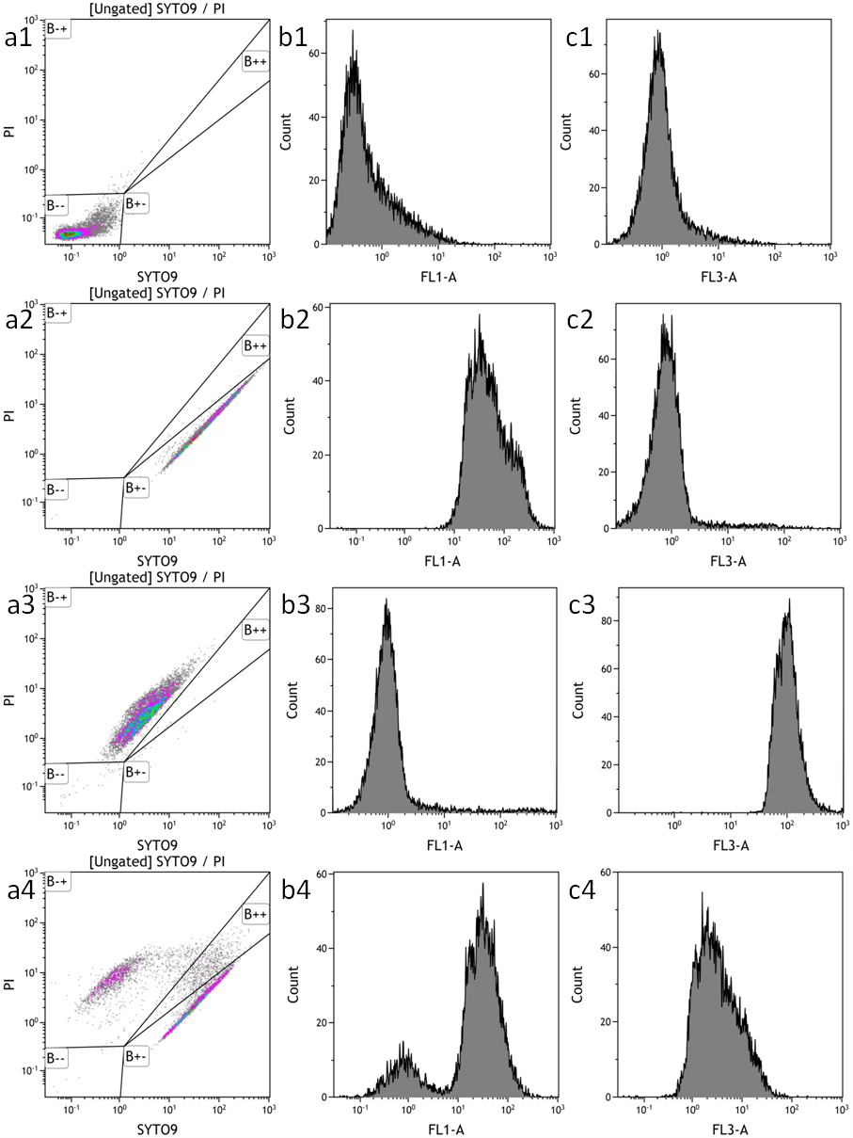
Fig. S1. The flow cytometric graph of the negative and positive groups.
(a1, b1 and c1), (a2, b2 and c2), (a3, b3 and c3) and (a4, b4 and c4) are the four groups corresponding to the cells without any dyes, living cells with SYTO 9, dead cells with PI and stable cells with both dyes, respectively. (a) Classification of stained cells, (b) fluorescence intensity distributions of green-stained cells obtained in the FL1 channel, and (c) fluorescence intensity distribution of red-stained cells obtained in the FL3 channel. B--, B+-, B-+ and B++ fields correspond to unstained, lived, dead and damaged B. brevis, respectively.

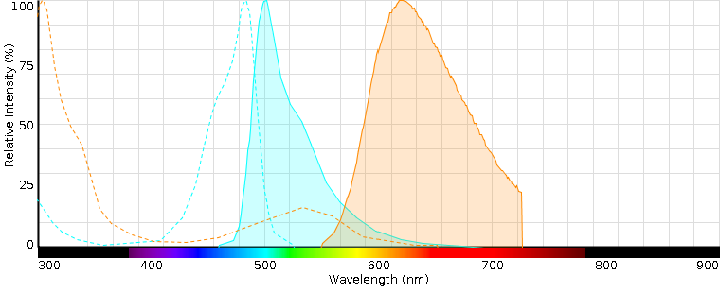
Fig. S2. Excitation and emission spectra of SYTO 9 and PI.
The blue and red dotted and solid lines correspond to the excitation and emission spectra of SYTO 9 and PI, respectively. This was taken from the official website of the Live/Dead® BacLight kit (Thermo Fisher Scientific, USA) product (https://www.thermofisher.com/order/catalog/product/L13152#/L13152).
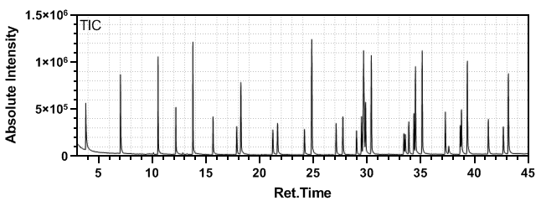
Fig. S3. Gas chromatogram mass spectra of qualitative and quantitative 32 fatty acid standards
Table S1. Data of detection time and number of cells
Number of B.brevis (×10⁶ cells/mL) | Detection time (s)
 | 2.5 μM SYTO 9 |  |  | 5.0 μM SYTO 9
10 | 2.02 | 1.98 | 1.98 |  | 2.01 | 2.04 | 2.01
8 | 2.47 | 2.48 | 2.51 |  | 2.50 | 2.52 | 2.51
5 | 4.04 | 4.08 | 4.02 |  | 4.05 | 4.10 | 4.08
2 | 9.98 | 9.96 | 10.02 |  | 10.03 | 10.04 | 10.08
1 | 20.10 | 20.06 | 19.95 |  | 20.09 | 20.06 | 20.03

Table S2. The retention time and types of fatty acids mixed standard sample.
No. | Ret.Time (t) | Types of fatty acids
1 | 3.784 | Caproic acid methyl ester (C6:0)
2 | 7.017 | Caprylic acid methyl ester (C8:0)
3 | 10.514 | Capric acid methyl ester (C10:0)
4 | 12.173 | Undecanoic acid methyl ester (C11:0)
5 | 13.759 | Lauric acid methyl ester (C12:0)
6 | 15.635 | Tridecanoic acid methyl ester (C13:0)
7 | 17.841 | Myristoleic acid methyl ester (C14:1)
8 | 18.227 | Myristic acid methyl ester (C14:0)
9 | 21.204 | Linolenic acid methyl ester (C18:2n6c)
10 | 21.641 | Pentadecanoic acid methyl ester (C15:0)
11 | 24.146 | Palmitoleic acid methyl ester (C16:1)
12 | 24.827 | Palmitic acid methyl ester (C16:0)
13 | 27.095 | cis-10-Heptadecenoic acid methyl ester (C17:1)
14 | 27.722 | Heneicosanoic acid methyl ester (C17:0)
15 | 28.995 | Linoleic acid methyl ester (C18:3n3)
16 | 29.456 | Linolelaidic acid methyl ester (C18:2n6t)
17 | 29.652 | Oleic acid methyl ester (C18:1n9c)
18 | 29.837 | Elaidic acid methyl ester (C18:1n9t)
19 | 30.372 | Stearic acid methyl ester (C18:0)
20 | 33.402 | Arachidonic acid methyl ester (C20:4n6)
21 | 33.531 | cis-5,8,11,14,17-Eicosapentaenoic acid methyl ester (C20:5n3)
22 | 33.862 | cis-8,11,14-Eicosatrienoic acid methyl ester (C20:3)
23 | 34.341 | cis-11,14-Eicosadienoic acid methyl ester (C20:2)
24 | 35.108 | Arachidic acid methyl ester (C20:0)
25 | 37.266 | Heneicosanoic acid methyl ester (C21:0)
26 | 37.58 | cis-4,7,10,13,16,19-Docosahexaenoic acid methyl ester (C22:6n3)
27 | 38.661 | cis-13,16-Docosadienoic acid methyl ester (C22:2)
28 | 38.768 | Erucic acid methyl ester (C22:1n9)
29 | 39.311 | Behenic acid methyl ester (C22:0)
30 | 41.266 | Tricosanoic acid methyl ester (C23:0)
31 | 42.664 | cis-15-Tetracosenoic Acid (C24:1)
32 | 43.132 | Lignoceric acid methyl ester (C24:0)

Table S3. Changes in fatty acid composition and content in cells exposed to SYTO 9 and PI.
 | Control | 0.25μM SYTO 9 | 0. 5μM SYTO 9 | 2.5μM SYTO 9 | 0.9μM PI | 1.8μM PI | 9.0μM PI | 0.25 μM SYTO 9 & 0.9μM PI | 0.25 μM SYTO 9 & 9.0μM PI | 2.5 μM SYTO 9 & 0.9μM PI
C12:0 | - | - | 0.046  ±0.002 | 0.059  ±0.003 | 0.055  ±0.001 | 0.056  ±0.001 | - | - | - | -
C14:0 | 0.206  ±0.002 | 0.215  ±0.008 | 0.233  ±0.014 | 0.235  ±0.0115 | 0.229  ±0.002 | 0.212  ±0.011 | 0.206  ±0.008 | 0.207  ±0.016 | 0.207  ±0.004 | 0.227  ±0.011
C15:0 | 0.120  ±0.001 | 0.125  ±0.003 | 0.122  ±0.003 | 0.126  ±0.002 | 0.120  ±0.005 | 0.123  ±0.002 | 0.125  ±0.003 | 0.125  ±0.003 | 0.122  ±0.001 | 0.123  ±0.002
C16:0 | 0.595  ±0.015 | 0.745  ±0.036 | 0.797  ±0.0239 | 1.957  ±0.237 | 0.492  ±0.016 | 0.742  ±0.085 | 0.825  ±0.106 | 0.702  ±0.069 | 0.830  ±0.066 | 2.660  ±0.115
C17:0 | - | - | - | 0.118  ±0.003 | 0.113  ±0.007 | 0.113  ±0.001 | - | - | 0.121  ±0.007 | 0.120  ±0.004
C18:0 | 0.465  ±0.014 | 0.574  ±0.024 | 0.555  ±0.0614 | 1.168  ±0.077 | 0.448  ±0.058 | 0.582  ±0.103 | 0.659  ±0.235 | 0.508  ±0.077 | 0.685  ±0.089 | 2.804  ±0.189
C18:1n9c | - | - | 0.314  ±0.020 | 0.294  ±0.008 | - | 0.312  ±0.021 | 0.265  ±0.003 | - | 0.287  ±0.005 | 0.231  ±0.013
C18:2n6c | - | 0.192  ±0.004 | 0.199  ±0.0260 | 0.202  ±0.012 | - | - | 0.196  ±0.012 | 0.189  ±0.006 | 0.193  ±0.001 | 0.211  ±0.001
C22:1n9 | - | - | - | 0.059  ±0.012 | - | - | - | - | - | -
Total | 1.577  ±0.035 | 1.853  ±0.073 | 2.526  ±0.136 | 4.160  ±0.287 | 1.771  ±0.045 | 2.026  ±0.212 | 2.082  ±0.334 | 1.544  ±0.133 | 2.563  ±0.155 | 6.436  ±0.178

Reference

1. Stiefel P, Schmidt-Emrich S, Maniura-Weber K, Ren Q. Critical aspects of using bacterial cell viability assays with the fluorophores SYTO9 and propidium iodide. BMC microbiology, 15(1), 36 (2015).
2. Herskovits TT, Gadegbeku B, Jaillet H. On the structural stability and solvent denaturation of proteins I. Denaturation by the alcohols and glycols. Journal of Biological Chemistry, 245(10), 2588-2598 (1970).
3. McDonnell G, Russell AD. Antiseptics and disinfectants: activity, action, and resistance. Clinical microbiology reviews, 12(1), 147-179 (1999).
4. Probes M. LIVE/DEAD BacLight bacterial viability kits. Fluorescence Spectroscopy Protocols. Staining Bacteria with either Kit L7007 or L, 7012 (2004).

