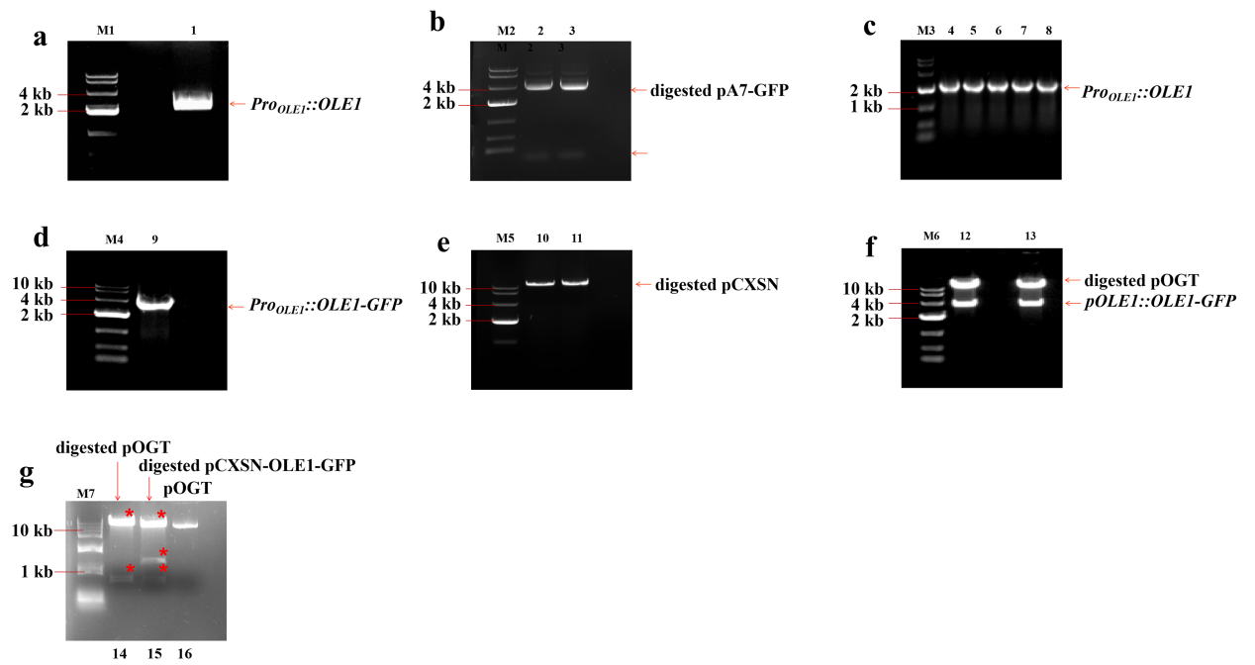
Fig S1 The picture of Gel electrophoresis during the constraction of pOGT vector
(a) Gel electrophoresis of PCR amplified Pro_{OLE1}::OLE1 fragment (lane 1; amplified fragment: 2245 bp, indicated by arrow). (b) XhoⅠ and SalⅠ digestion of the vector pA7-GFP (lane 2, 3; large fragment: 4591 bp; small fragment: 57 bp; both fragments were indicated by arrows). (c) Colony PCR from five random clones using primers pOLE1-F and pOLE1-R (lane 4-8; amplified fragment: 2245 bp; indicated by arrow). (d) Gel electrophoresis of PCR amplified Pro_{OLE1}::OLE1-GFP fragment (lane 9, amplified fragment: 2989 bp; indicated by arrow). (e) HindⅢ digestion of the vector pCXSN (lane 10, 11; fragment: 10802 bp; indicated by arrow). (f) HindIII digestion of pCXSN-OLE1-GFP (lane 12, 13; large fragment: 10802 bp; small fragment: 2957 bp; both fragments were indicated by arrows ). (g) XcmI digestion of the vector pOGT with mutated promoter and the pCXSN-OLE1-GFP with original promoter. The asterisks indicated the resulting fragments after XcmI digestion. The last lane was the undigested pOGT vector.

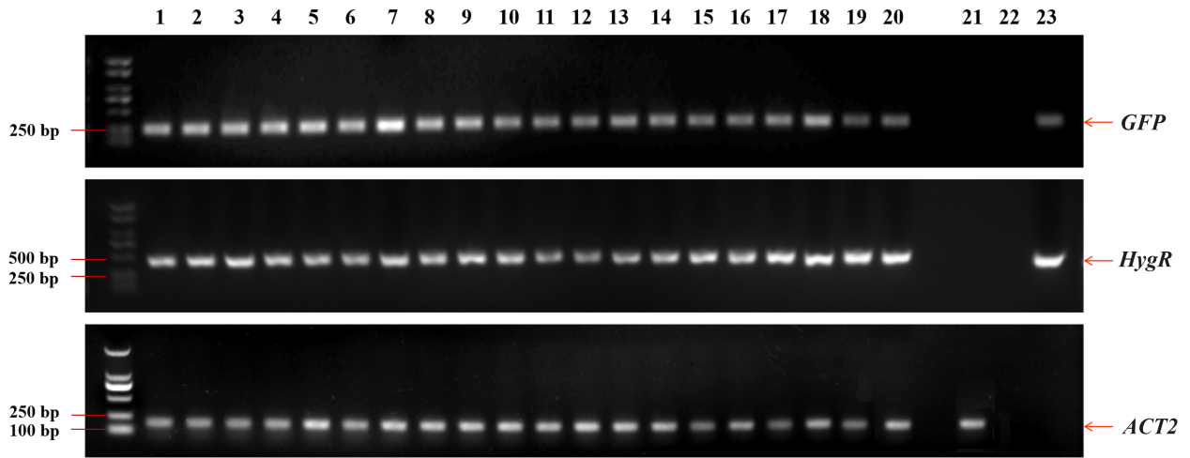
Fig S2 PCR amplification of GFP, HygR, ACT2 fragment from T₁ transgenic plants expressing pOGT.
Lane 1-20 shows the amplification from 20 independent T₁ plants. Lane 21 shows the amplification from Arabidopsis wild type plants (Col-0). Lane 22 shows the amplification with no template. Lane 23 shows the amplification from pOGT plasmid. GFP fragment: 272 bp, HygR fragment: 444 bp, ACT2 fragment: 188 bp.

