Virulence factors | Organisms | Role | Inhibitors | References
Proteinases | C. albicans | Hydrolytic enzyme | Pepstatin A, saquinavir, indinavir  Human domain antibodies | [152,153]
Phospholipases | C. albicans, C. neoformans, Aspergillus flavus | Hydrolytic enzyme | Alexidine dihydrochloride,  1,12 bis-(tributylphosphonium)-  dodecane dibromide | [64]
Haemolysin | C. albicans | Hydrolytic enzyme | cationic lipo-benzamide compound C9M | [154]
Candidalysin | C. albicans | Hydrolytic enzyme | cis-2-dodecenoic acid | [155]
Elastase | Trichophyton mentagrophytes, Candida spp | Hydrolytic enzyme | Aliphatic aldehydes | [68]
Glyoxilate cycle | C. albicans | Metabolic pathways | Caffeic acid, rosmarinic acid and apigenin | [156]
Inositol phosphoryl  ceramide synthase (IPC1) | C. neoformans, Candida spp, Aspergillus spp | Metabolic pathways | Aureobasidin A, khafrefungin | [157]
Isocitratelyase (ICL) | C. albicans | Metabolic pathways | 3-nitropropionate, 3-bromopyruvate, mycenon, mohangamide A and mohangamide B | [138,139]
Target of Rapamycin (TOR) signaling pathway | Saccharomyces cerevisae | Metabolic pathways | Small molecule CID 3528206 | [158]
Calcineurin | C. albicans, C. neoformans | Metabolic pathways | Tacrolimus, cyclosporin A | [135]
Hyphal formation | Candida spp, C. neoformans | Morphogenesis | Saponins | [88]
Adhesion, morphogenesis, biofilm | C. albicans | Ras1-cAMP-Efg1 pathway | Magnolol and honokiol | [159]
Biofilm | Candida spp | drug-resistance | Farnesol, Diazaspiro-decane structural analogs, cationic lipo-benzamide compound C9M | [100, 112, 154]
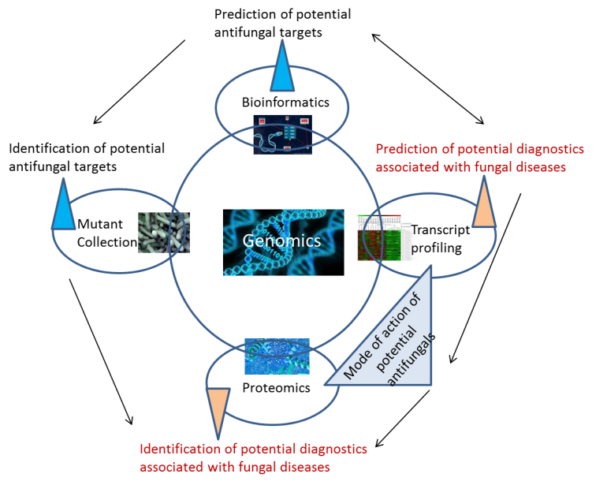
Need for newer antifungal drug discovery by
- Targeting pathogenicity of fungi especially in Candida albicans
- Prominent Virulence factors being targeted are extracellular hydrolytic enzymes, adherence, morphogenesis, and biofilm formation
- Targeting metabolic pathways or transcription factors controlling these virulence determinants
Use of molecular approaches
various virulence factors in fungi and their known inhibitors
Problems associated with currently available antifungals
- Drug resistance
- Host toxicity
- Cost measures
- Drug efficacy

