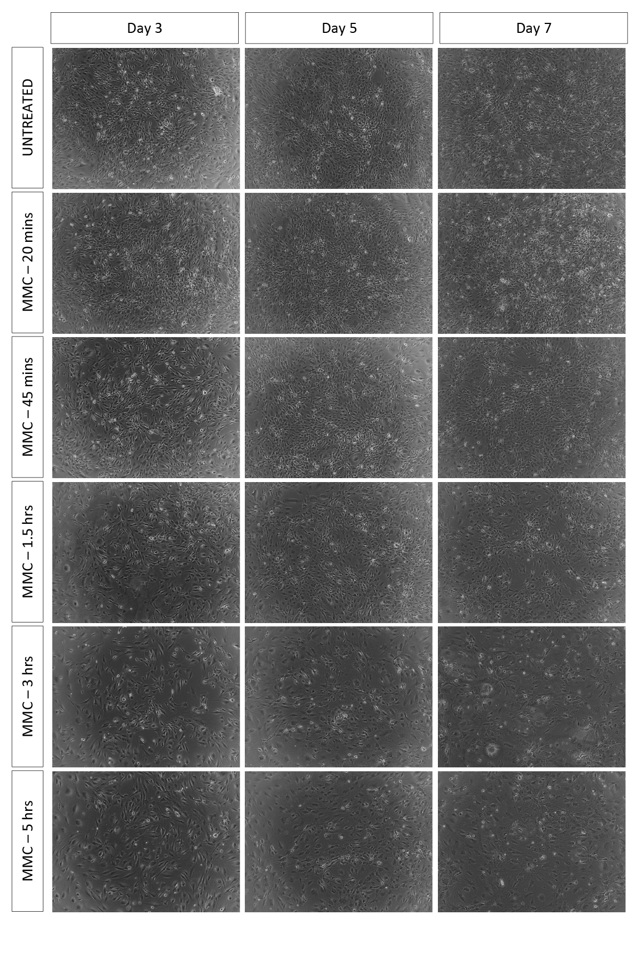
Figure S1. Phase-contrast images of SL10 feeder cells treated with mitomycin-C (MMC) at varying exposure times. Cells were treated with MMC and seeded at 1.56 x10⁴/cm² in 24-well plates and monitored for 7 days. In Untreated, MMC-20mins and MMC-45mins, obvious increase in densities are observed. In MMC-1.5hrs and MMC-3hrs, densities remained constant visually. In MMC-5hrs, a decrease in cell density is apparent. Images were captured using Carl Zeizz Axiovert A.1 inverted microscope at 20X magnification.

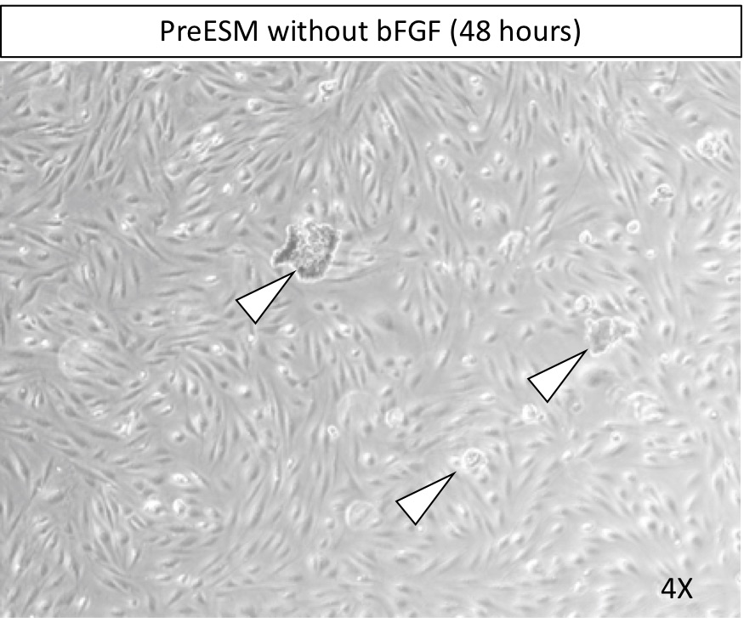

Figure S2. Revival of iPSC using Primate embryonic stem cell media (PreESM) without bFGF. induced pluripotent stem cells colonies (arrowheads) after 48 hours failed to attach on the mitotically incapacitated SL10 feeder layer. These colonies were eventually washed out after succeeding media replacement. Photomicrograph was taken at 4X magnification.
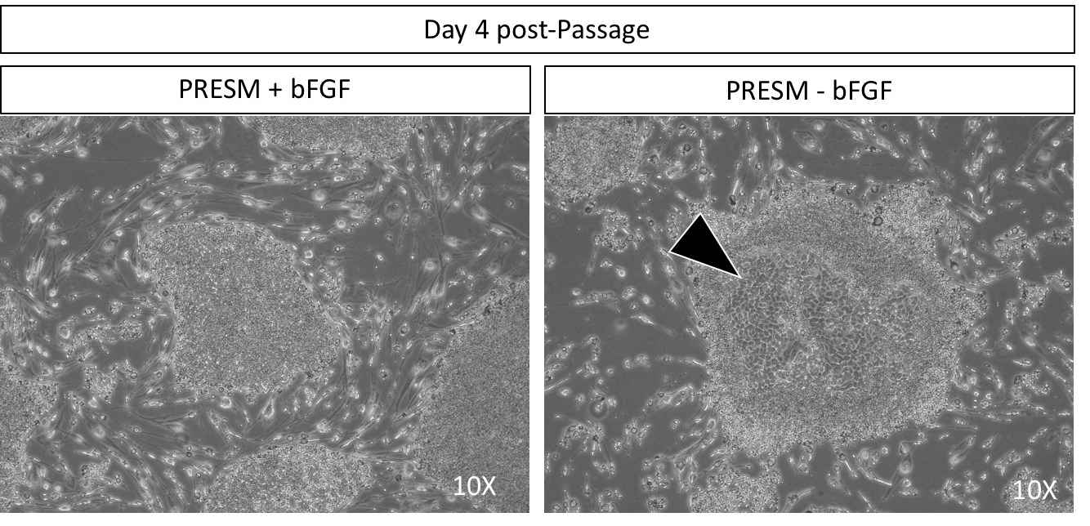
Figure S3. Withdrawal of bFGF in active culture of induced pluripotent stem cells (iPSCs) results in premature differentiation. Withdrawal of bFGF after 48 hours of passage, results into premature differentiation of iPSC. This is characterized morphologically in colonies as a consequence of increased cytoplasm of predifferentiation iPSCS. (arrowhead). All pictures taken at 10X magnification.

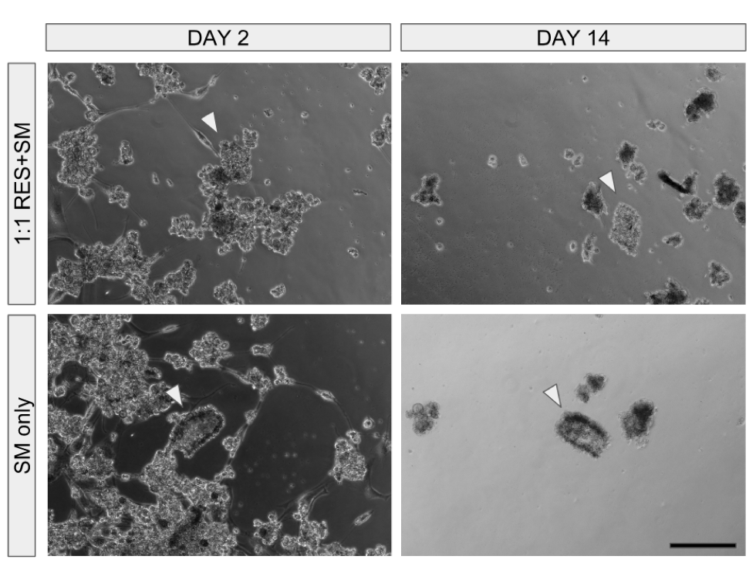
Figure S4. Feeder-free culture of induced pluripotent stem cells (iPSCs) using matrigel and classic Primate embryonic stem cell media (PrESM) and StemMacs (SM). Colonies of iPSCs (white arrowheads) thawed in two media conditions remained viable but exhibit senescent behaviour after two weeks incubation. Scale bars set at 100 uM.

