Supplementary to

Expression of mouse small interfering RNAs in lettuce using artificial microRNA technology

Tayebeh Kakeshpour¹, Tej Man Tamang¹, Woojun D Park², Murli Manohar³, Jian Yang⁴, Kendal D Hirschi^{4*} & Sunghun Park^{1*}

¹Department of Horticulture and Natural Resources, Kansas State University, Manhattan, KS 66506, USA
²Department of Molecular & Human Genetics, Baylor College of Medicine, Houston, TX 77030, USA
³Boyce Thompson Institute, Cornell University, Ithaca, NY 14853, USA
⁴United States Department of Agriculture/Agricultural Research Service, Children’s Nutrition Research Center, Department of Pediatrics, Baylor College of Medicine, Houston, TX 77030, USA

Supplementary Figure S1

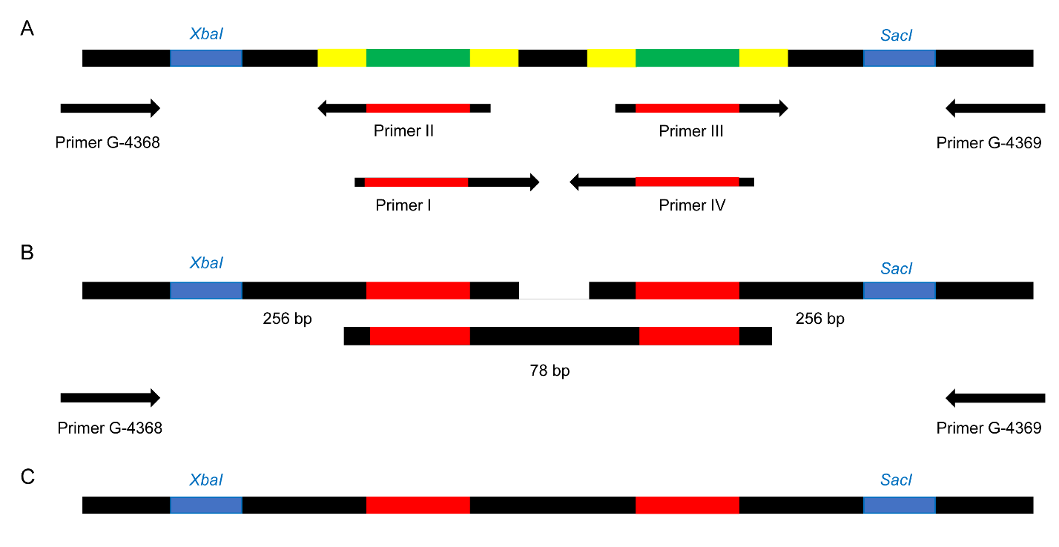

Supplementary Figure S1. PCR scheme to produce artificial microRNA constructs. (A) The original rice micro RNA 528 sequences (green) were replaced by C3 and CF7 artificial microRNA sequences (red) during the first PCR using three pairs of primers. Primer sequences are shown in Supplementary Table S1. Yellow sequences are complementary to primers and multiple cloning sites are shown in blue. (B) Three DNA fragments were amplified during PCRs and were combined by fusion PCR using G-4368 and G-4369 primers to obtain one DNA sequence. (C) Final DNA sequence ready for subsequent cloning.
Supplementary Figurer S2

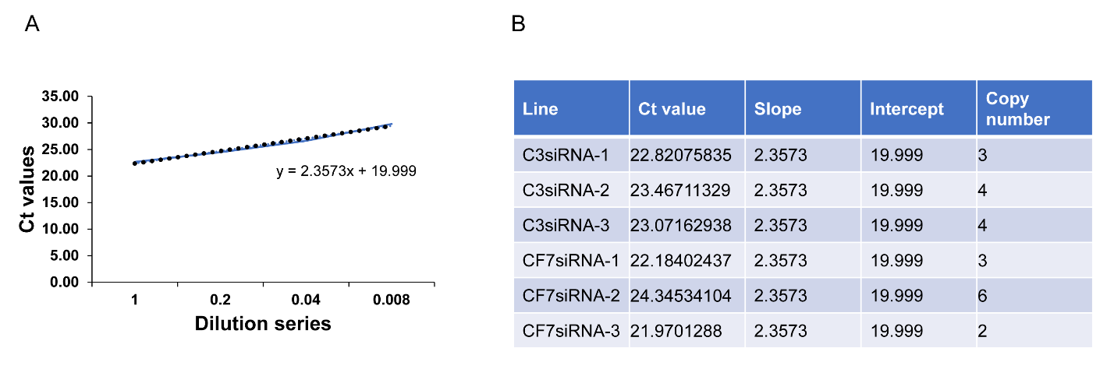

Supplementary Figure S2. Absolute quantification of transgene copy number in C3siRNA- and CF7siRNA-expressing lettuces using quantitative real-time PCR. (A) Standard curve showing Ct values plotted against a series of 5-fold DNA dilutions. (B) Transgene copy number results using standard curve for primary C3 and CF-7 artificial microRNA backbones. Data were analyzed using Ct_{(samples)}=slope_{(standard.curve)}×log_{(copy.number)}+intercept_{(standard.curve)} formula.

Supplementary Figure S3

Supplementary Figure S3. Quantitative real-time PCR analysis of mature C3 and CF7 artificial microRNAs (amiRNAs) in C3siRNA- and CF7siRNA-expressing lettuces using stem-loop primer. (A) Fold change expression of mature C3 amiRNA in different transgenic lines compared to line with the lowest expression level of C3 amiRNA. (B) Fold change expression of mature C7 amiRNA in different transgenic lines compared to line with the lowest expression level of C7 amiRNA. TIP-41 (Tonoplastic intrinsic protein 41) was used as internal control and data were analyzed by Livak method. Primer sequences are shown in Table 1.

Supplementary Table S1

Supplementary Table S1. Primer sequences for siRNA cloning.

