Supplementary data

Supplementary Figure S1. Improvement of PCR reaction system using dilution comparing to spin column.
M: 100bp marker. (A) The patterns of the first/second-round PCR reaction system by agarose gel electrophoresis. Forthe 50μL PCR reaction system, compared with the previously reported primer concentration which was 3.3μL (ITSP1s) and 0.66μL (AP1) in Lane l, Lane 2 shows no difference in the yield when primer concentration was 2.2μL (ITSP1s) and0.44μL (AP1). For the 10μL PCR reaction system, compared with the previously reported primer concentration which was 0.66μL (ITSP1s) and 0.26μL (AP1) in Lane3, Lane 4 shows no difference in the yield when primer concentration was 0.44μL (ITSP1s) and 0.17μL (AP1). Lane 5: purification of the first-round PCR product by spin column (50µL PCR reaction system). Lane 6: purification of the first-round PCR product by spin column (10µL PCR reaction system). Lane 7, 8 and 9: the performance of the second-round PCR using diluted first-round PCR products (from lane 3 of figure A), including dilution times of 25, 50 and 100. Lane 10, 11 and 12: the performance of the second-round PCR using diluted first-round PCR products (from lane 4 of figure A), including dilution times of 25, 50 and 100. (B) The optimization of template in the second-round PCR reaction system by agarose gel electrophoresis. The four dilution gradients of the first-round PCR products we set were 10, 30, 60, and 100 times; and three concentration gradients of the second-round PCR template are shown. (Lane1, 2 and 3), (lane 4, 5 and 6), (lane 7, 8 and 9) and (lane 10, 11 and 12) show the results of the first-round PCR products with different dilution gradients: 10, 30, 60 and 100 times. (Lane 1, 4, 7 and 10), (lane 2, 5, 8 and 11) and (lane 3, 6, 9 and 12) depict the concentration of the second-round PCR template with 0.5μL , 1μL and3μL , respectively.

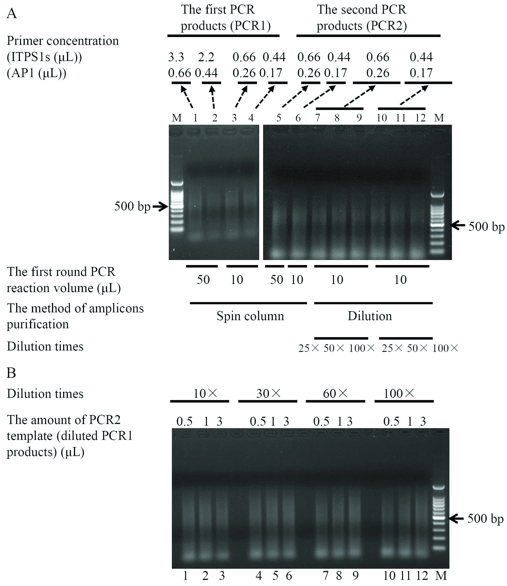

Supplementary Figure S2. Comparison of the performance in the fragment length and sequencing depth between using spin column and dilution to process with the first-round PCR products.
(A) The distribution of the average length of the 12 target enriched fragments from spin column and dilution. (B) The distribution of the average sequencing depth of the 12 enriched fragments from spin column and dilution.
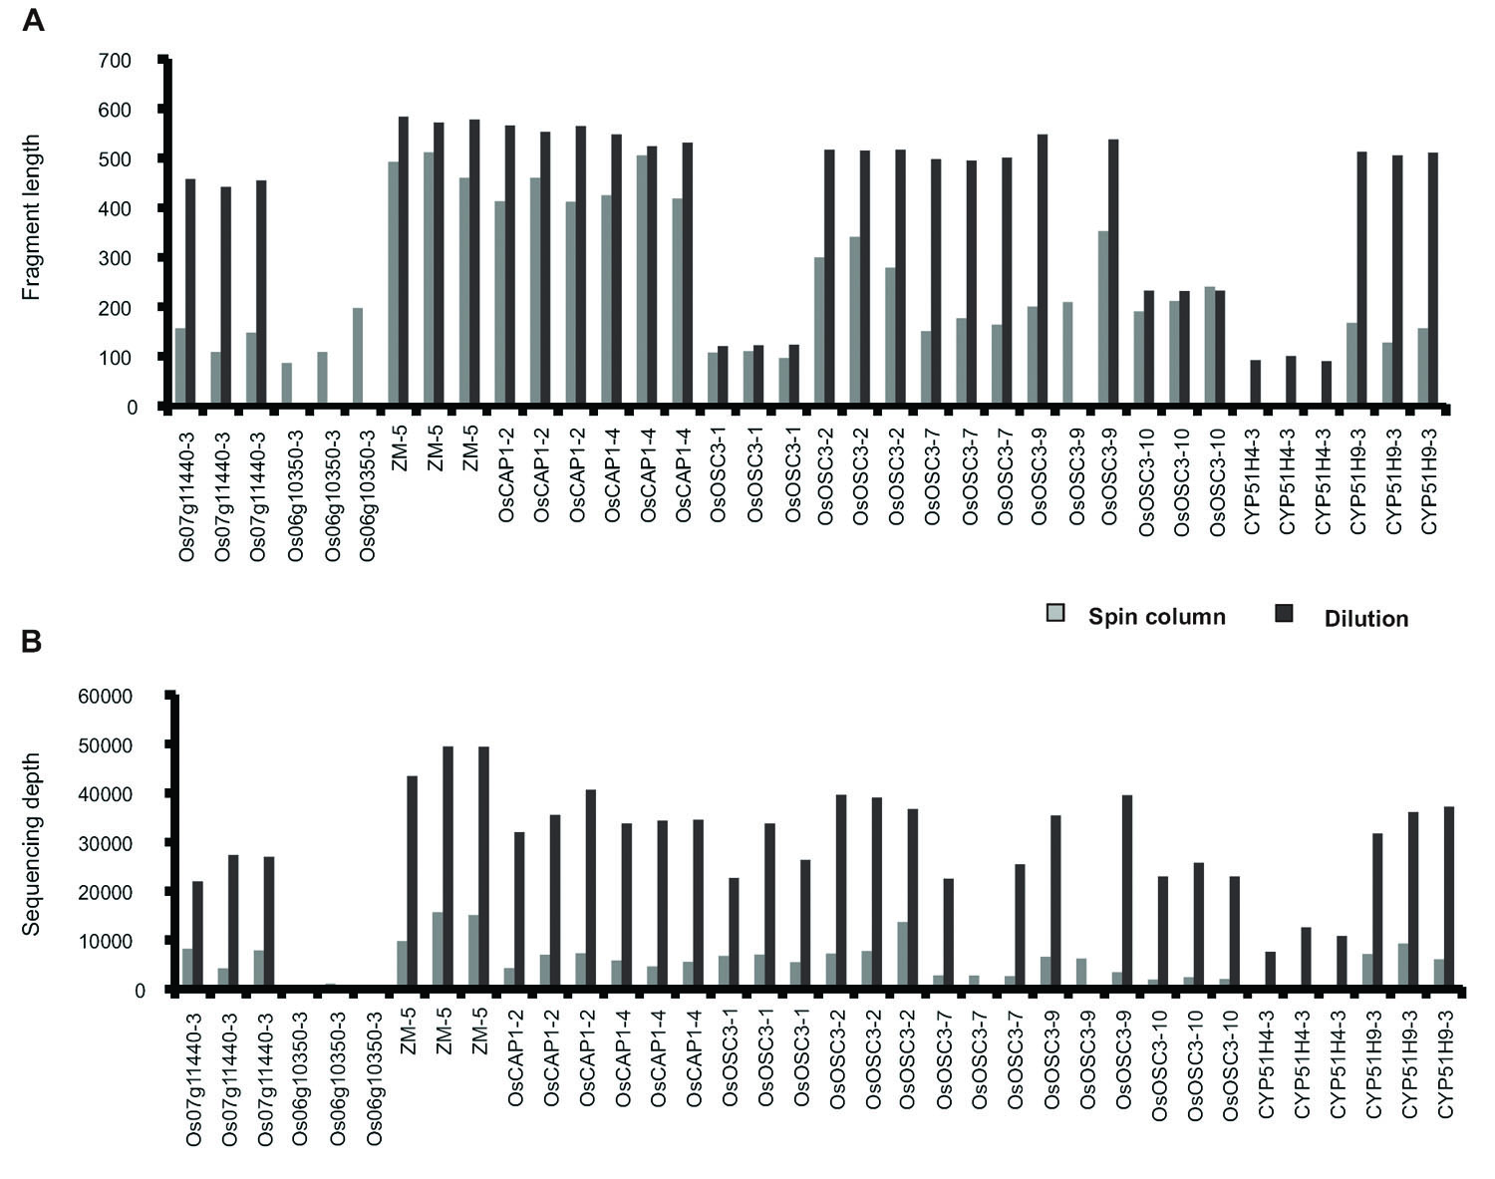

Supplementary Figure S3. Summary of the enriched fragments in Pool 1 and Pool 2.
(A & B)The fragment length of each enriched target fragment (shown by the box plot) and the number of successfully enriched (red) fragments.
(C & D) The distribution of sequencing depth among the enriched fragments.
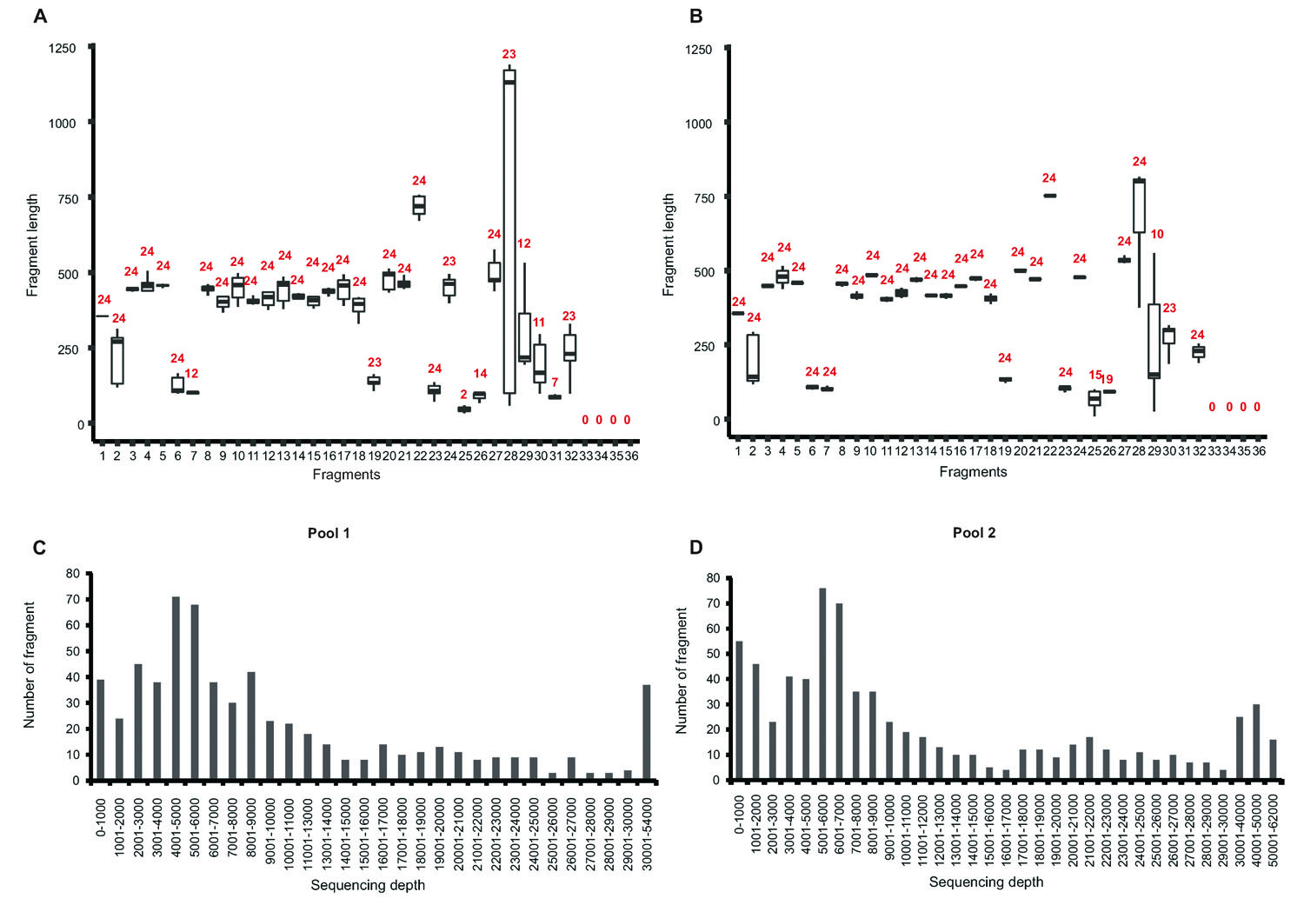

Table S1. The information of the obtained sequence fromthe samples of dilution treated and spin column treated
Sample | Dilution |  |  | Spin column
 | Data output (Mb) | Number of reads | The ratio of mapped reads | Data output (Mb) | Number of reads | The ratio of mapped reads
Z₇ | 405 | 962,860 | 96.41% | 594 | 1,412,323 | 38.00%
Y₂ | 441 | 1,048,656 | 95.94% | 393 | 933,383 | 53.24%
X₈ | 851 | 2,025,406 | 50.86% | 511 | 1,214,277 | 45.68%
Total | 1,697 | 4,036,922 |  | 1498 | 3,559,983

Bulks | Ratio （%） | Bulks | Ratio （%） | Bulks | Ratio （%）
AX1 | 60.12 | AZ1 | 53.49 | BY1 | 58.71
AX2 | 58.33 | AZ2 | 50.49 | BY2 | 65.33
AX3 | 62.53 | AZ3 | 49.53 | BY3 | 59.24
AX4 | 60.65 | AZ4 | 49.54 | BY4 | 65.24
AX5 | 74.91 | AZ5 | 54.05 | BY5 | 67.05
AX6 | 64.64 | AZ6 | 57.86 | BY6 | 58.18
AX7 | 80.73 | AZ7 | 53.47 | BY7 | 58.73
AX8 | 77.22 | AZ8 | 68.26 | BY8 | 59.27
AY1 | 52.8 | BX1 | 65.91 | BZ1 | 60.31
AY2 | 57.73 | BX2 | 64.37 | BZ2 | 56.78
AY3 | 54.52 | BX3 | 60.29 | BZ3 | 58.88
AY4 | 59.82 | BX4 | 60.18 | BZ4 | 63.9
AY5 | 57.77 | BX5 | 59.86 | BZ5 | 60.13
AY6 | 61.49 | BX6 | 62.46 | BZ6 | 60.14
AY7 | 58.82 | BX7 | 63.08 | BZ7 | 58.52
AY8 | 60.73 | BX8 | 62.59 | BZ8 | 60.19
Table S2 Ratio of on-target reads

Table S3 The confirmed genuine mutations by Sanger sequencing
Candidate mutations | Fragments | Positions (in CDS) | Types | Coordinates in 3D pool | TRUE* or FALSE | Pool
No.1 | Os07g11440-2 | 319 | C-T | X7Y8Z3 | TURE | 1
No.2 | Os07g11440-2 | 350 | C-T | X1Y4Z5 | TURE | 1
No.3 | Os07g11440-3 | 891 | C-T | X6Y6Z2 | TURE | 1
No.4 | Os07g11440-1 | 121 | C-T | X4Y4Z5 | TURE | 1
No.5 | OsOSC11-11 | 1836 | C-T | X2Y3Z1 | TURE | 1
No.6 | OsOSC11-9 | 2017 | C-T | X4Y7Z6 | TURE | 1
No.7 | OsOSC3-2 | 359 | G-A | X5Y3Z6 | TURE | 1
No.8 | Os07g11440-2 | 329 | G-A | X3Y2Z6 | TURE | 1
N0.9 | Os07g11440-2 | 500 | G-A | X1Y8Z6 | TURE | 1
No.10 | Os07g11440-3 | 1019 | G-A | X4Y2Z7 | TURE | 1
No.11 | Os07g11440-1 | 80 | G-A | X1Y3Z3 | TURE | 1
No.12 | OsCAP1-2 | 365 | G-A | X5Y4Z8 | TURE | 1
No.13 | OsCAP1-3 | Intron | G-A | X1Y4Z6 | TURE | 1
No.14 | OsCAP1-1 | 10 | G-A | X1Y8Z6 | TURE | 1
No.15 | OsOSC11-7 | 1510 | G-A | X7Y8Z3 | TURE | 1
No.16 | OsOSC11-11 | 1917 | G-A | X7Y7Z1 | TURE | 1
No.17 | OsOSC11-9 | 2012 | G-A | X1Y2Z8 | TURE | 1
No.18 | OsOSC7-8 | 1821 | G-A | X5Y1Z5 | TURE | 1
No.19 | OsOSC11-7 | Intron | G-A | X4Y7Z2 | TURE | 1
No.20 | OsCAP1-2 | 322 | C-T | X4Y7Z2 | TURE | 1
No.21 | OsCAP1-2 | Intron | C-T | X5Y6Z8 | TURE | 1
No.22 | OsCAP1-3 | 719 | C-T | X7Y6Z5 | TURE | 1
No.23 | OsOSC7-8 | 1822 | G-A | X1Y7Z6 | TURE | 1
No.24 | Os06g03610 | 702 | C-T | X3Y5Z2 | TURE | 1
No.25 | Os06g03610 | 1781 | G-A | X6Y1Z8 | TURE | 1
No.26 | Os06g03610 | 1994 | C-T | X5Y6Z7 | TURE | 1
No.27 | Os06g03610 | 2157 | G-A | X5Y4Z6 | TURE | 1
No.28 | Os06g03610 | 2236 | C-T | X2Y8Z7 | TURE | 1
No.29 | Os06g10350-1 | 123 | C-T | X7Y6Z6 | FASLE | 1
N0.1 | OsOSC3-2 | 278 | C-T | X3Y3Z5 | TURE | 2
No.2 | Os07g11440-1 | Intron | C-T | X4Y8Z3 | TURE | 2
No.3 | Os07g11440-2 | 545 | C-T | X7Y8Z3 | TURE | 2
No.4 | OsOSC11-4 | Intron | C-T | X2Y7Z6 | TURE | 2
No.5 | OsOSC11-6 | 1286 | C-T | X3Y8Z5 | TURE | 2
No.6 | OsOSC11-7 | Intron | C-T | X2Y2Z4 | TURE | 2
No.7 | OsOSC11-8 | 1635 | C-T | X7Y6Z6 | TURE | 2
No.8 | OsOSC11-8 | 1636 | C-T | X5Y7Z4 | TURE | 2
No.9 | OsOSC11-9 | Intron | C-T | X3Y4Z8 | TURE | 2
No.10 | OsOSC11-11 | 1857 | C-T | X1Y1Z7 | TURE | 2
No.11 | OsOSC7-8 | 1723 | C-T | X2Y4Z3 | TURE | 2
No.12 | OsOSC7-8 | 2544 | C-T | X2Y5Z7 | TURE | 2
No.13 | OsUGT | 624 | C-T | X8Y1Z5 | TURE | 2
No.14 | Os07g11440-1 | 61 | G-A | X4Y7 Z5 | TURE | 2
No.15 | Os07g11440-2 | 363 | G-A | X7Y5Z8 | TURE | 2
No.16 | Os07g11440-2 | 369 | G-A | X2Y6Z8 | TURE | 2
No.17 | Os07g11440-3 | Intron | C-T | X1Y8Z1 | TURE | 2
No.18 | OsCAP1-3 | 793 | G-A | X3Y5Z4 | TURE | 2
No.19 | OsOSC11-4 | Intron | G-A | X8Y8 Z7 | TURE | 2
No.20 | OsOSC11-8 | 1791 | G-A | X6Y5Z5 | TURE | 2
No.21 | OsOSC11-9 | Intron | G-A | X3Y5Z6 | TURE | 2
No.22 | Os06g03610 | 632 | C-T | X8Y3Z8 | TURE | 2
No.23 | Os06g03610 | 846 | G-A | X6Y1Z7 | TURE | 2
No.24 | Os06g03610 | 850 | G-A | X6Y6Z7 | TURE | 2
No.25 | Os06g03610 | 896 | G-A | X3Y4Z3 | TURE | 2
No.26 | Os06g03610 | 1287 | G-A | X2Y5Z4 | TURE | 2
No.27 | Os06g03610 | 1300 | G-A | X4Y7Z5 | TURE | 2
No.28 | Os06g03610 | 1322 | G-A | X8Y3Z7 | TURE | 2
No.29 | Os06g03610 | 1342 | G-A | X6Y4Z4 | TURE | 2
N0.30 | Os06g03610 | 1371 | C-T | X7Y6Z2 | TURE | 2
No.31 | Os06g03610 | 1434 | C-T | X3Y1Z7 | TURE | 2
No.32 | Os06g03610 | 1784 | C-T | X3Y7Z8 | TURE | 2
No.33 | Os06g03610 | 1868 | G-A | X6Y1Z3 | TURE | 2
No.34 | Os06g03610 | 1991 | G-A | X6Y3Z7 | TURE | 2
No.35 | Os06g03610 | 2246 | C-T | X1Y1Z8 | TURE | 2
No.36 | OsOSC3-1 | 160 | C-T | X8Y4Z1 | FALSE | 2
No.37 | OsOSC11-6 | 934 | G-A | X6Y1Z6 | FALSE | 2

Table S4 Comparison of target re-sequencing strategies in cost and complexitylevel
The name of method | Simple or Complicate | The cost ($/Kilobase) | Reference
Multiplex semi-nested PCR target enrichment | Complicate | 0.45 | [17]
Improvement of multiplex semi-nested PCR target enrichment | Simple | 0.135
Capillary electrophoresis | Complicate | 0.45 | [18]
Sanger | Simple | 4.8 | www.majorbio.com
Microarray-based exome capture | Complicate | 0.0075  ($40/microarray library) | [19]
Molecular inverse probe (MIP) | Complicate | $7.2/MIP library | [20]
Bold fonts represent the information of this method.

Table S5 The adaptors and primers for 31B8 (positive control) in the pilot experiment
Primers and adaptors | Target region names | Sequence（5'-3'）
Ad75 |  | CGAGATCGTGATGTGACTGGAGTTCAGACGTGTGCTCTTCCGATCTTCTCAT
Ad76 |  | 5'-Phosphate-TGAGAAGATCG-amino-3'
Ad105 |  | CGAGATCGTGATGTGACTGGAGTTCAGACGTGTGCTCTTCCGATCTGTGTCT
Ad106 |  | 5'-Phosphate-GACACAGATCG-amino-3'
Ad117 |  | CGAGATCGTGATGTGACTGGAGTTCAGACGTGTGCTCTTCCGATCTGTACAT
Ad118 |  | 5'-Phosphate-TGTACAGATCG-amino-3'
ITSP1-1 | Os06g10350-3 | GTTGTCAGGTGGTCTCTCATTGCAG
ITSP1-2 | Os07g11440-3 | AGATTGTGTCGGCGAGCCAGACCAT
ITSP1-3 | OsCAP1-2 | CATCGAATTCGTCGCAATTCGCACC
ITSP1-4 | OsCAP1-4 | CGGATAGAACTGGTGTTGTAGCTGC
ITSP1-5 | OsOSC3-1 | CCACGAGCAATTCAGACGAGCTAAG
ITSP1-6 | OsOSC3-2 | TTCAGATGACAAAGCAGTGTTCAGC
ITSP1-7 | OsOSC3-7 | TTGCAGCTGCACATGTATTCCATTC
ITSP1-8 | OsOSC3-9 | AGCCACAGGTAAGTAATGAGATGGC
ITSP1-9 | OsOSC3-10 | GCAGACAATTGCTATGGAACAGACT
ITSP1-10 | ZM-5 | CGTTCACTTGTCGCAGCGTAAGAAC
ITSP1-11 | CYP51H4-3 | GCAGGACCTGATAGACTCGACGTAC
ITSP1-12 | CYP51H9-3 | CCTGATAATTCCGGTGATCACCAGG
ITSP2-1 | Os06g10350-3-2r | TACACGACGCTCTTCCGATCTTACTGGAACAGCACGCTCAG
ITSP2-2 | Os07g11440-3-2r | TACACGACGCTCTTCCGATCTAAGGACGTCCCGGAGTTCAT
ITSP2-3 | OsCAP1-2-2r | TACACGACGCTCTTCCGATCTGTGTTCGATCGCTTTGACAC
ITSP2-4 | OsCAP1-4-2r | TACACGACGCTCTTCCGATCTTTGGAGCTCCAAATGGGTCG
ITSP2-5 | OsOSC3-1-2r | TACACGACGCTCTTCCGATCTAGTACAGTAGTAGGAGCGAG
ITSP2-6 | OsOSC3-2-2r | TACACGACGCTCTTCCGATCTAACGACTTGTGGTGAGTTAG
ITSP2-7 | OsOSC3-7-2r | TACACGACGCTCTTCCGATCTAGTGTGTACCCATATAATGG
ITSP2-8 | OsOSC3-9-2r | TACACGACGCTCTTCCGATCTCGTATAAGGGAACATGCATG
ITSP2-9 | OsOSC3-10-2r | TACACGACGCTCTTCCGATCTTTCTCATGCATACCAGAGAG
ITSP2-10 | ZM-5-2r | TACACGACGCTCTTCCGATCTCTCTGTCACATCACTCACTC
ITSP2-11 | CYP51H4-3-2r | TACACGACGCTCTTCCGATCTTGCTAGTGGCGCTGCTCTTC
ITSP2-12 | CYP51H9-3-2r | TACACGACGCTCTTCCGATCTACGAGCTGTACGTGAAGCTG
AP1 |  | CATACGAGATCGTGATGTGACTGGAG
AP2 |  | GATGTGACTGGAGTTCAGACGTGT
AP3R |  | AATGATACGGCGACCACCGAGATCTACACTCTTTCCCTACACGACGCTCTTCCGATCT
AP3F |  | CAAGCAGAAGACGGCATACGAGATCGTGATGTGACTGGAGTTCAGACGT
ITSP：target specific primer; AP：Adaptor-derived primer

References
18. Jiang GQ, Yao XF, Liu CM A simple CEL I Endonuclease-Based Protocol for Genotyping both SNPs and InDels. Plant Molecular Biology Reporter 31,1325-1335 (2013).
19. Henry IM, Nagalakshmi U, Lieberman MC Efficient genome-wide detection and cataloging of EMS-Induced mutations using exome capture and Next-Generation Sequencing. Plant Cell 26, 1382-1397 (2014).
20. Carlson KD, Sudmant PH, Press MO MIPSTR: a method for multiplex genotyping of germline and somatic STR variation across many individuals. Genome Res. 25, 750-761(2015).

