Supporting Information

High-throughput phenotyping of cell-to-cell interactions in gel microdroplet pico-cultures

Materials and Methods
GMD capture of cells. Bacterial and algal Chlorella sorokiniana 1412 cells were captured in GMDs (OneCell Systems, Inc., Cambridge, MA) using our previously described protocol¹, modified as indicated in the main text. Specifically, the bacterial concentration was adjusted to OD₆₀₀ = 0.3375 with 1x PBS, whereby 100 µl containing ~1.7 x 10⁷ cells was used as cell input in the multi-cell capture per GMD CelGel Matrix step. The algal concentration was adjusted to OD₇₅₀ = 4.023 with 1x PBS, whereby 100 µl containing ~ 4.0 x 10⁶ cells was used as cell input (see Table S1). GMDs greater than 70 µm were removed through filtration with a 70 µm cell strainer. It is important to note that the upper limit of sorting particles via FACS must first be determined based on the flow cytometer’s sorting capability¹. In this study, we determined that our Influx™ flow cytometer (BD Biosciences, Franklin Lakes, NJ) can sort particles < 70 µm in diameter.

Table S1. Cell input modifications for GMD capture. Bacterial and algal concentrations were adjusted to cell concentrations OD₆₀₀, OD₇₅₀ in 1x PBS and 100 µl of the resultant cell suspension (or 50 + 50 µL for abGMDs) was used as cell input for initial capture in the CelGel Matrix prior to sorting. This ratio of bacteria-to-matrix or algae-to-matrix (# cells/GMD) was verified by microscopy; data not presented. “aGMD” = algae only GMDs, “bGMD” = bacteria only GMDs, “abGMD” = co-captured algal/bacterial GMDs.

 | Cell concentrations
 | OD ₆₀₀ | OD ₇₅₀ | input vol (µL) | total cell # | # cells/GMD
aGMD | - | 4.3 ± 0.05 | 100 | ~ 4.0 x 10⁶ | 1 ± 1
bGMD | 0.35 ± 0.05 | - | 100 | ~ 1.7 x 10⁷ | 4 ± 1
abGMD | 0.7 ± 0.05 | 8.6 ± 0.05 | 50 + 50

HS Sheath Fluid/Medium Preparations. For this experiment, we used Sueoka’s high salt medium (HS medium)² as sheath fluid for flow cytometry, and as cell growth medium and for generating the MDs. HS medium was filtered after autoclaving with a 0.2 µm filter prior to flow cytometry.
FACS Enrichment of Target aGMDs and abGMDs prior to culturing. To enrich for and validate that the GMDs contained algae and/or bacteria, the filtered GMDs were flow sorted using chlorophyll a and b autofluorescence (combined average emission at 655 nm) with a BD Influx™ cytometer equipped with BD Sortware software (ver. 1.0.0.650) and using a 650/50 nm filter, as previously described (200-μm nozzle, sheath pressure set to 3.5 - 3.9 psi, and a 488 nm laser) [18] with the following modification: sheath fluid was prepared from Sueoka’s high salt medium (HS medium) [26] per the manufacturer’s instructions, sterilized by autoclaving, and filtered with a 0.2-μm PES filter. All GMDs were detected using forward scatter (FSC, x-axis at linear scale) versus side scatter (SSC, y-axis at logarithmic scale) for size and granularity measurements, while chlorophyll a and b fluorescence emissions were detected using a 650/50 nm filter (x-axis at logarithmic scale) versus 530/40 nm filter (y-axis at logarithmic scale). To select aGMDs and abGMDs containing the target number of a single algal cell per GMD, a three-stage sub-gating strategy was utilized (Figure S1). Initially, the presence of algae in GMDs was confirmed and identified based upon chlorophyll fluorescence emission using a 530/40 nm filter (x-axis, log scale) versus a 650/50 nm filter (y-axis; log scale). A “fluorescence” parent gate was subsequently generated for the next gating step. Second, GMDs were further selected based on granularity and size, using side scatter (SSC; y-axis in log scale) versus forward scatter (FSC; x-axis in linear scale) (Figure S1A, cytograph), respectively. In this step, a gate was generated as a subset of the parent, initial fluorescent gate to target GMDs in Quadrant II of the SSC vs FSC cytograph (Figure S1B, cytograph). As the final third step, flow analysis was done using SSC (x-axis) versus 650/50 (y-axis; both log scale) to generate a final sub-gate for target aGMD and abGMD enrichment. Here, a sub-gate as a function of the previous SSC vs FSC gate was made just below the mode of the population (Figure S1C). GMDs identified within this final SSC vs 650/50 gate shape were empirically validated by microscopy to contain the desired single algal cell (aGMDs) or single algal cell with 4 ± 1 bacterial cells (abGMDs); GMDs defined within this gate were sorted and visualized via bright-field microscopy to verify the presence of captured cells [18]. We estimated by microscopy that 88% of the sorted abGMDs from this gate contained one algal cell co-captured with three (mean) putative bacterial cells (data not shown). This three-gate strategy yielded approximately 40,000 GMDs / mL of sorted material. GMDs were sorted at the high purity setting at a typical flow rate of 1,000 events per second into a sterile 50-mL conical tube, whereby each sorted GMD particle included ~0.3 μl of HS sheath/growth medium. Post sorting, 330,900 candidate GMDs were initially suspended in 8.9 mL of HS sheath fluid. The aGMDs and/or abGMDs were then pelleted through gentle centrifugation (400 x g for 5 min) and 5 mL of HS sheath fluid was removed.
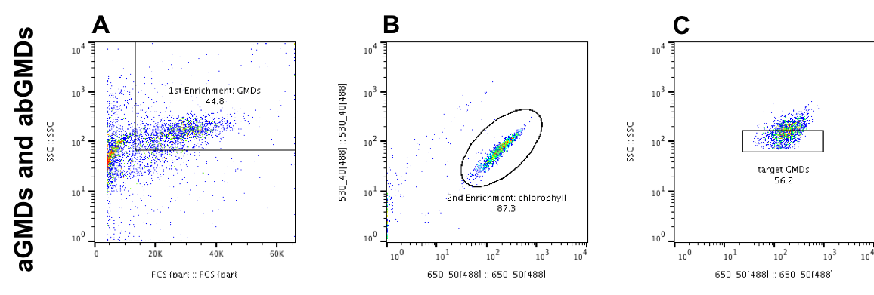
Figure S1. Pre-cultivation targeted FACS enrichment of aGMDs and abGMDs. (A) Only aGMDs and abGMDs containing algal/bacterial cells were first sorted by size by measuring forward scatter (FSC, x-axis at linear scale) versus side scatter (SSC, y-axis at logarithmic scale). (B) aGMDs and abGMDs were further analyzed by chlorophyll autofluorescence using a 650/50 nm filter (x-axis at logarithmic scale) versus 530/40 nm filter (y-axis at logarithmic scale), to select for GMDs containing algal/bacterial cells. (C) aGMDs and abGMDs were last sorted by measuring chlorophyll autofluorescence using a 650/50 nm filter (x-axis at logarithmic scale) versus side scatter (SSC, y-axis at logarithmic scale) and validated by microscopy to contain the desired single algal cell with 4 ± 1 bacterial cells.
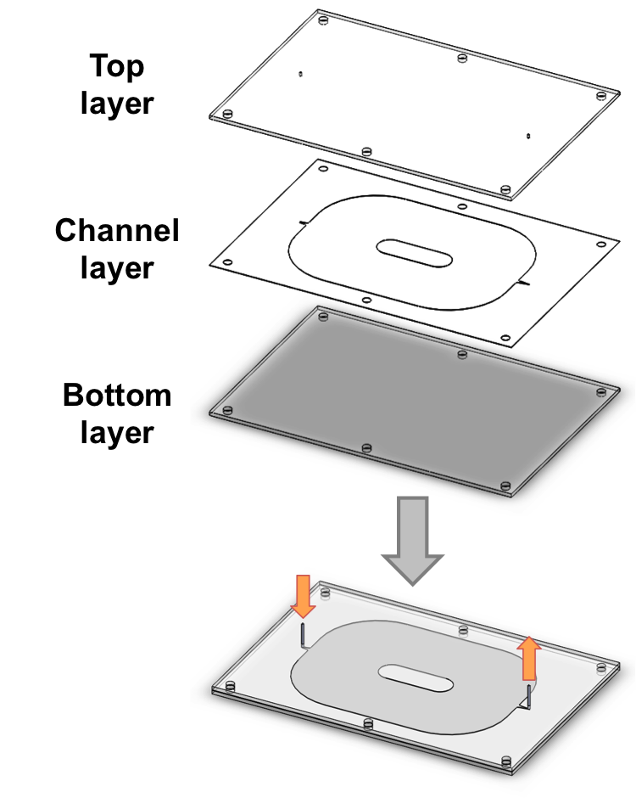
Figure S2. Schematic for cultivation chamber. The cultivation chamber was fabricated and
sterilized as described for the microfluidic droplet generator chip (Figure 2 legend). The microfluidic cultivation chamber was used to microscopically visualize droplets without disturbing them or sacrificing viability, as well as providing an even distribution of light.

Fabrication and optimization of droplet generator and growth chamber. The microfluidic system contains two modules: a microfluidic droplet generator (Figure 2) and a cultivation chamber (Figure S2). The system was fabricated in-house using modified lamination techniques. The droplet generator was fabricated by applying silicone A1 adhesive (SiATT 9122, 3M, St. Paul, MN, USA) to one side of an acrylic sheet (1/16 inch thick, Plaskolite Optix®, Columbus, Ohio) using pressure rollers. The adhesive coated acrylic sheets were cut on a CO₂ laser cutter into top and bottom portions for the microfluidic device, including inlets and outlets for the top section. Kapton® inner sections were designed on Solid Edge software and cut with a UV laser (A-Laser, FCT Assembly). Sections were aligned and sealed using pressure rollers or a rotary lamination press. Following device assembly, needles were glued with epoxy into the outlets and inlets and left to dry. All devices were incubated with 0.22 µm filtered 10% bleach solution for 15 min at room temperature, and thoroughly flushed with DiH₂O prior to use. The cultivation chamber was similarly fabricated (but used a Plaskolite acrylic sheet as the middle layer, rather than Kapton) and sterilized.
MD capture of enriched GMDs. Enriched GMDs were encapsulated in microdroplets (MDs) using the microfluidic droplet generator (Figure 2). MDs were generated with 2.5% (biologically compatible surfactant) PFPE-PEG block copolymer (RainDance™ Technologies, Billerica, MA) in Novek-7500/HFE (3M Company, St. Paul, MN) as the oil input, while the aqueous input was the flow sorted target GMD solution (n = ~300,000 in 8.25 mL). Two 10-mL sterile syringes dispensed the oil solution, while a third 10-mL sterile syringe dispensed the GMD solution. Silicone tubing connected syringes to the droplet generator inlet and outlet to the cultivation chamber. A syringe pump (Model Fusion 720, Chemyx Inc.) was used to inject the fluids into the droplet generator chip. Input flow rates for droplet generation were 100/100/50 μl/min (oil/oil/aqueous, respectively). The aqueous GMD solution syringe was disconnected from the droplet generator and mixed via gentle inversion every 7 min to prevent excessive settling of GMDs. The total MD encapsulation experiment duration times were ~45 min, generating ~12,000,000 MDs.
Cultivation Chamber. Inlet silicone tubes were cut (with razor blade) leaving behind ~5 cm of tubing attached onto the metal inlet channel, and were sealed with plastic clamps. The sealed cultivation raceway chip (Figure S2) was placed on an orbital shaker (continuous shaking at 110 rpm; Model: Classic C1 Platform, New Brunswick Scientific) at 22° C. The MDs were incubated for seven days.
MD Destabilization. After incubation, all MDs were recovered from the collection chamber with a sterile syringe and transferred to a 15 mL conical tube (~7 mL total recovered volume), incubated at room temperature for 5 min to allow separation of excess oil to the bottom of the tube (i.e., lower phase) and facilitate GMD extraction from the aqueous phase (i.e., upper phase) via gentle pipetting. After removal of the lower oil phase, the remaining emulsion volume (typically < 2 mL) was equally aliquoted into sterile 1.5 mL microcentrifuge tubes. Droplet destabilizer, 1H, 1H, 2H, 2H-Perfluoro-1-octanol (40% v/v; HFE-7500, RainDance™ Technologies, Billerica, MA) was added at half the total volume emulsion volume (e.g., 300 μl destabilizer to 600 μl emulsion), vortexed at ~3,000 rpm for 30 s, and centrifuged for 5 min at 2,000 x g at room temperature. This collapsed the emulsion, resulting in a visible oil phase at the lower half of the tube and the target aqueous GMD phase at the top. The resultant aqueous layer (typically half the total destabilizer-emulsion volume) was pooled to a sterile 5 mL polypropylene culture tube for direct analysis by flow cytometry. We estimate a recovery of 50,000 GMDs / mL.
Post-Cultivation FACS Enrichment of Top Performing abGMDs. FACS was utilized to identify abGMDs that displayed greater algal biomass using chlorophyll a and b fluorescence as an indicator. Cultivated aGMDs were harvested from MDs and analyzed with flow cytometry under the same parameters described earlier. In detail, the aGMD population was first analyzed using FSC (x-axis; linear scale) versus SSC (y-axis; log scale; Figure S3A). The same population was analyzed for chlorophyll fluorescence using filters 650/50 (x-axis; log scale) versus 530/40 (y-axis; log scale; Figure S3B). This permitted the upper limit detection of chlorophyll fluorescence normally found in Quadrant II of the fluorescent cytograph to define the aGMDs gate (Figure S3B). Once the aGMD gate was established, the target abGMDs gate was defined above the aGMDs gate, which would identify our expected top performing abGMDs. To verify that none of the aGMDs fell within the target abGMDs gate, particles were sub-selected from the target abGMDs gate and re-analyzed under SSC vs FSC, which showed that none of the cultivated aGMDs (i.e., 0%) qualified as target abGMDs (Figure S3C). After establishing these two gates, the cultivated abGMDs (also harvested from MDs post-cultivation) were analyzed using FACS as just described. After analysis under SSC versus FSC, the abGMDs were analyzed for chlorophyll fluorescence using filters 530/40 versus 650/50 using the same predetermined aGMDs and target abGMDs gates (Figure S3E). This revealed a small population of abGMDs that fluoresced greater than what was observed in the control aGMD population. These abGMDs were sub-selected for further analysis under SSC versus FSC to reveal which of the total abGMD population (Figure S3D) possessed the target algal phenotype (Figure S3F). These target abGMDs were single sorted in 96-well culture plates for downstream cultivation, recovery, and identification of the associated bacteria.

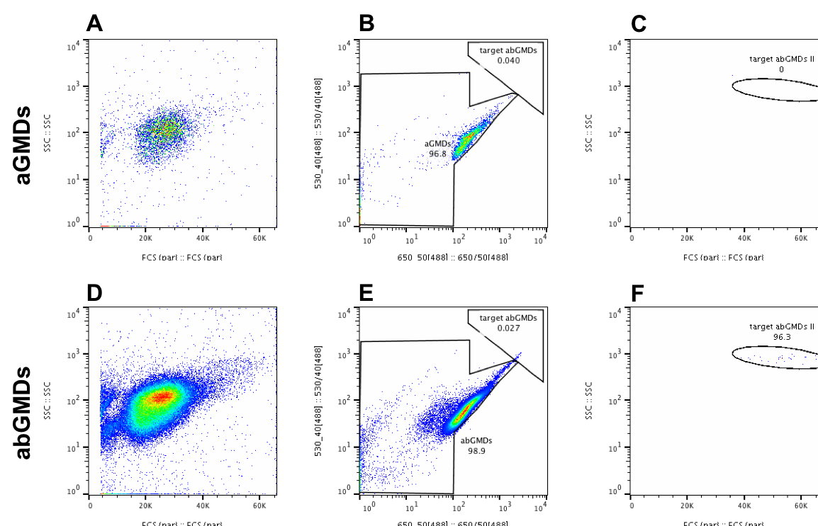
Figure S3. Post - cultivation targeted FACS enrichment of abGMDs. Control population of cultivated aGMDs (A) and experimental cultivated population of abGMDs (D) using FSC (x-axis; linear scale) versus SSC (y-axis; log scale). (E) Cultivated abGMDs exhibiting chlorophyll autofluorescence higher than that of the cultivated control aGMDs shown in (B) using a 650/50 nm filter (x-axis at logarithmic scale) versus 530/40 nm filter (y-axis at logarithmic scale). (F) Gated selection of cultivated abGMDs exhibiting higher FSC (to distinguish from free
algae) and SSC (to distinguish from aGMDs without microcolonies) values than that of the
uncultivated controls. (C) Application of the same gating strategy shown in (F) to a cultivated aGMD control.

Iterative Selection. To selectively enrich for interspecies relationships (e.g. growth effects) using the HISCI technique, four rounds of selection were performed on co-cultured Chlorella sorokiniana 1412 and an environmentally sourced pool of bacteria (see methods, main text). GMDs were packaged with algal and bacterial cells (abGMDs) and enriched using FACS with the aforementioned pre-cultivation target enrichment strategy (Figure S1). These abGMDs were then packaged in MDs and incubated. The time a GMD is incubated is dependent on the growth rate of the species. We target the stage of microcolony growth prior to GMD bursting into MD space, so the GMDs may be flow sorted. In this case, we determined the growth rate of Chlorella and the bacteria to be sufficient after 7 days in a microfluidic collection chamber. After growth in the chamber, the abGMDs were recovered from their oil-phase (MD) by emulsion collapse and sorted by FACS with the aforementioned post-cultivation target enrichment strategy (Figure S3) into 24 or 96-well plates with 1 abGMD per well. The sorted abGMDs were grown for 10-14 in a 12 h light, 12 h dark cycle, and constant shaking at 120 RPM. After incubation, wells with the desired phenotype of increased algal growth were pooled. This pooled sample was filtered with a 5 μm filter to remove algal cells, concurrently sequenced to identify the bacterial cohort present and repackaged into abGMDs with fresh C. sorokiniana 1412 to be re-entered into the next screen.

